**Summary of Magnetic Sensors signal analysis**

**General Glucose Levels, Ensure/Insulin Events and Signal experimental visualizations:**

patient = "Insulin Clamp #1"  
tdms_file = "Patient3_0202.tdms"  
sub_dir = "Insulin Clamp #1 January 23 2025"

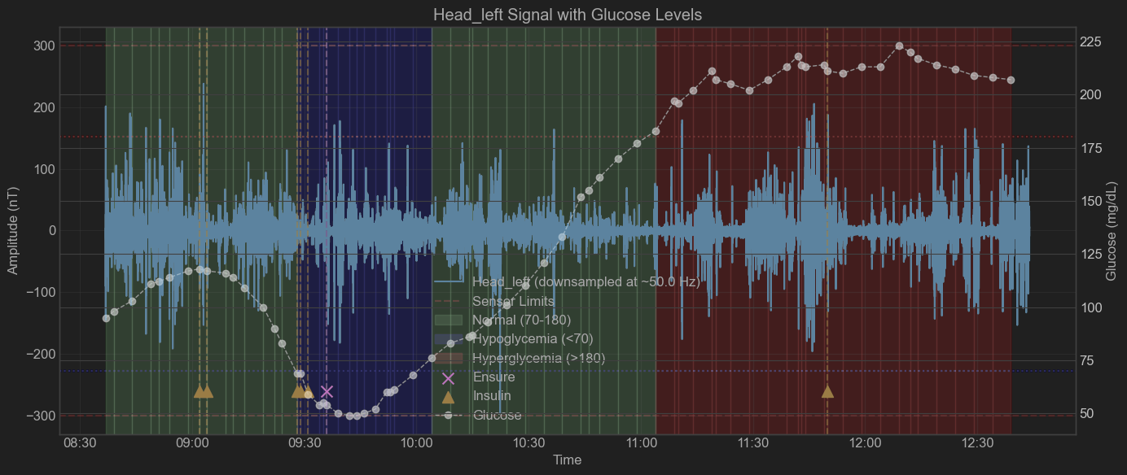

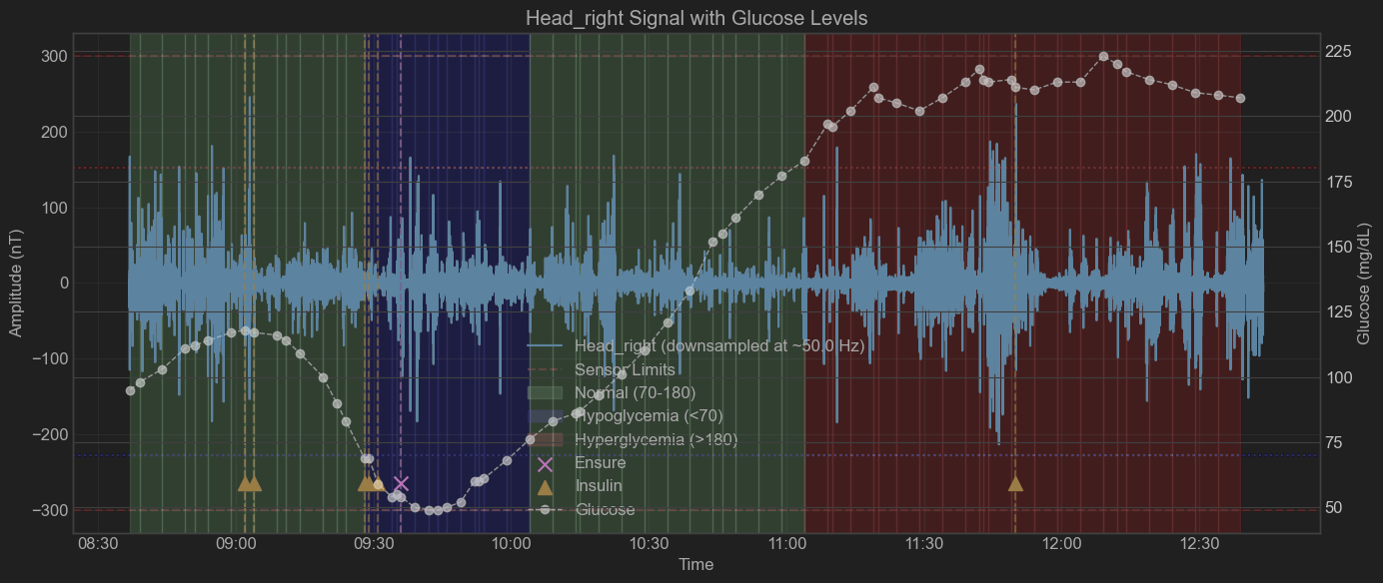

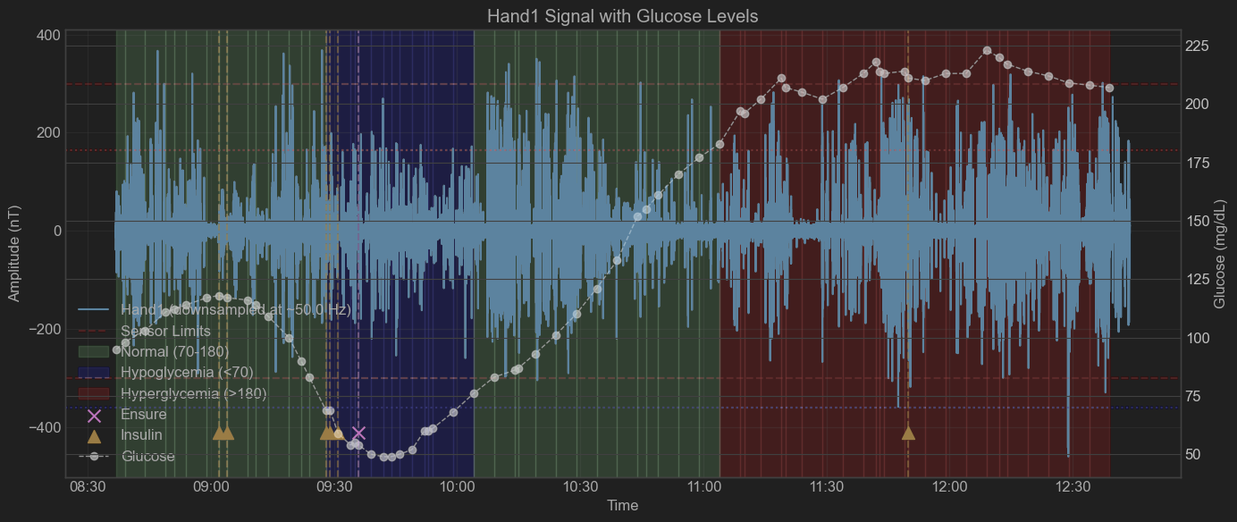

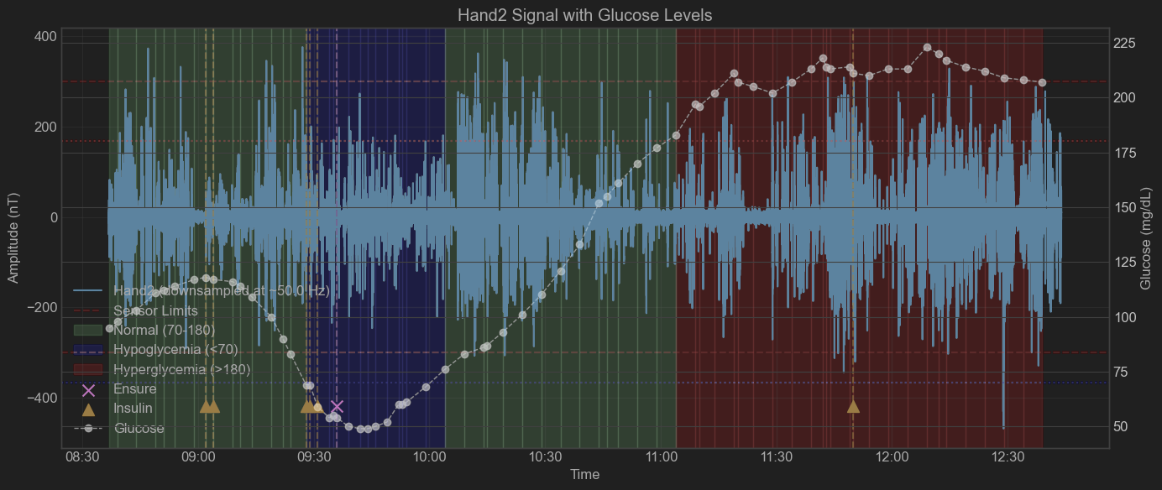

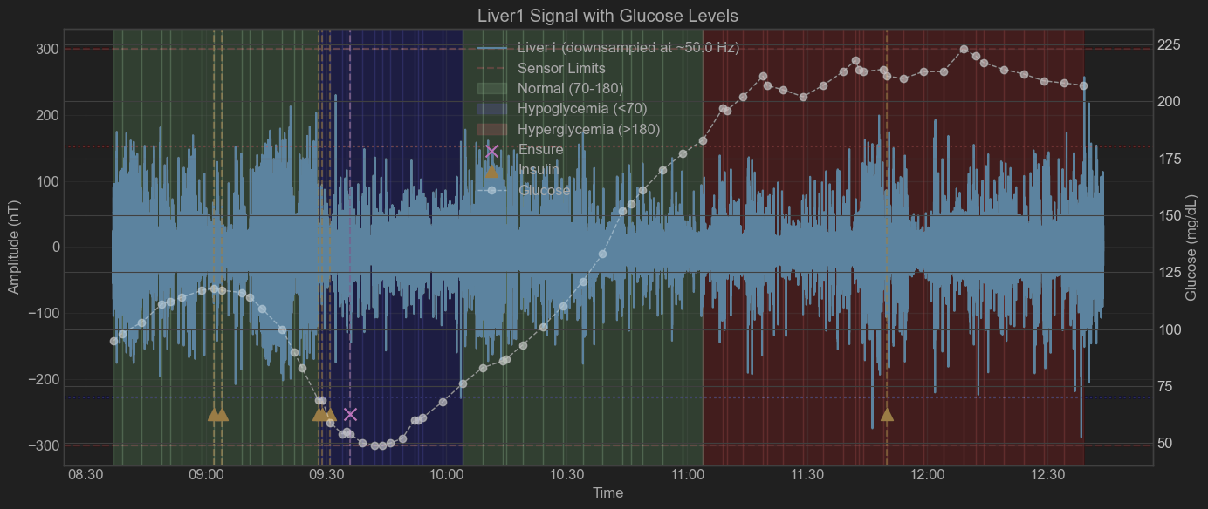

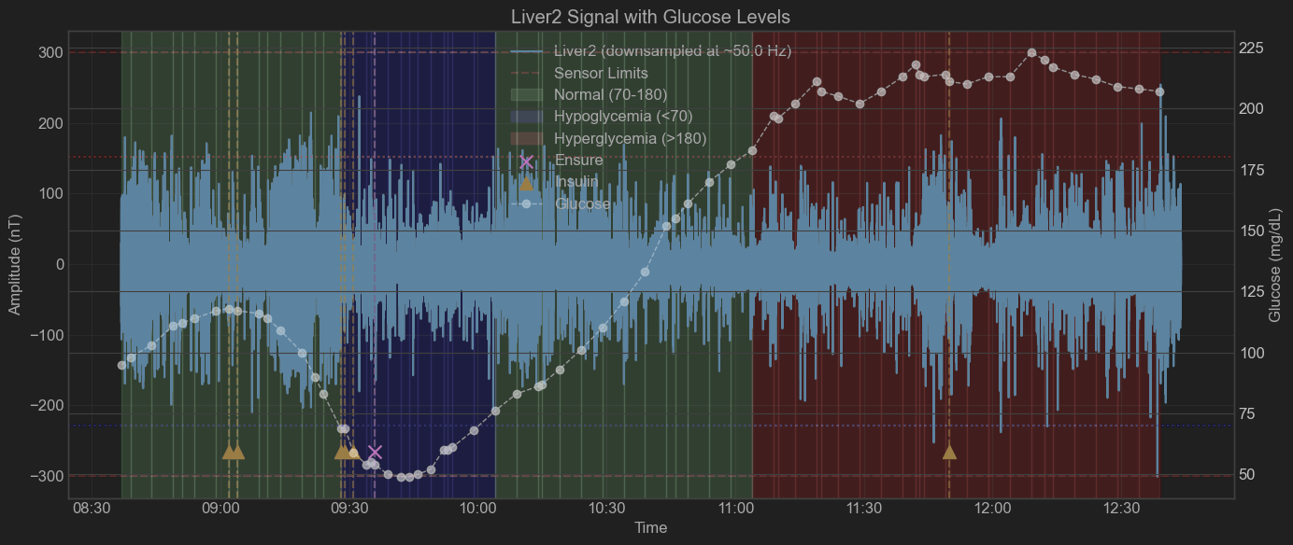

patient = "Insulin Clamp #2"  
tdms_file = "Patient5_1.tdms"  
sub_dir = "Insulin Clamp #2 January 30, 2025"

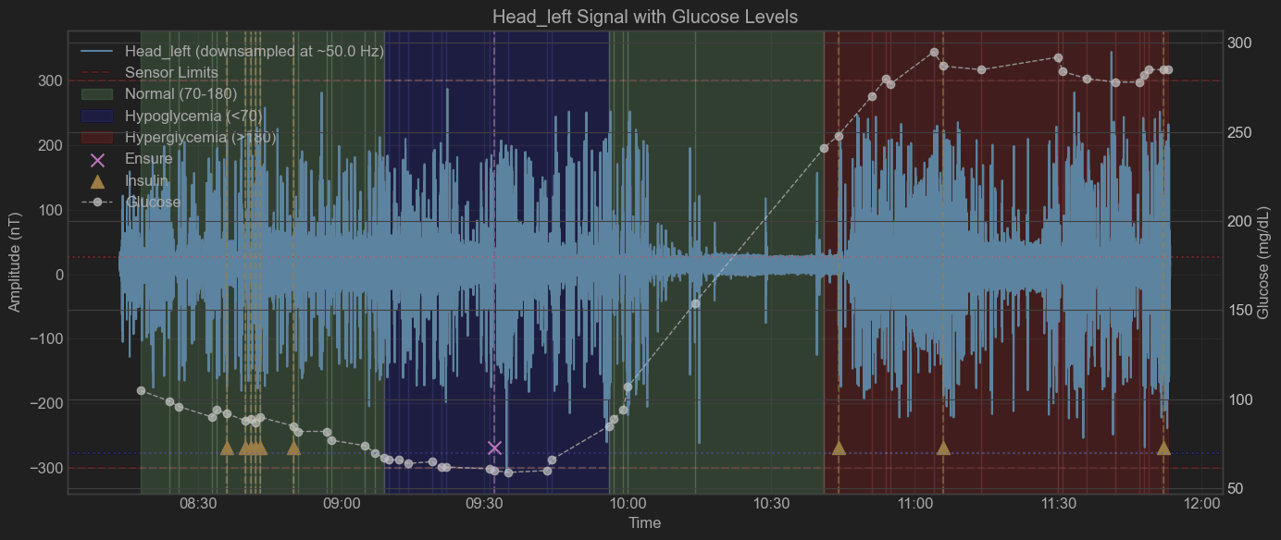

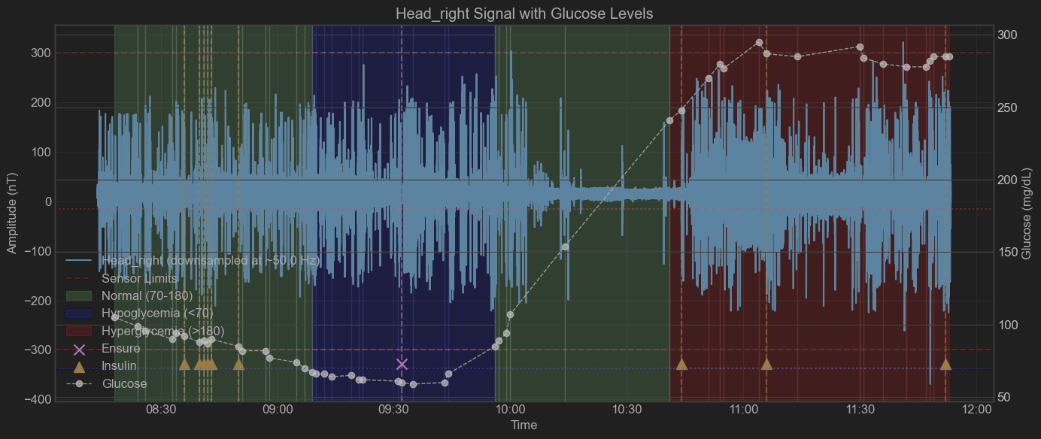

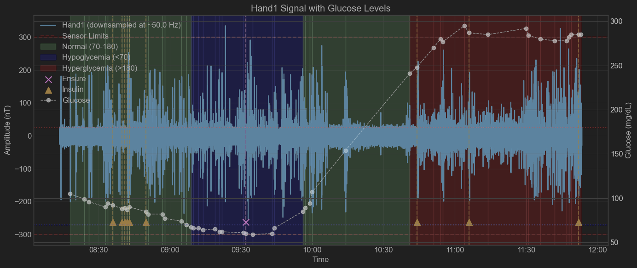

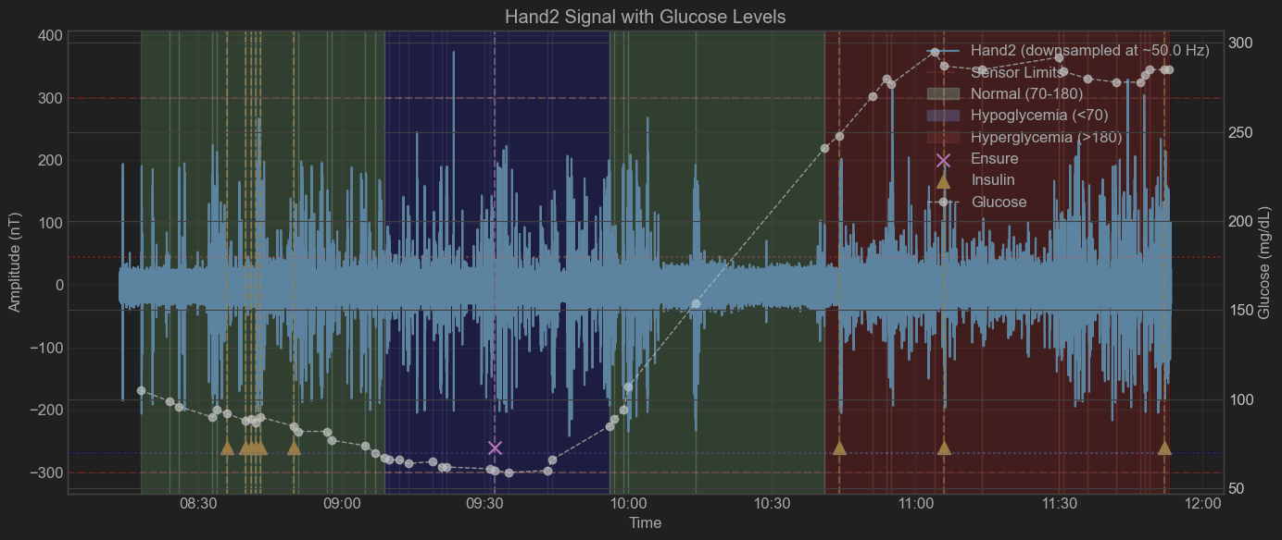

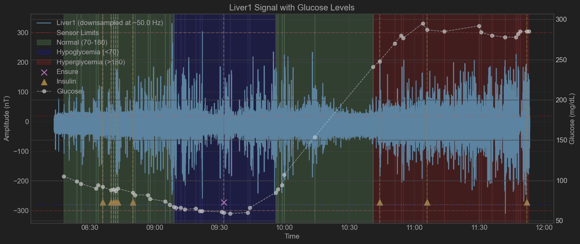

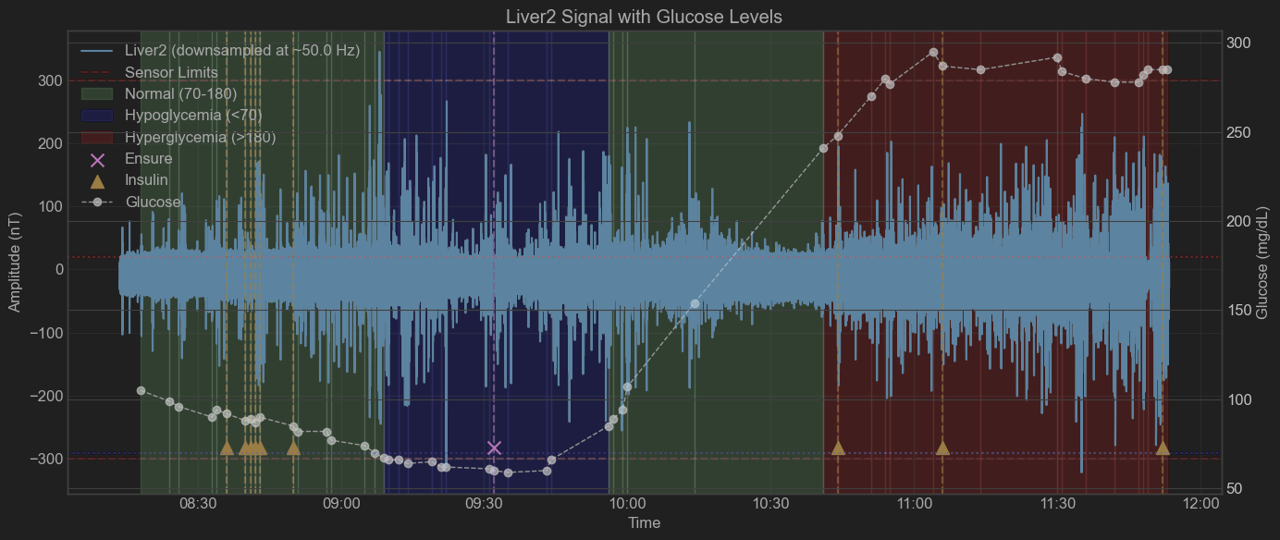

patient = "Insulin Clamp #3"  
tdms_file = "Patient_0201_1.tdms"  
sub_dir = "Insulin Clamp #3 February 6 2025"

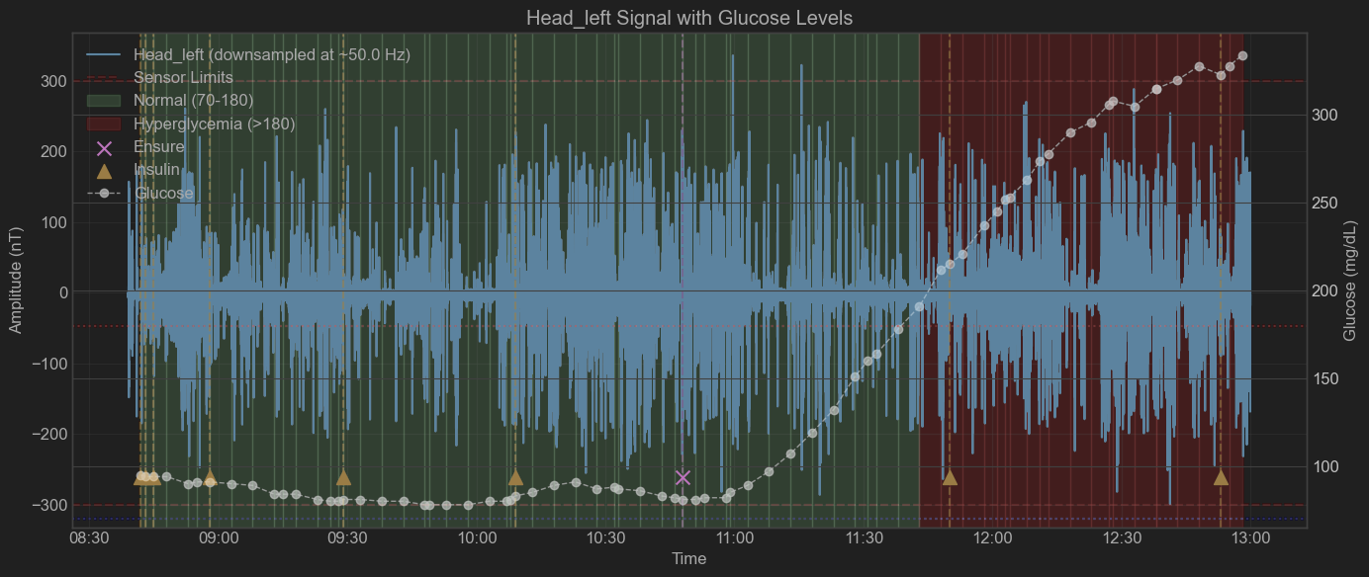

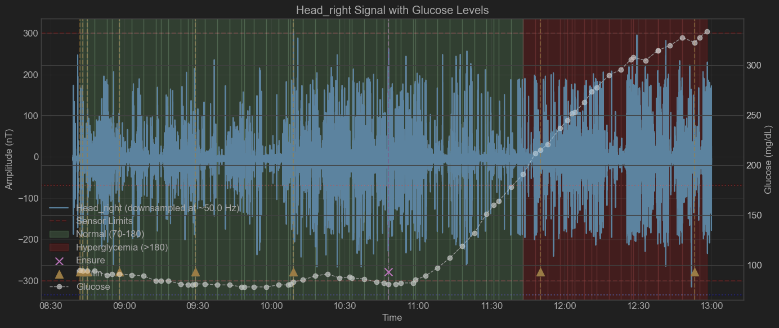

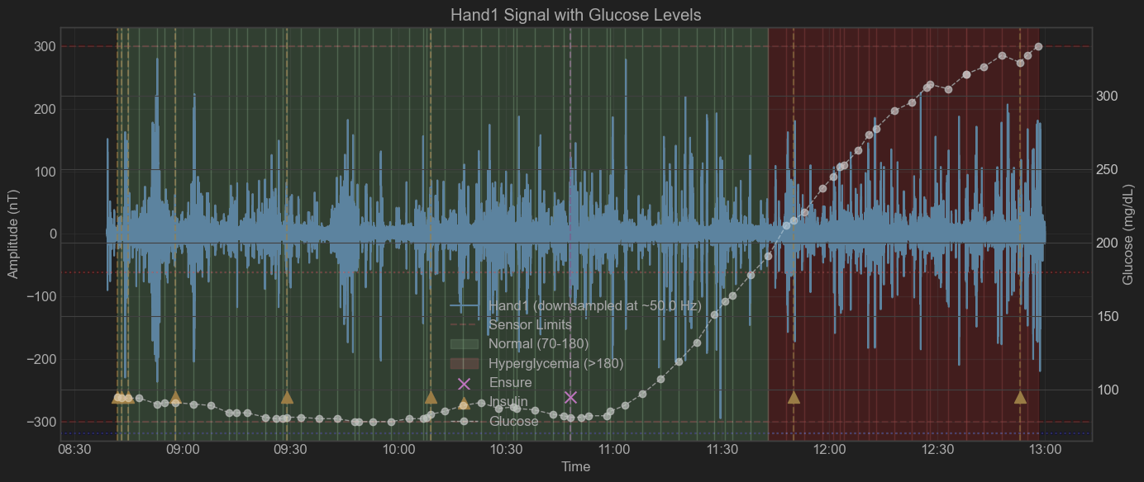

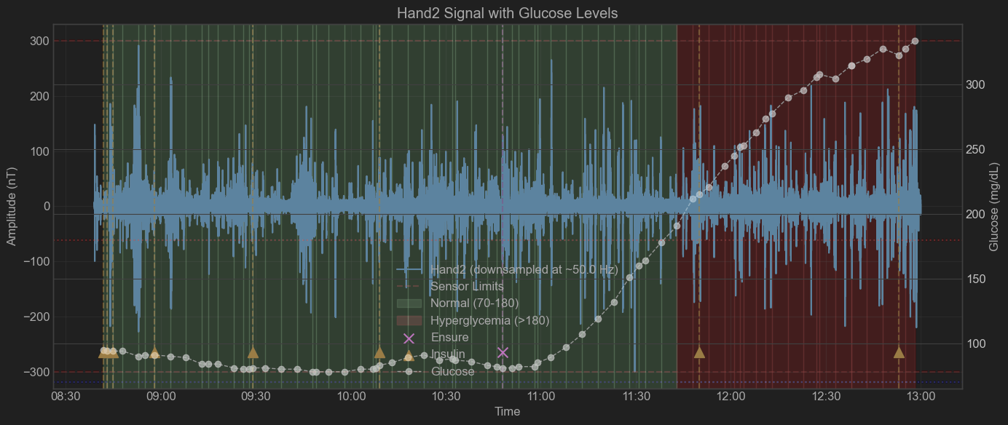

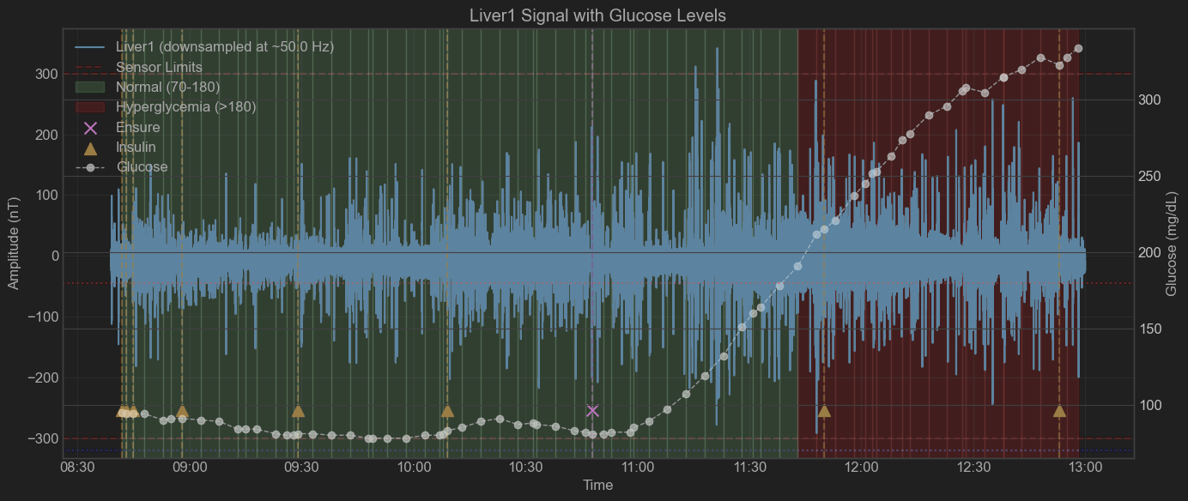

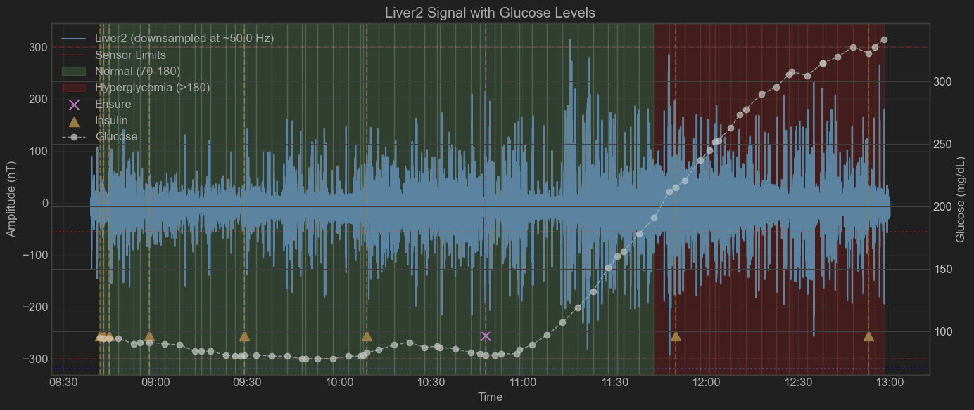

patient = "Insulin Clamp #4"  
tdms_file = "Patient_0205_1.tdms"  
sub_dir = "Insulin Clamp #4 February 13, 2025"

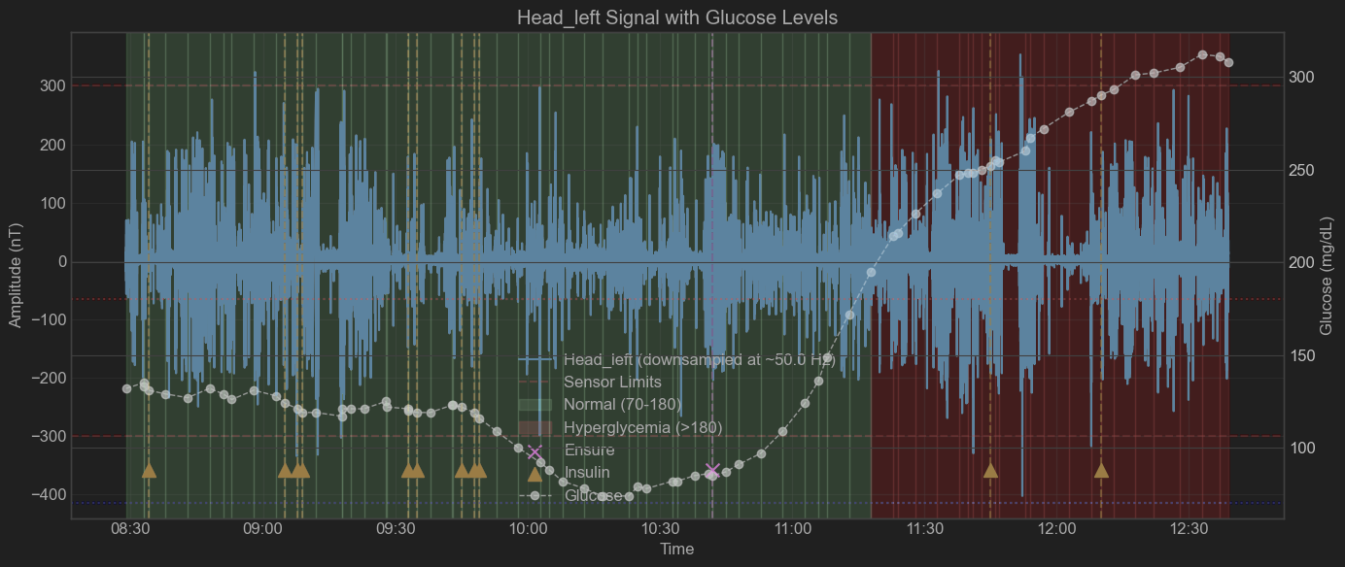

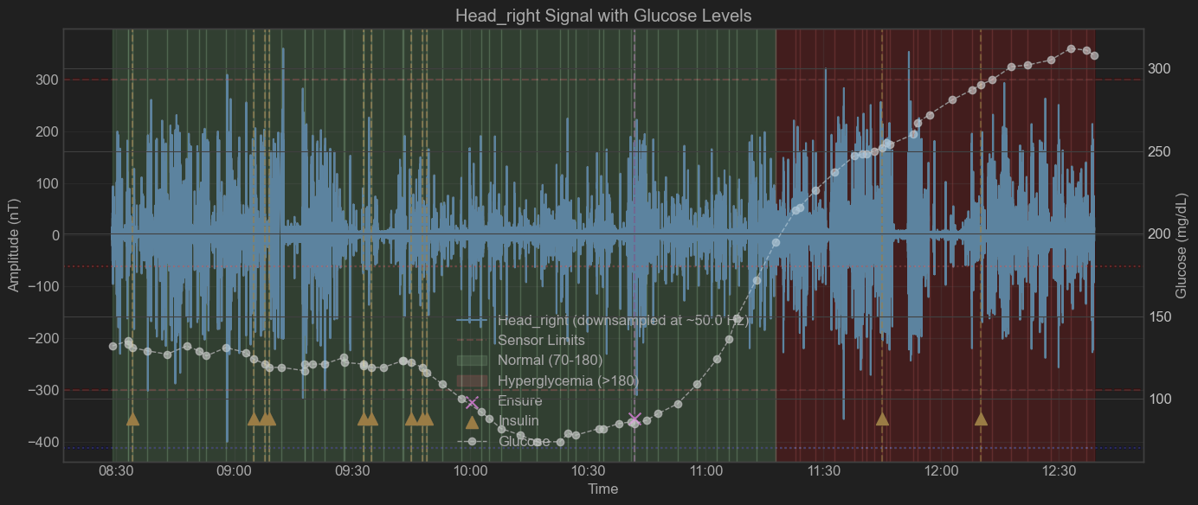

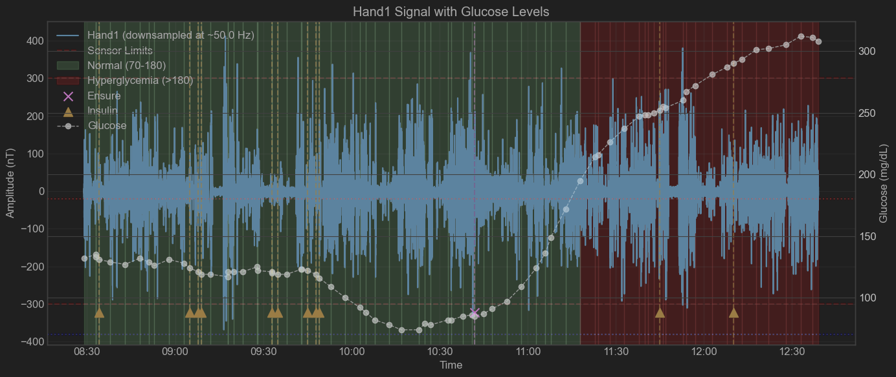

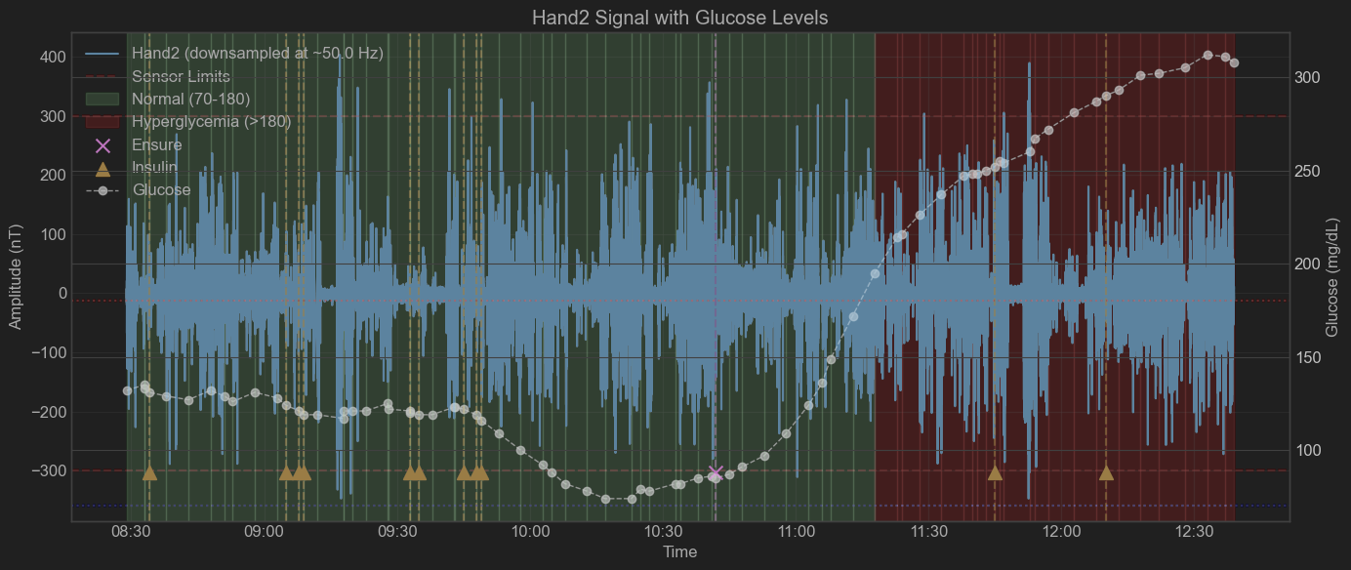

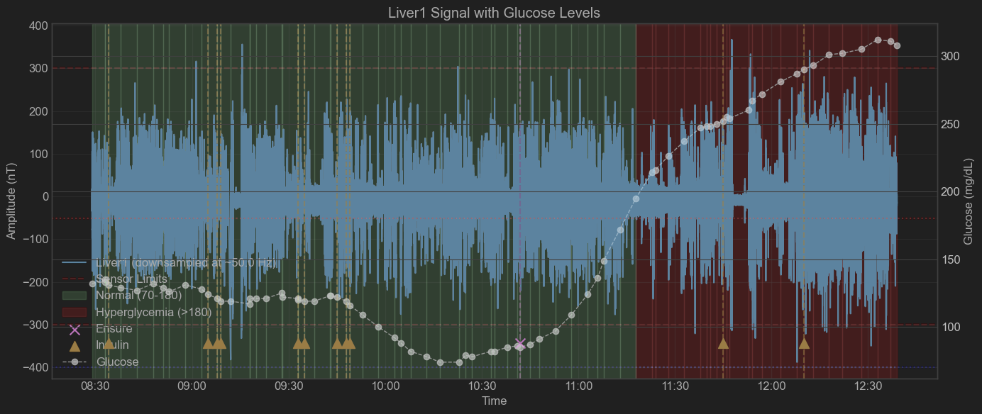

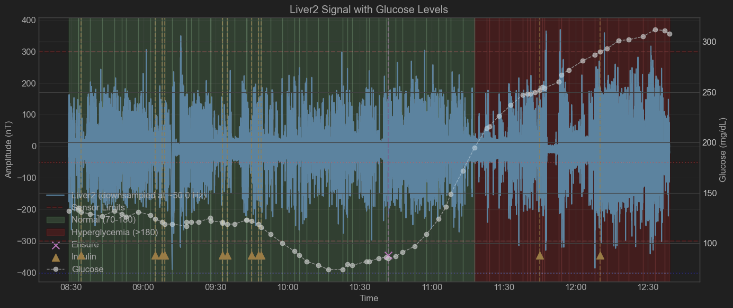

patient = "Insulin Clamp #5"  
tdms_file = "Patient_0204_1.tdms"  
sub_dir = "Insulin Clamp #5 February 20 2025"

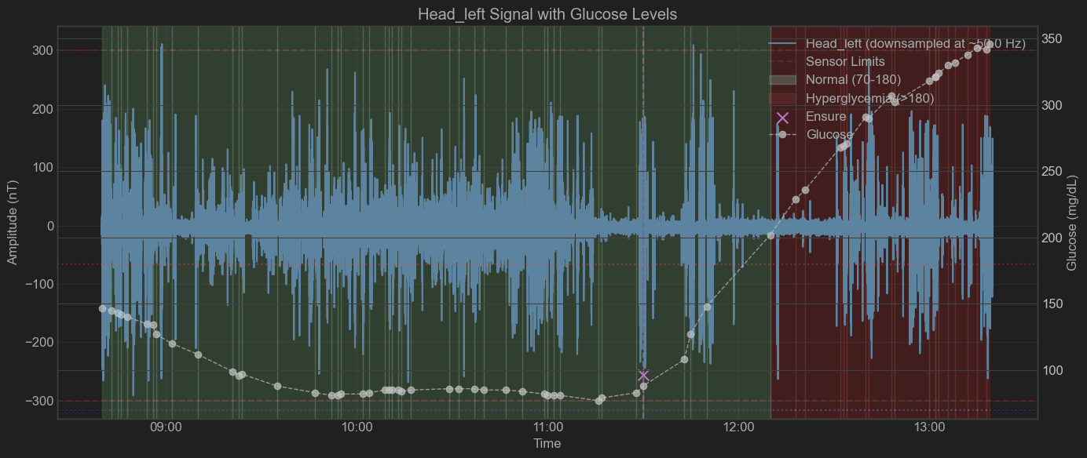

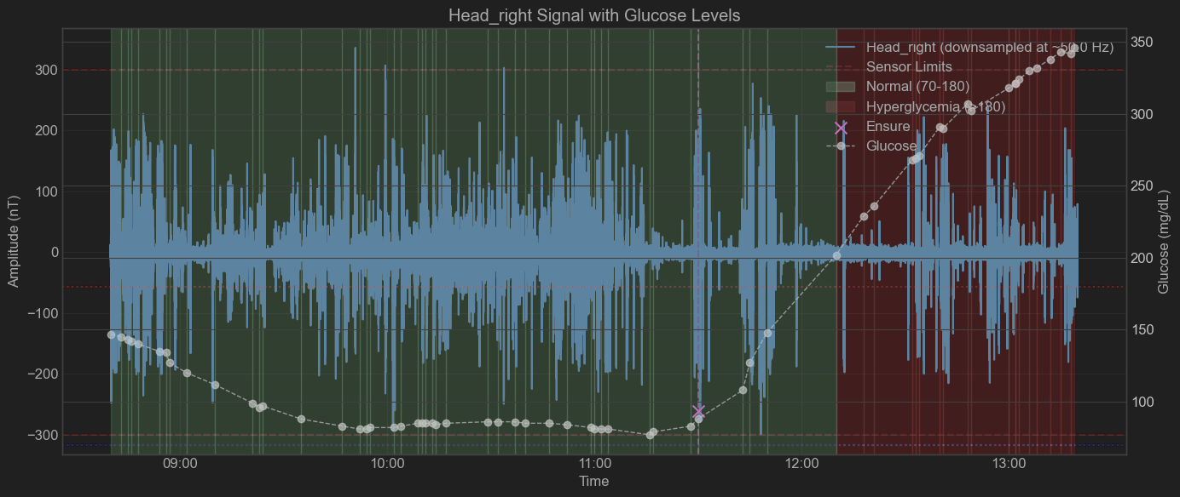

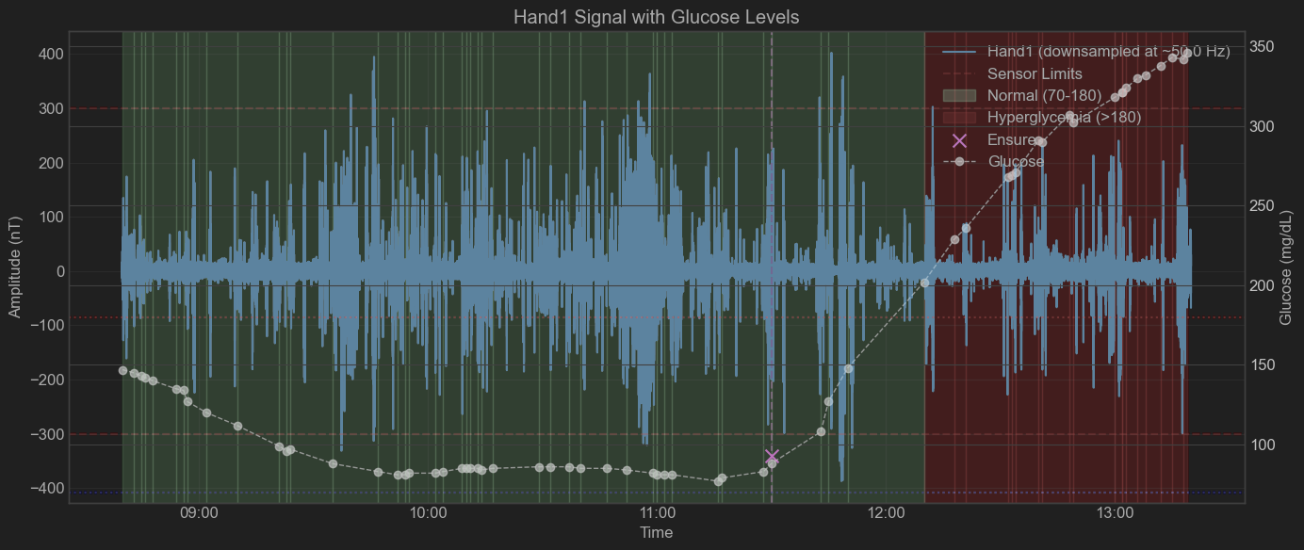

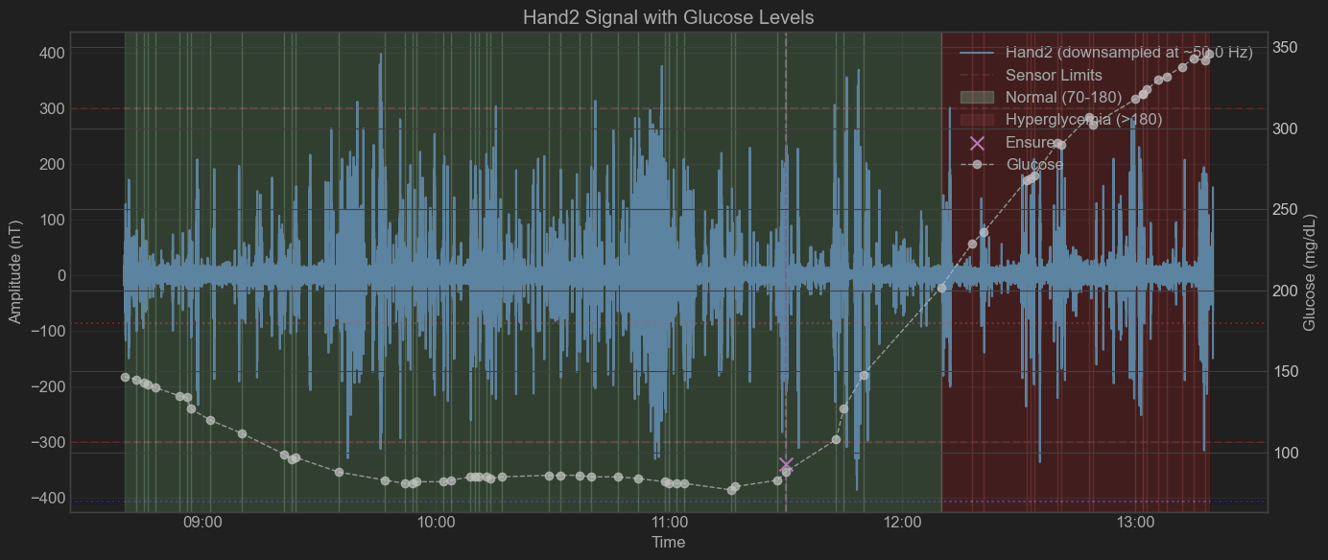

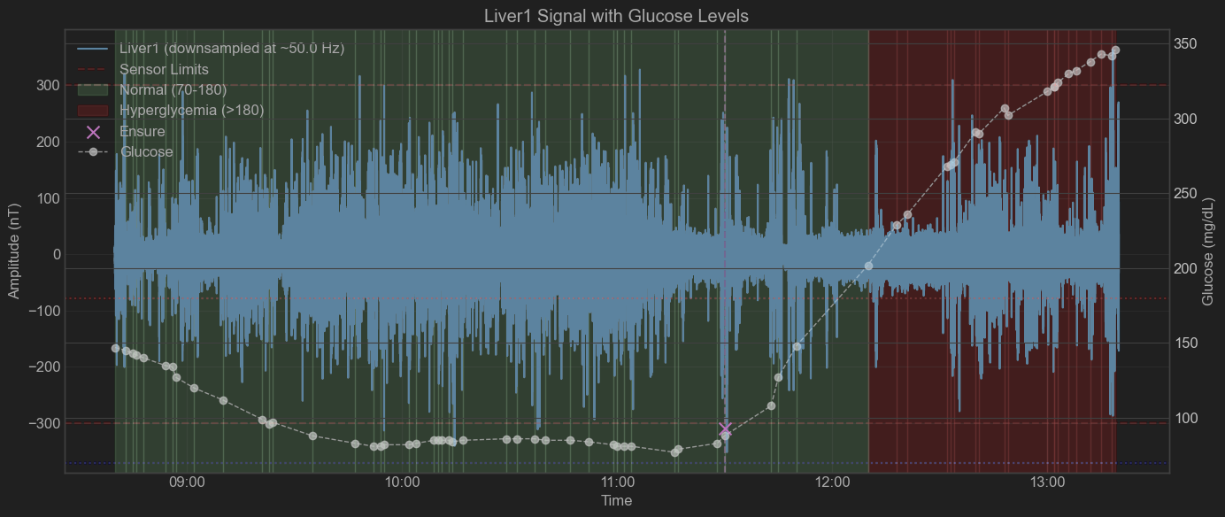

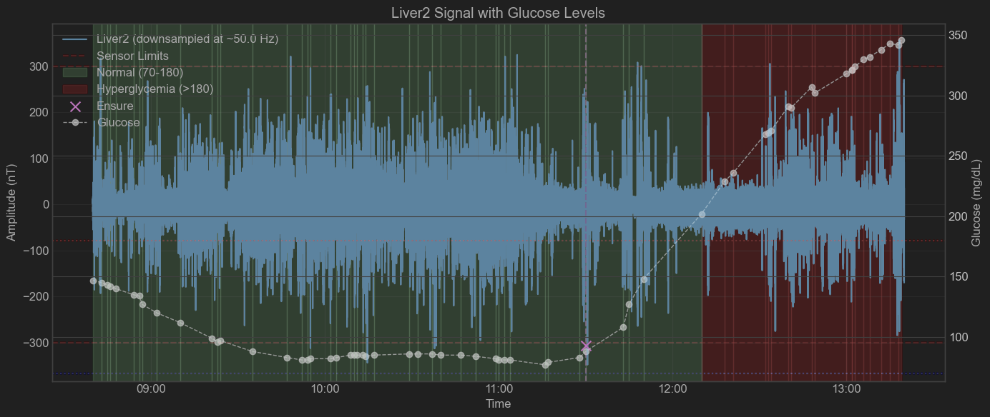

patient = "Insulin Clamp #6"  
tdms_file = "patient_0206_1.tdms"  
sub_dir = "Insulin Clamp #6 March 2 2025"

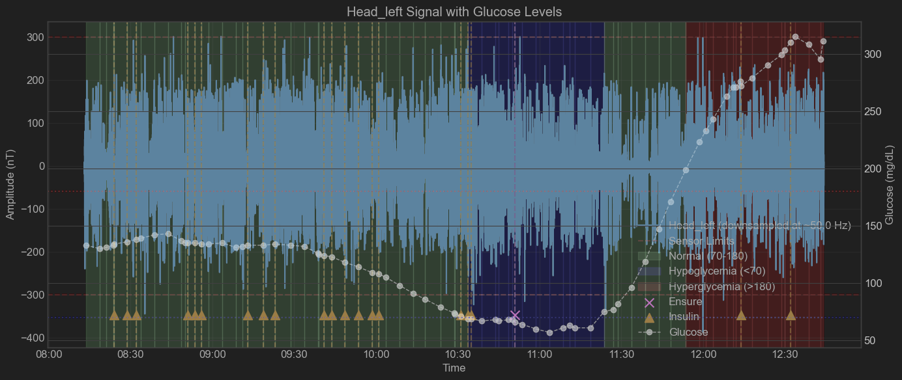

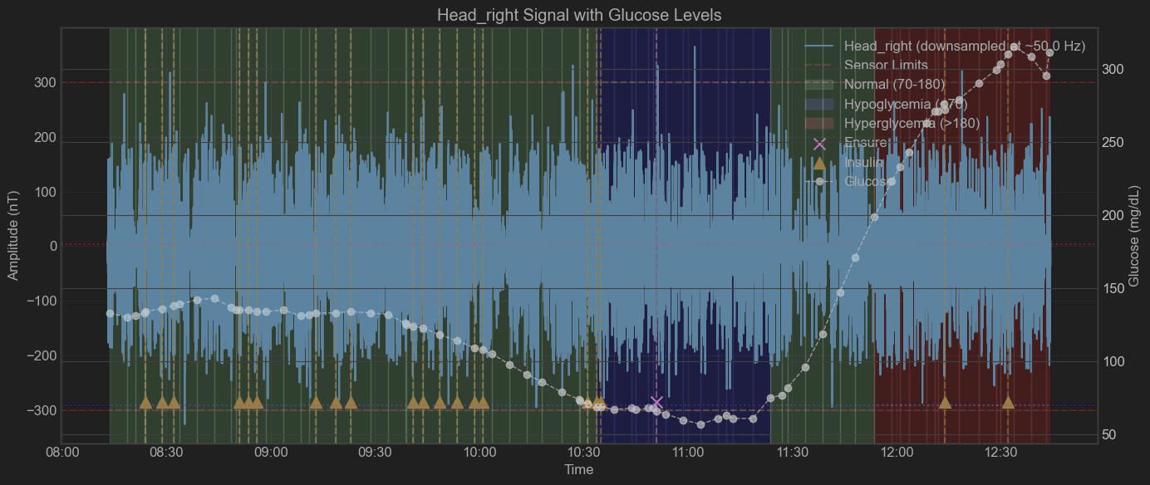

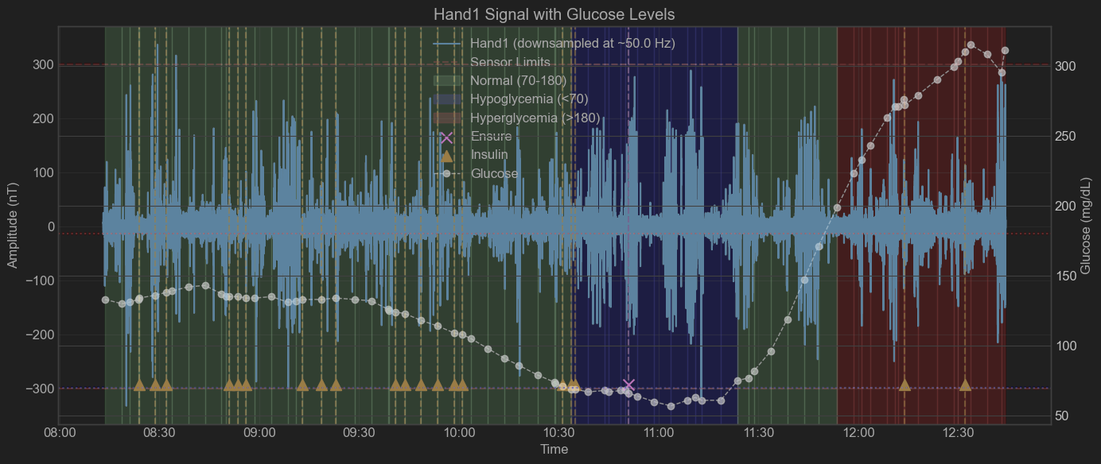

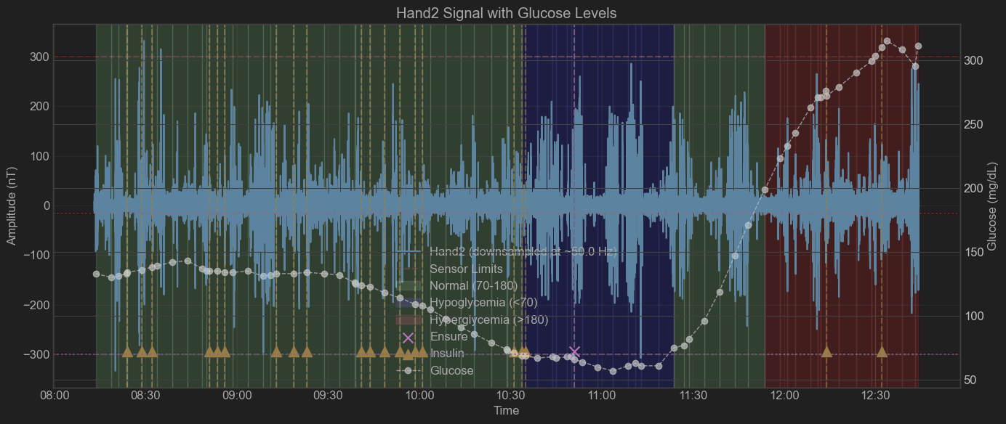

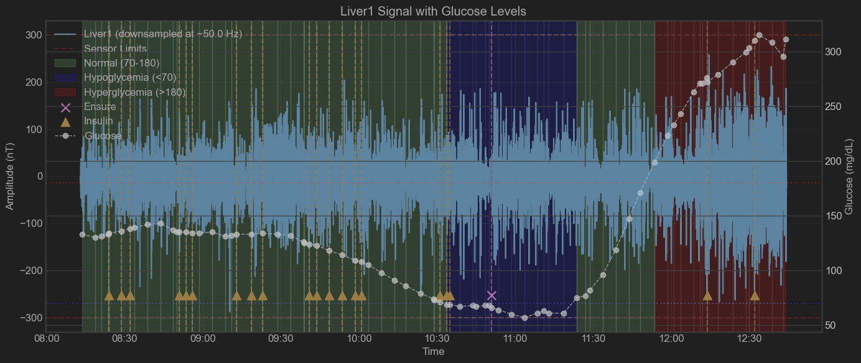

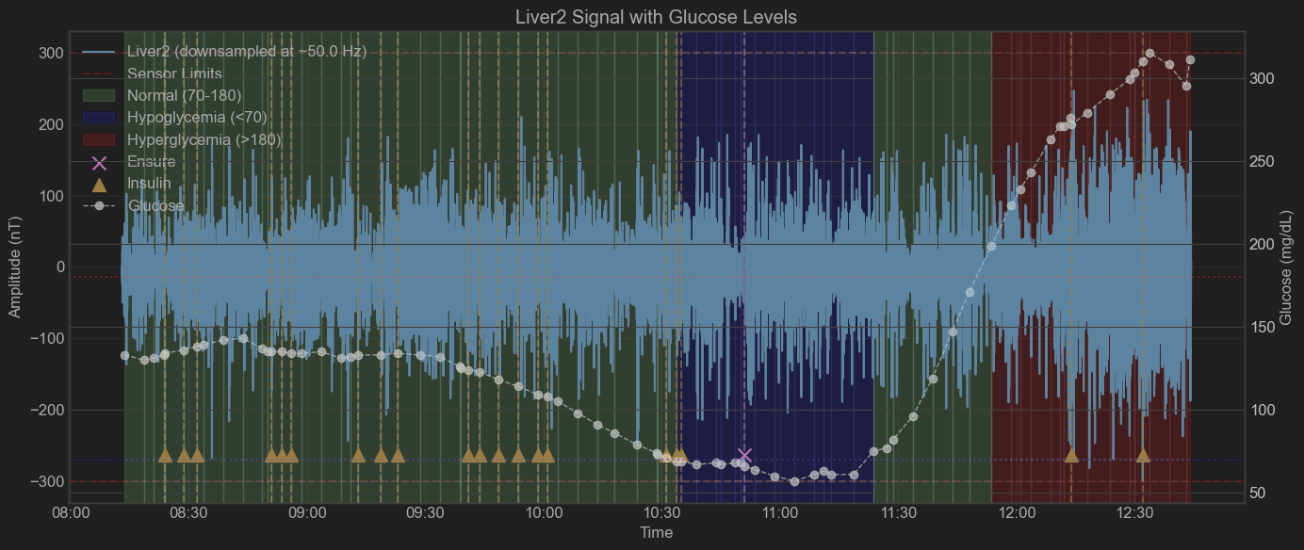

patient = "Insulin Clamp #7"  
tdms_file = "patient_0207_girl_1-001.tdms"  
sub_dir = "Insulin Clamp #7 March 13 2025"

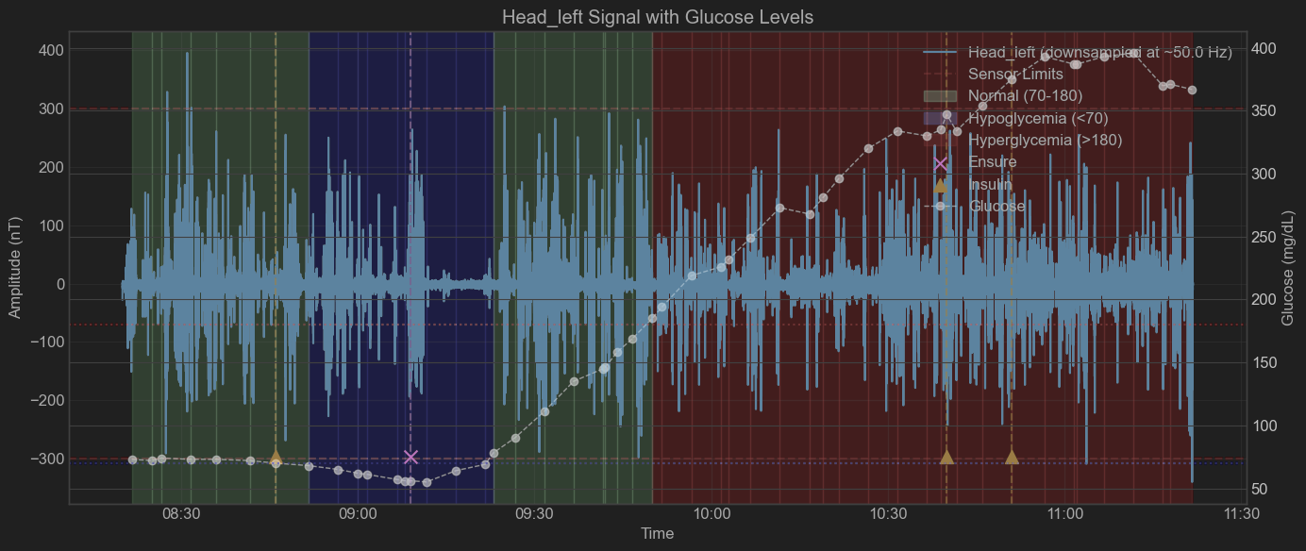

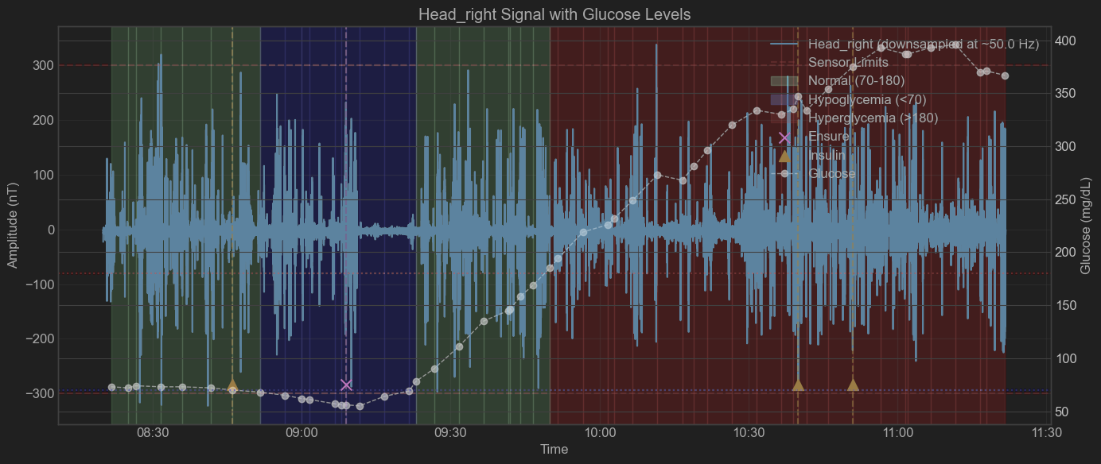

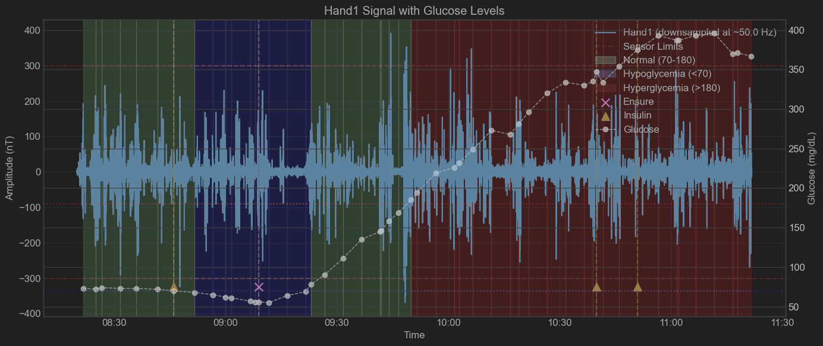

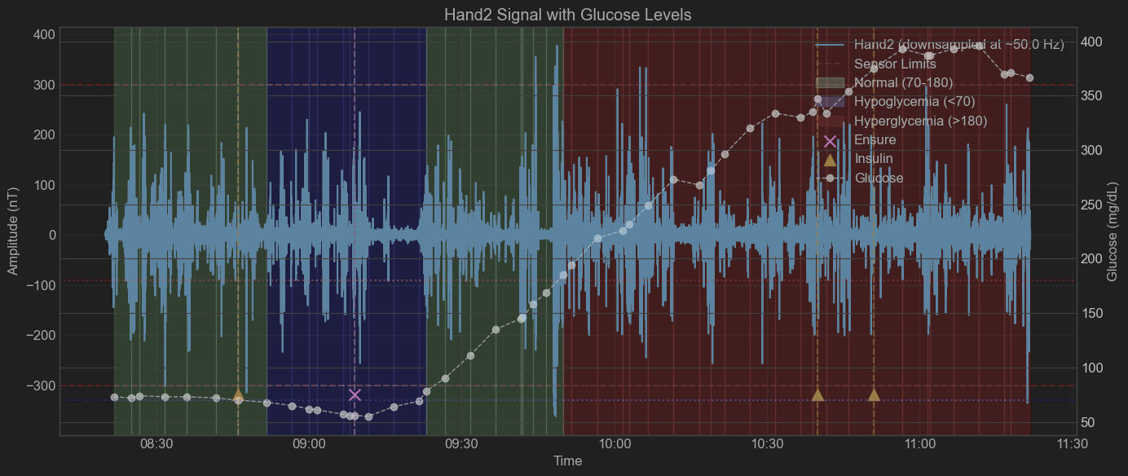

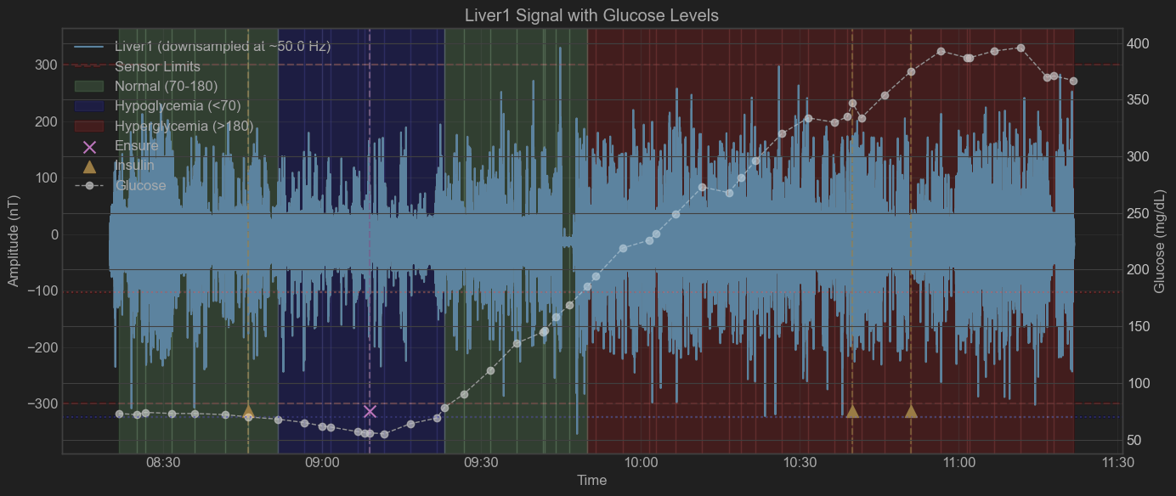

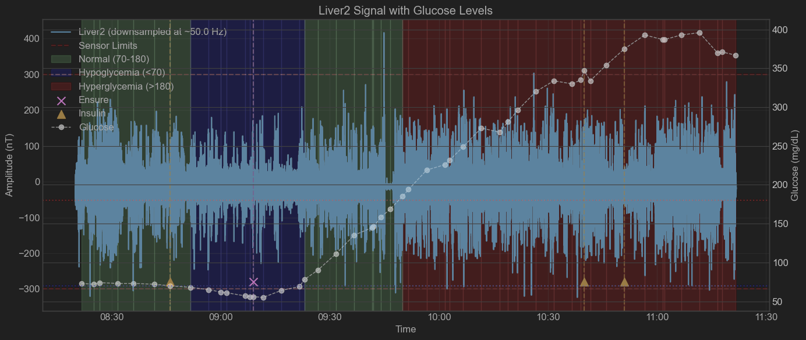

patient = "Insulin Clamp #8"  
tdms_file = "patient_0208_1-001.tdms"  
sub_dir = "Insulin Clamp #8 March 20 2025"

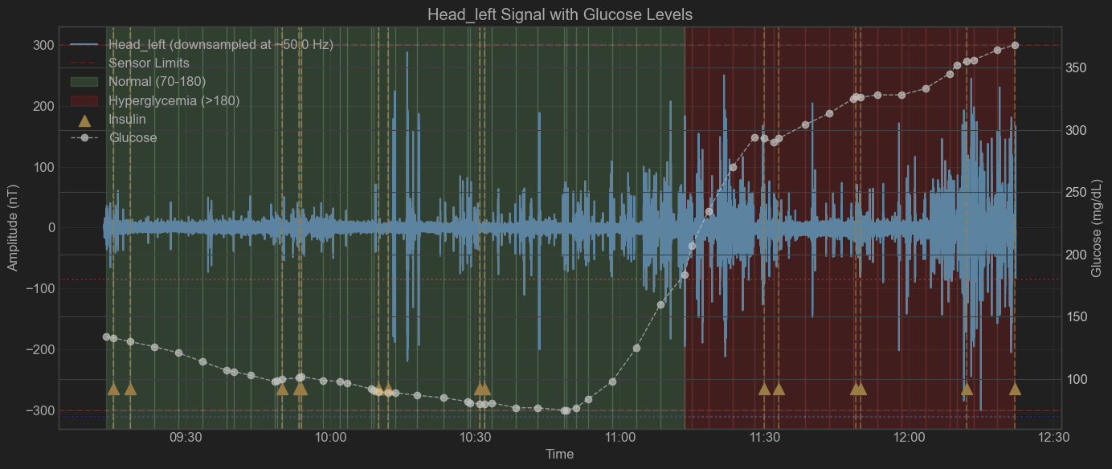

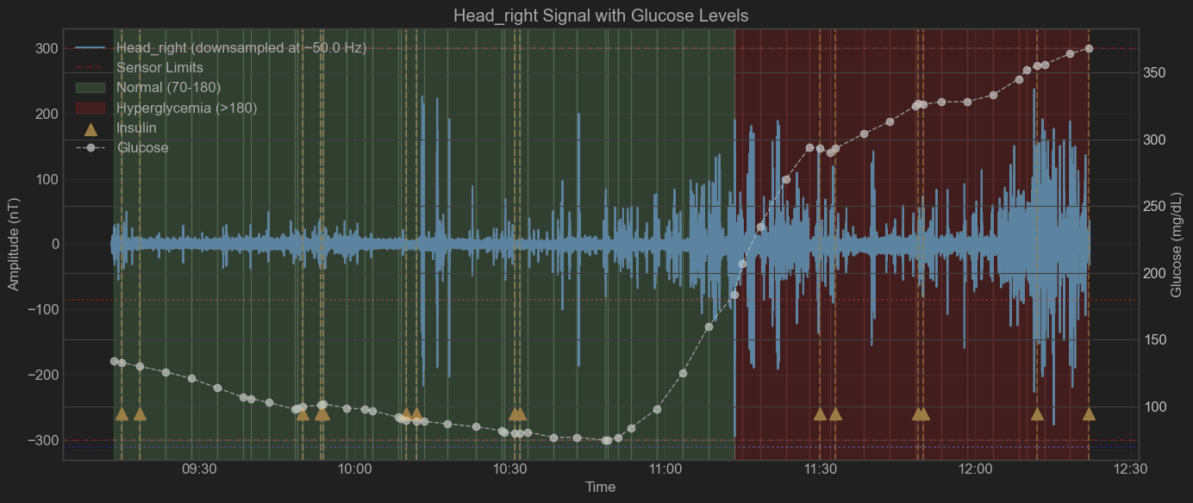

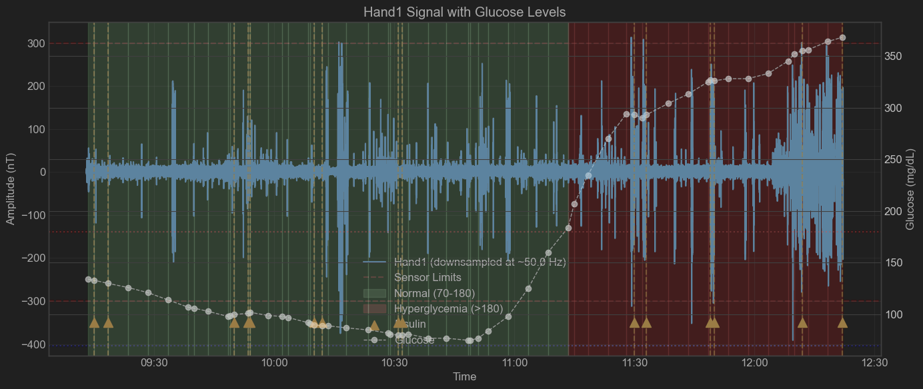

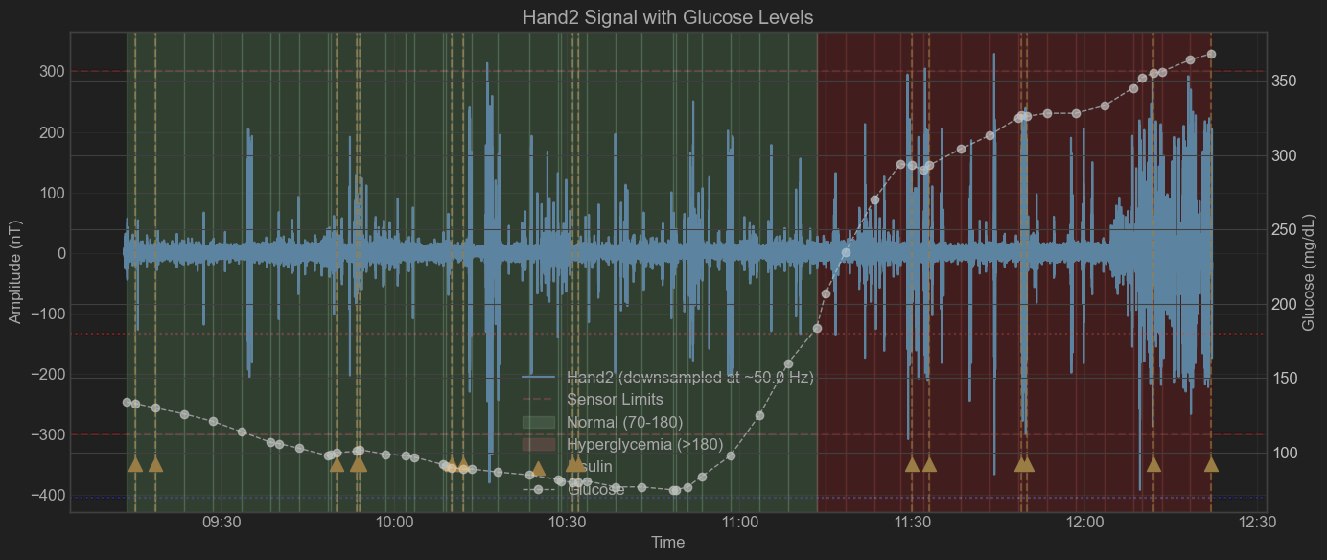

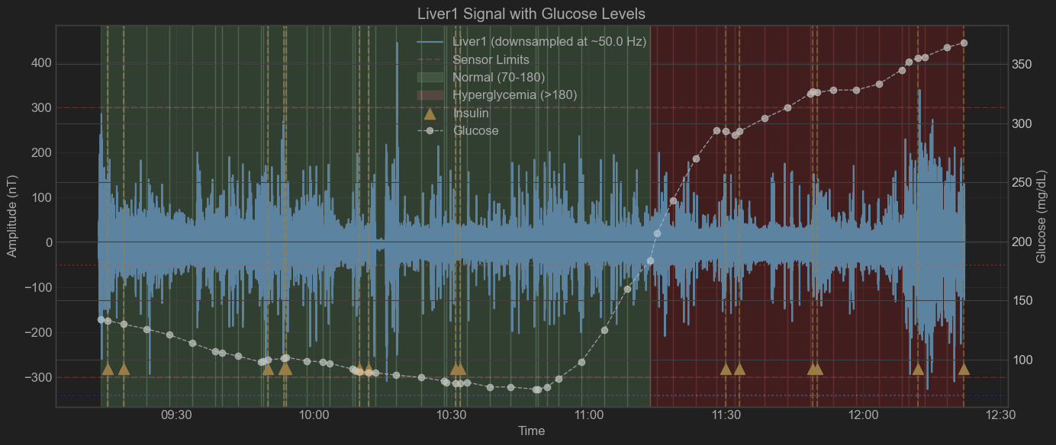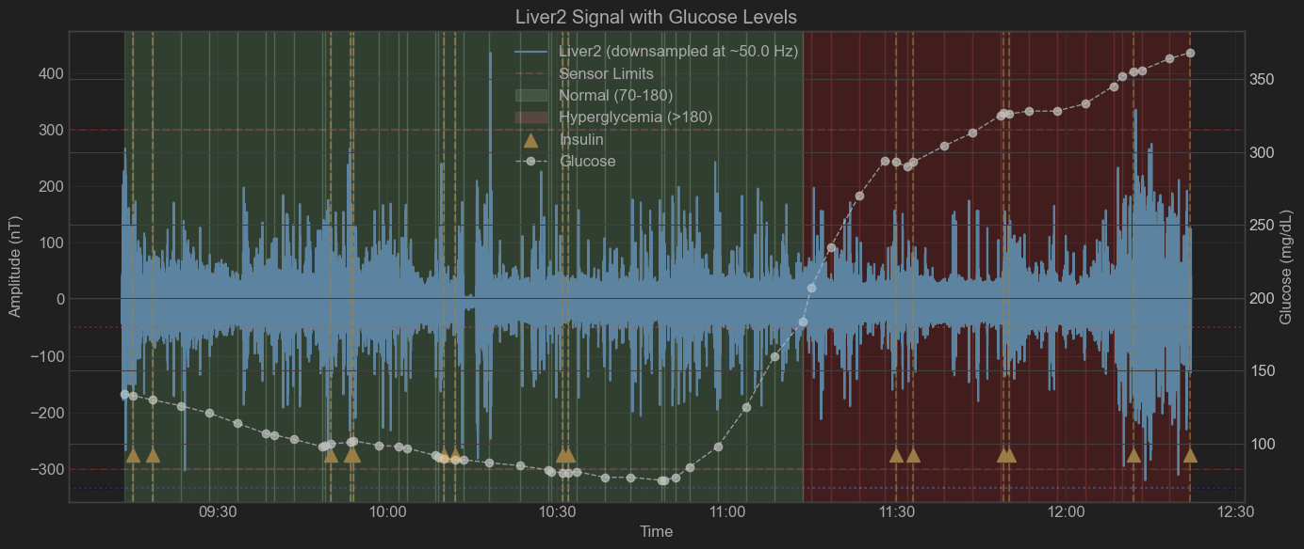

**Background Analysis and Signal Preprocessing:**

* We have conducted an analysis of background channels to identify the optimal filtering strategy for the signals.
* The analysis revealed the presence of high-frequency pink noise characterized by a 1/f flickering pattern, along with electrical noise primarily at 50 Hz and its higher harmonics.
* To preserve data integrity and minimize the risk of information loss due to relatively low signal-to-noise ratios (SNR), we applied a standardized filtering procedure rather than experiment-specific filtering. Also, no direct DC-background extraction in time domain has been done.
* Specifically, we implemented a band-pass filter spanning 0-50 Hz along with individual notch filters targeting the harmonics of the 50 Hz electrical noise. Additionally, baseline correction was uniformly performed across all channels

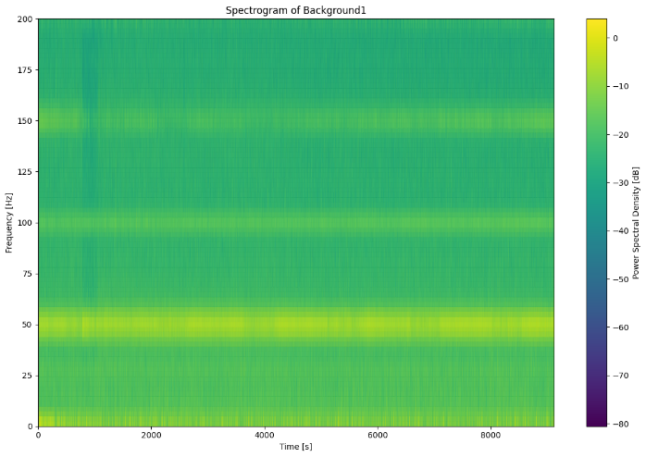 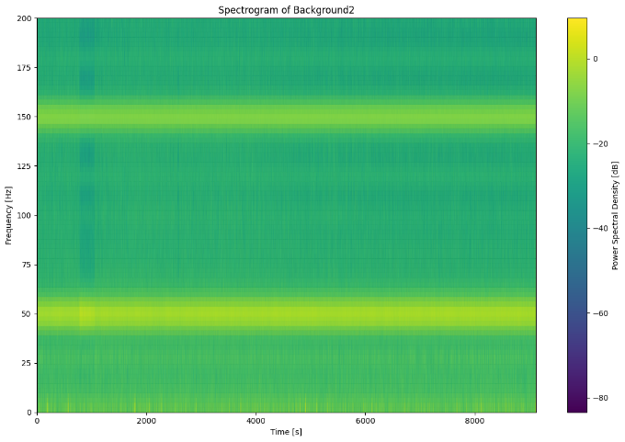

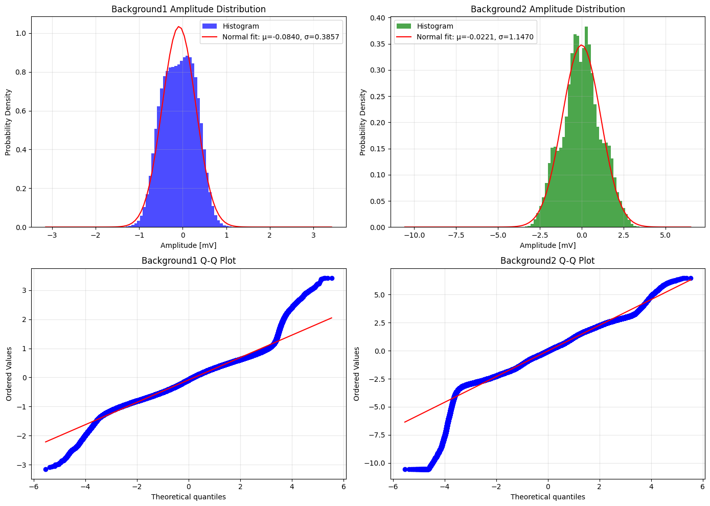

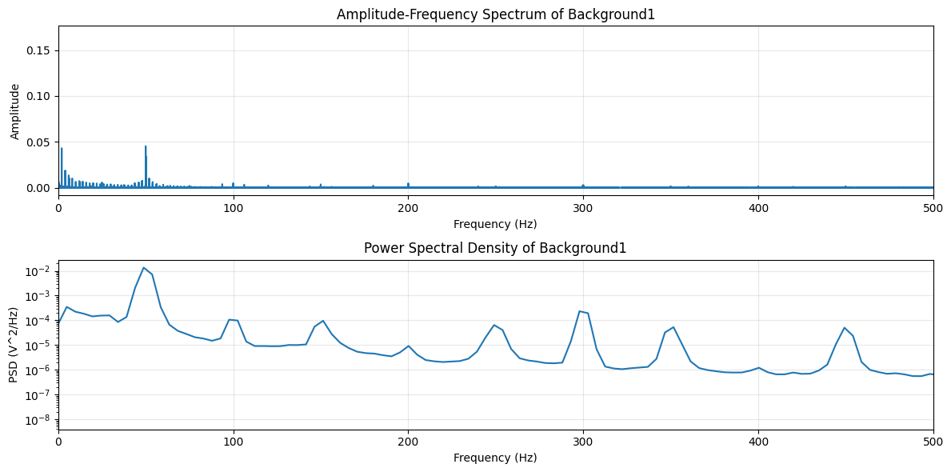

**Signal Feature Construction and Feature Extraction**

* At this stage, we focused on simpler and more robust feature extraction methods, intentionally avoiding complex Wavelet or Empirical Mode Decomposition (EMD)-based features due to their high computational demands. Currently, the feature extraction pipeline already requires approximately 30-40 minutes per experimental file, and integrating more advanced methods would significantly increase processing time.
* Signal sampling frequency has been maintained at 5 kHz without any downsampling.
* The sampling window duration was adjusted from 60 seconds to 20 seconds, maintaining a 50% overlap. Shorter windows, though more computationally demanding, provide greater sensitivity and temporal resolution for capturing immediate and short-term physiological changes. Other window sizes may be explored in the future.
* Frequency sub-bands have been oversampled to ensure thorough coverage with narrow gaps, enhancing the resolution of frequency-specific features.
* Handling of sensor signal overflow and channel pairing has not yet been implemented at this stage.

Here are the features that have been constructed:

**Time Domain Features**

**Basic Statistics:**

* Mean: Average signal amplitude (nT). Reflects baseline magnetic field strength and overall metabolic state.
* RMS: Root mean square amplitude (nT). Indicates overall signal energy, correlating with metabolic activity intensity.
* Variance: Signal variance (nT²). Measures fluctuations in the signal, indicating metabolic variability or instability.
* Skewness: Asymmetry of amplitude distribution. Suggests imbalance or directional trends in metabolic processes.
* Kurtosis: "Peakedness" of amplitude distribution. High values highlight extreme metabolic events or impulsive activities.

**Signal Quality Metrics:**

* SNR: Signal-to-noise ratio (dB). Higher values imply cleaner physiological signals versus environmental noise.
* Peak-to-peak: Maximum amplitude range (nT). Reflects maximum metabolic response amplitude.
* Crest Factor: Ratio of peak amplitude to RMS. Identifies sharp metabolic responses against background activity.
* Form Factor: Ratio of RMS to mean absolute value. Distinguishes different metabolic waveform shapes.
* Mobility: Hjorth parameter for complexity (Hz). Reflects the rate of change in the metabolic signal.
* Complexity: Ratio of mobility derivatives. Quantifies irregularities in metabolic activity.

**Frequency Domain Features**

**Spectral Features:**

* Centroid: Spectral center of mass (Hz). Indicates dominant metabolic oscillation frequency.
* Bandwidth: Spectral spread around centroid (Hz). Measures frequency diversity within metabolic activity.
* STFT Entropy: Spectral entropy (bits). Measures randomness in metabolic signal distribution.
* STFT Spectral Centroid: Time-varying center of frequency (Hz). Tracks shifts in dominant frequencies.
* STFT Spectral Bandwidth: Time-varying spread of frequencies (Hz). Detects frequency diversity changes.
* STFT Spectral Flatness: Ratio of geometric to arithmetic mean. Differentiates organized metabolic signals from noisy ones.
* STFT Spectral Rolloff: Frequency containing 85% of the signal's energy (Hz). Identifies significant upper-frequency metabolic components.

**Frequency Band Energies**

**Individual Sub-bands**:   
(the division to the bands\sub-bands is custom, to keep the resemblance to the general EMG activity bands)

* Delta1 (0.1-1 Hz): Cellular homeostasis; very slow metabolic oscillations.
* Delta2 (1-2 Hz): Baseline cellular metabolic processes.
* Delta3 (2-3 Hz): Low-frequency metabolic energy storage processes.
* Delta4 (3-4 Hz): Transitional metabolic rhythms.
* Theta1 (4-5 Hz): Early mitochondrial rhythmic responses.
* Theta2 (5-6 Hz): Low-medium frequency metabolic activity.
* Theta3 (6-7 Hz): Medium rhythmic metabolic activity.
* Theta4 (7-8 Hz): Transition to faster metabolic rhythms.
* Alpha1 (8-10 Hz): Medium-speed enzymatic cycles.
* Alpha2 (10-13 Hz): Faster organized metabolic patterns.
* Beta1 (13-20 Hz): Increased metabolic demand responses.
* Beta2 (20-25 Hz): Rapid metabolic signaling.
* Beta3 (25-30 Hz): High-frequency metabolic regulation.
* Gamma1 (30-35 Hz): Very fast synchronized cellular activity.
* Gamma2 (35-40 Hz): Rapid energy utilization.
* Gamma3 (40-50 Hz): Ultrafast metabolic oscillations.

Band Names meanings (Following the literature):

* + Delta (0.1-4 Hz): Overall slow metabolic processes and baseline cellular energy states.
  + Theta (4-8 Hz): Aggregated slow rhythmic mitochondrial activity.
  + Alpha (8-13 Hz): Key enzymatic and medium-speed metabolic cycles.
  + Beta (13-30 Hz): Increased metabolic energy demand and rapid signaling.
  + Gamma (30-50 Hz): Ultra-fast synchronized metabolic network activity.

**Band Ratios**

* Theta/Beta: Slow vs. fast metabolic processes.
* Alpha/Beta: Balance between medium and fast metabolic activity; indicator of efficiency.
* Delta/Theta: Baseline vs. active metabolic states.
* Delta/Alpha: Relationship between baseline and medium-speed metabolic activities.
* Delta/Beta: Contrast between slowest and fastest metabolic activities.
* Delta1/Delta3: Fine structure of slow metabolic oscillations.
* Theta1/Theta4: Transition patterns within slower metabolic bands.

**Advanced Signal Analysis Features**

**Cross-Channel Correlation Features:**

* Mean Pearson Correlation: Average synchronization between sensors; indicates possible overall body-region coordination.
* Max Pearson Correlation: Strongest possible physiological coupling between body regions.
* Min Pearson Correlation: Least possible coupled physiological processes.

**Direct Feature Correlation Analysis**

Patient - Insulin Clamp #1

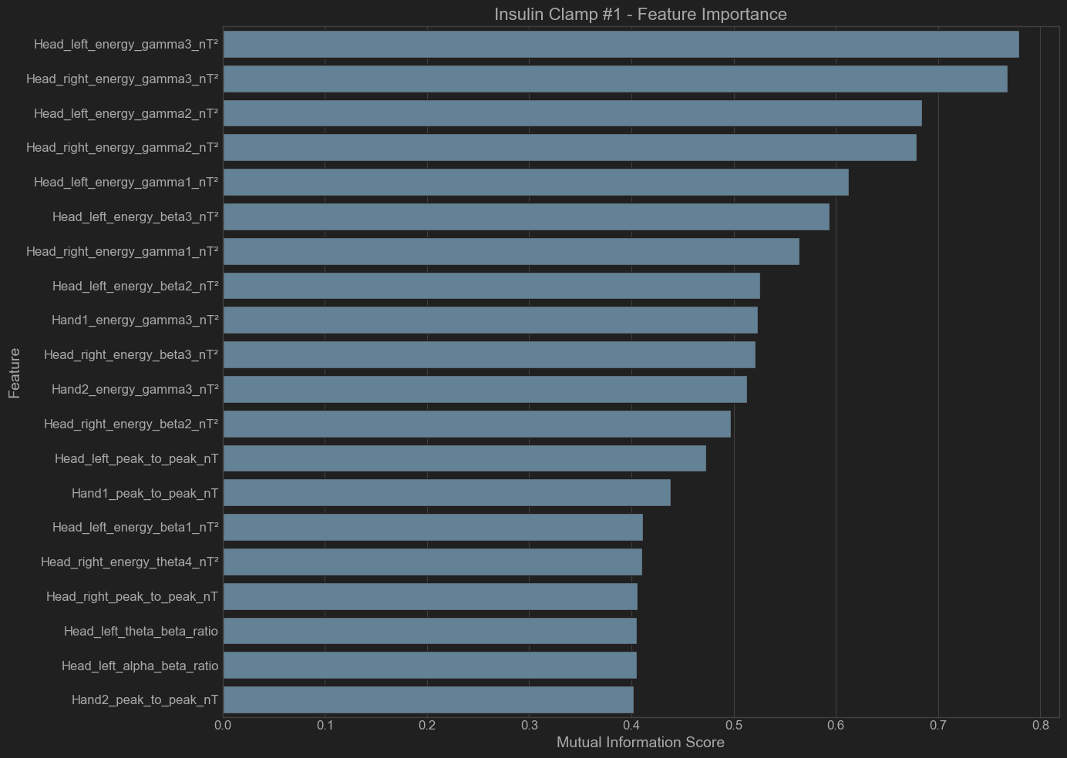

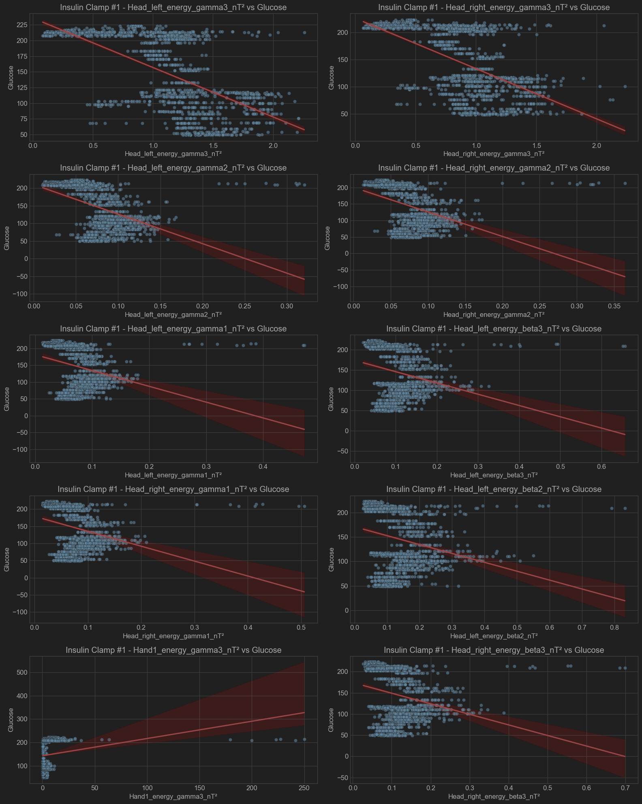

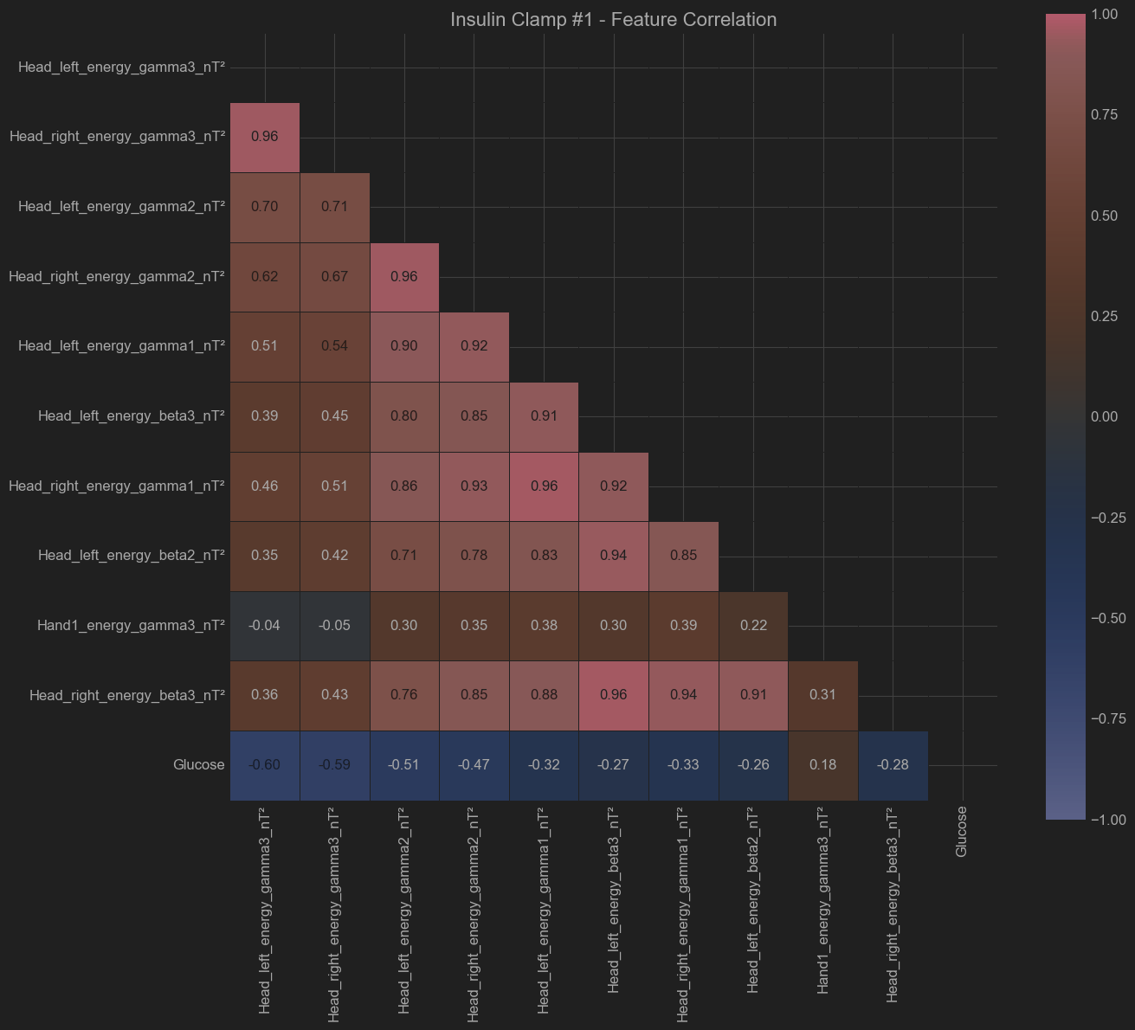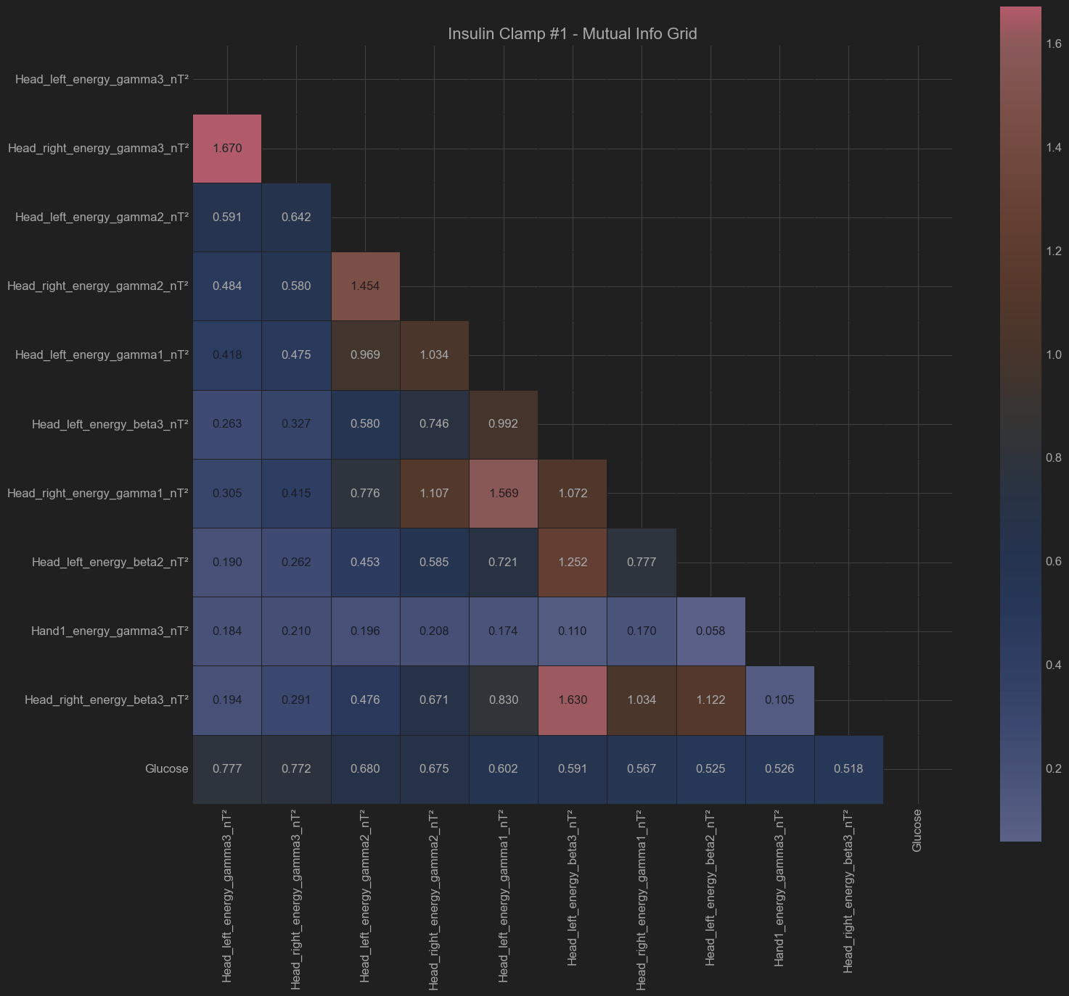

Patient - Insulin Clamp #2

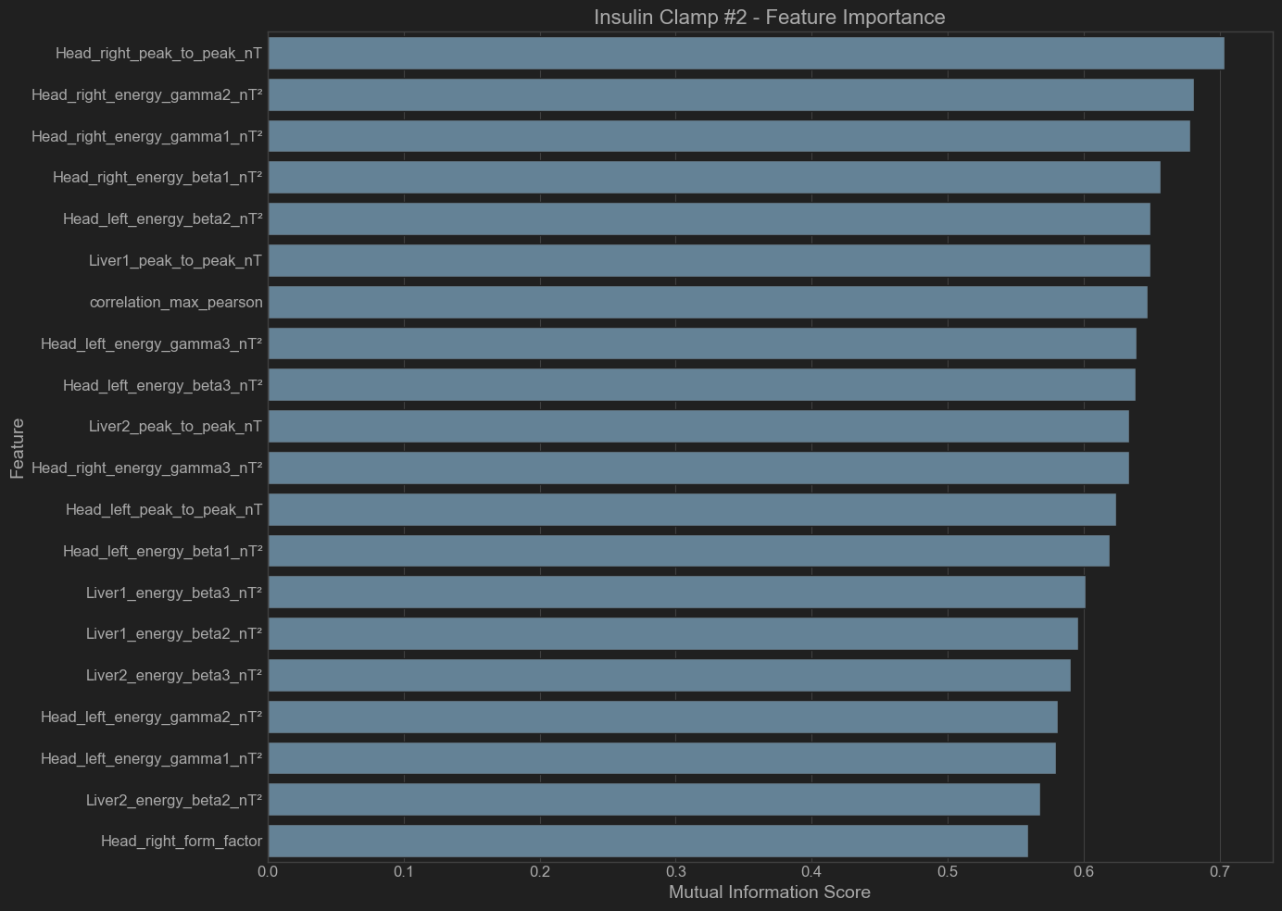

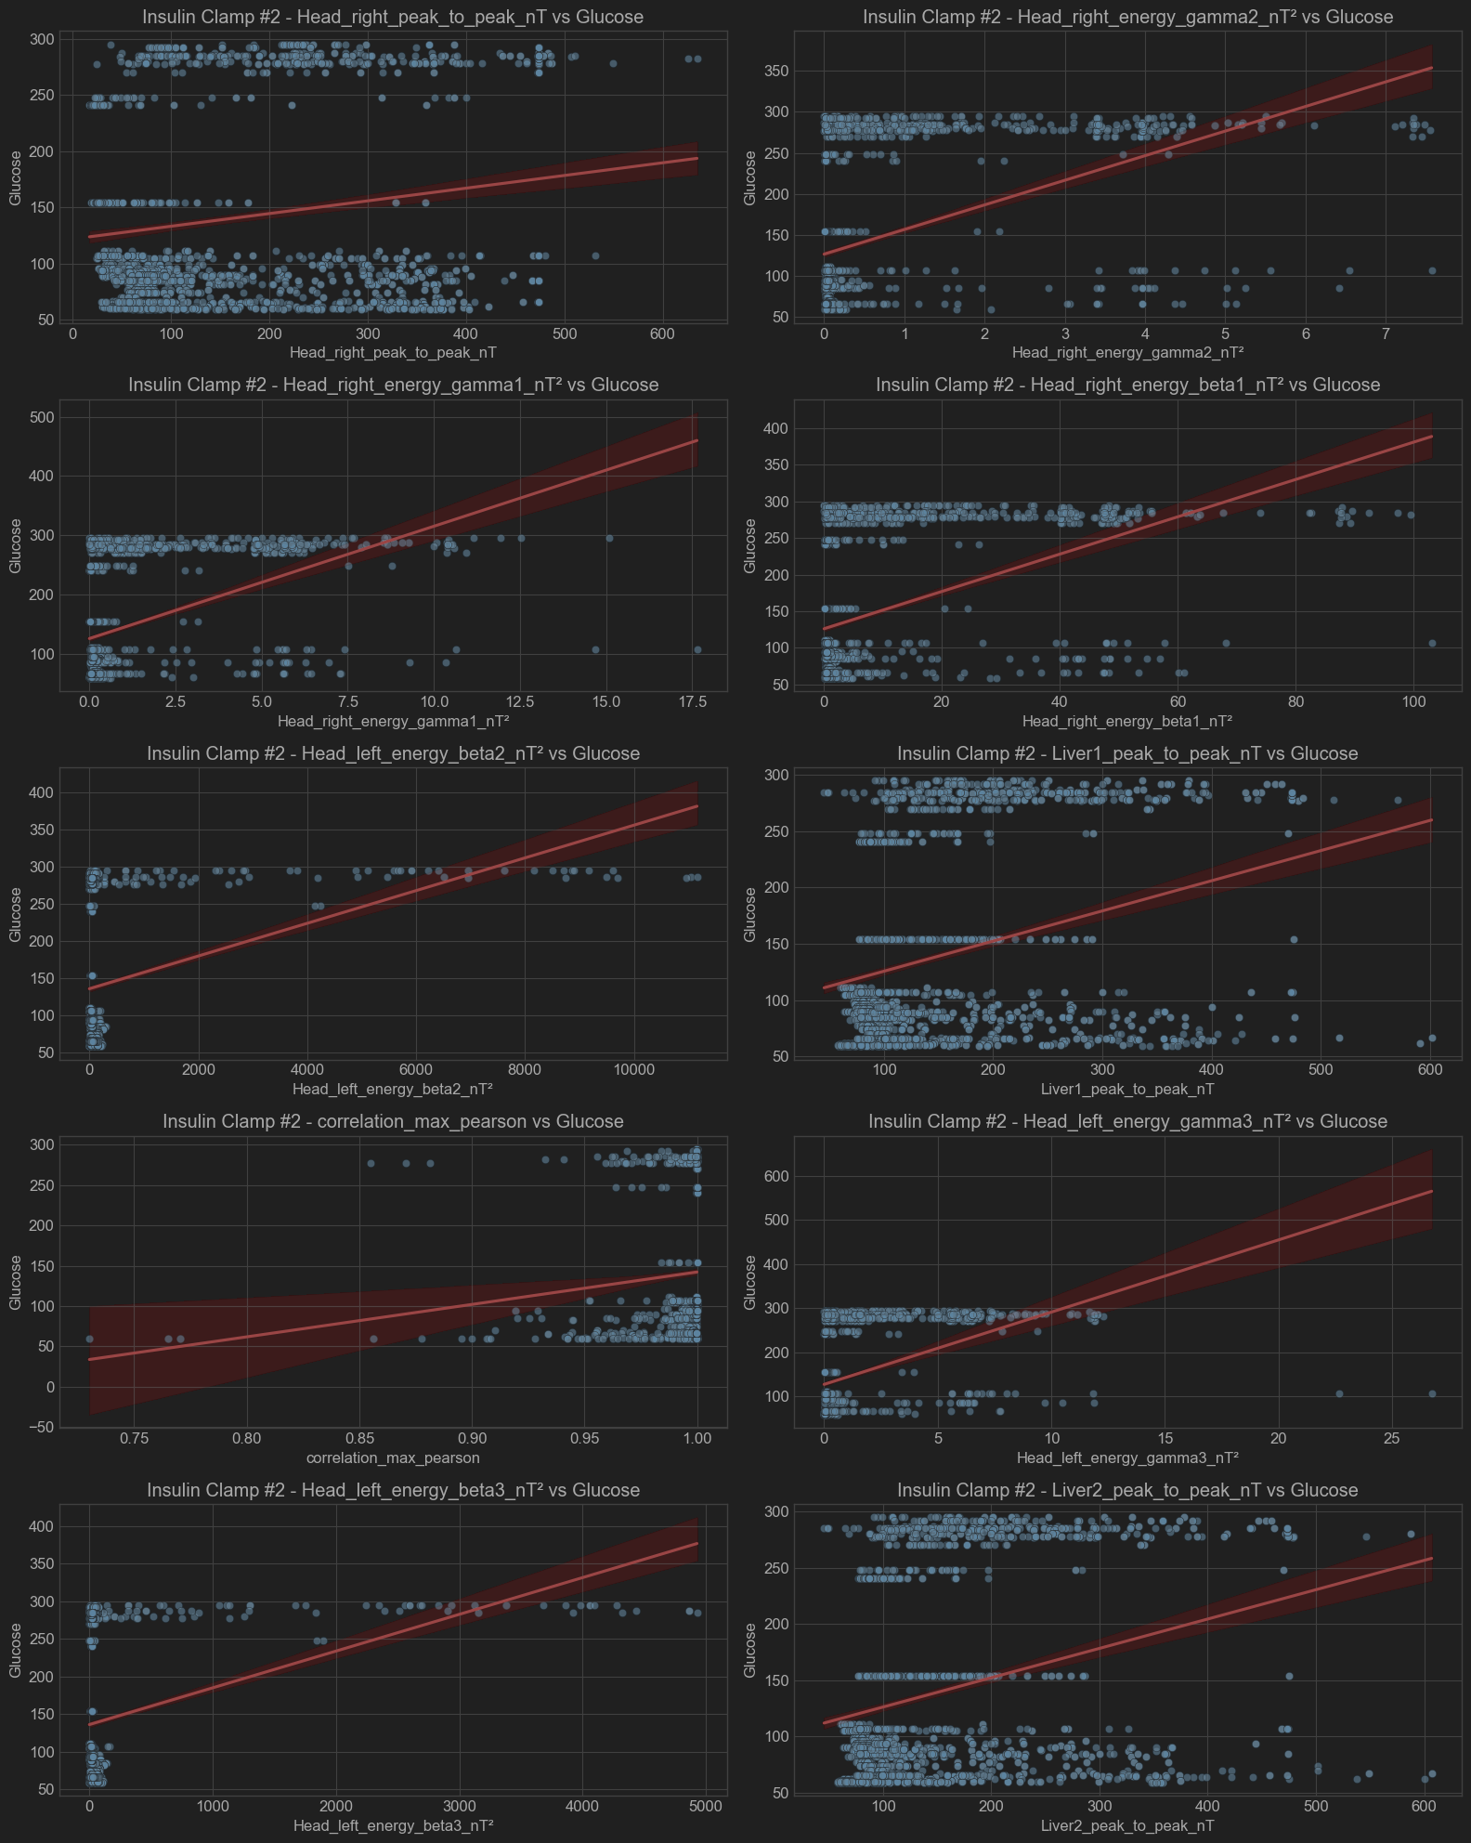

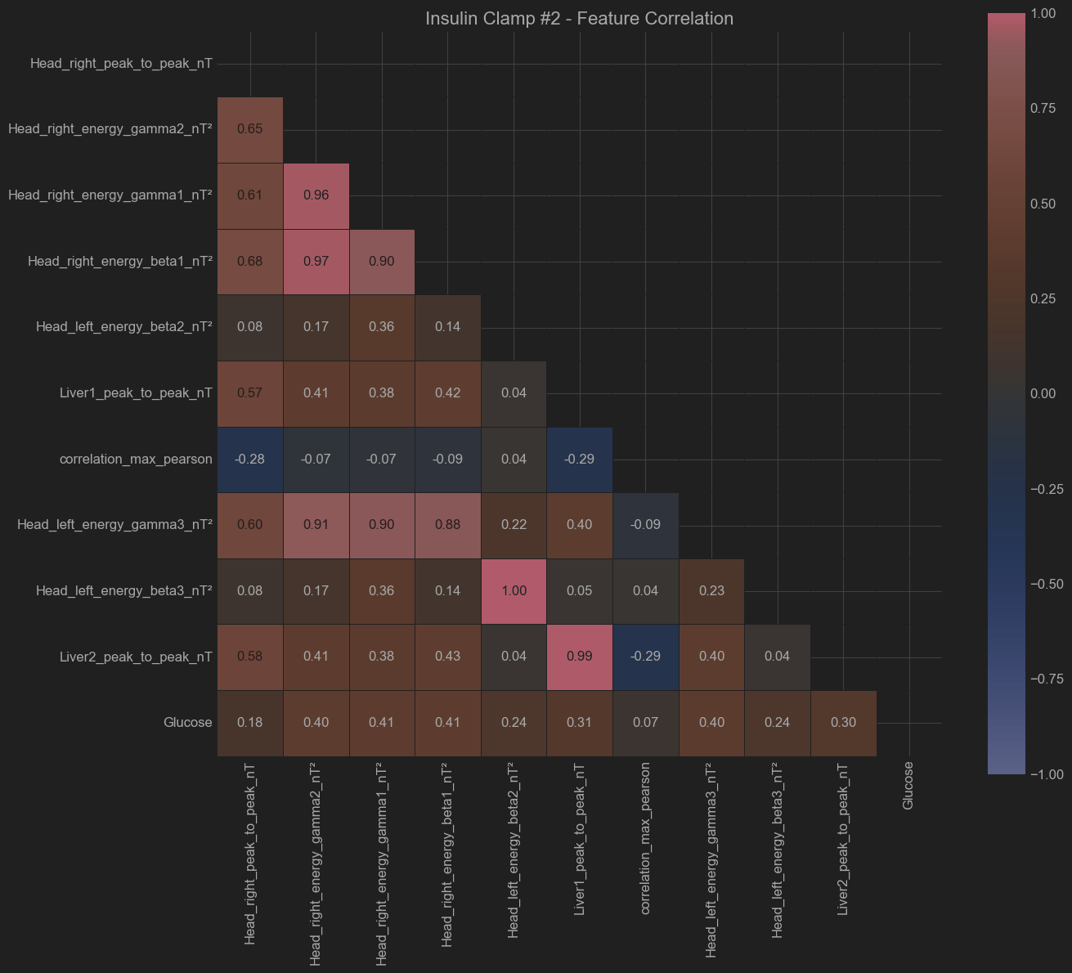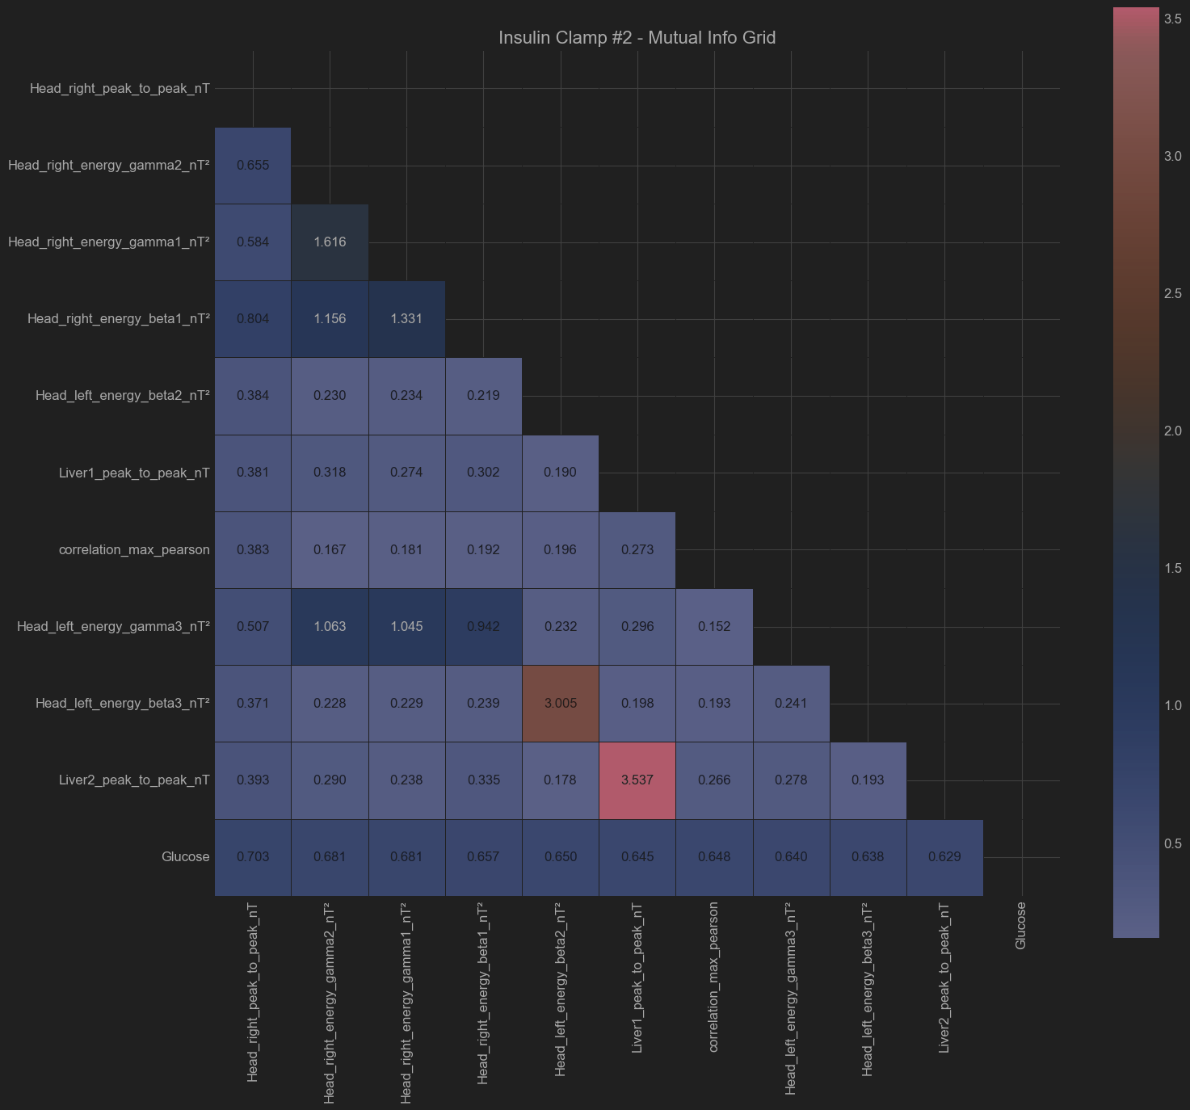

Patient - Insulin Clamp #3

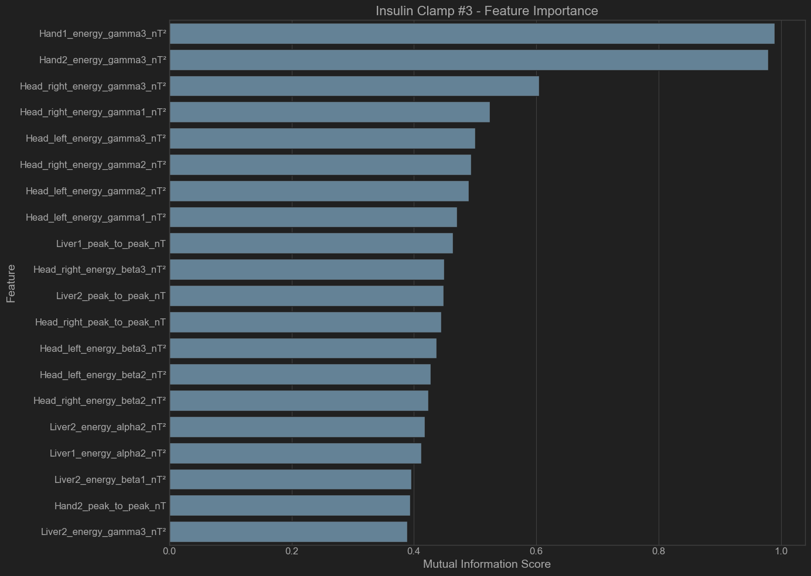

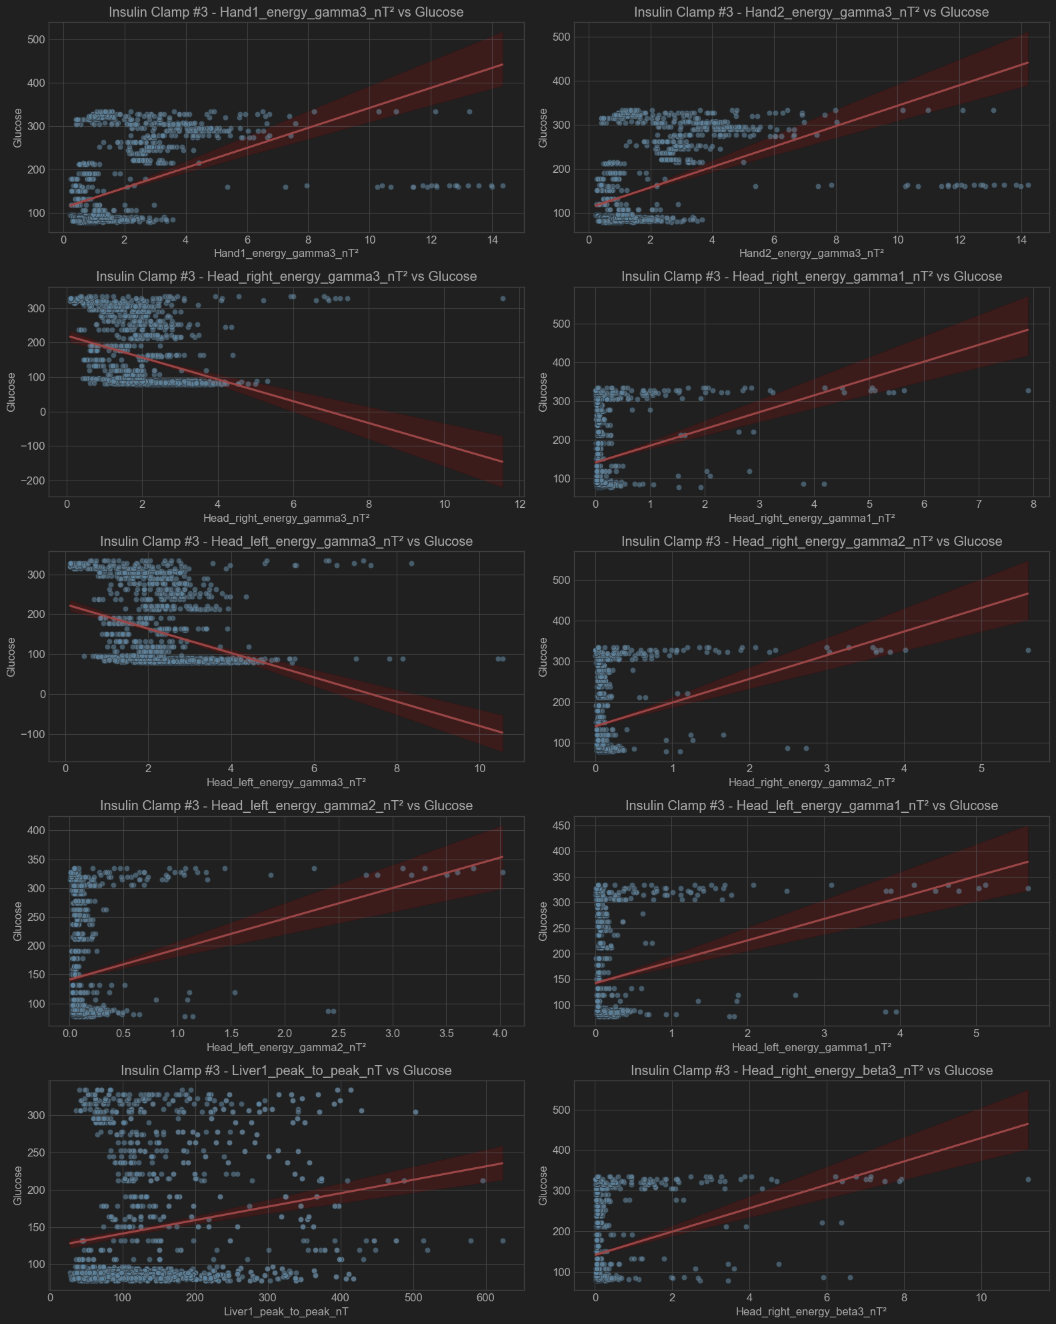

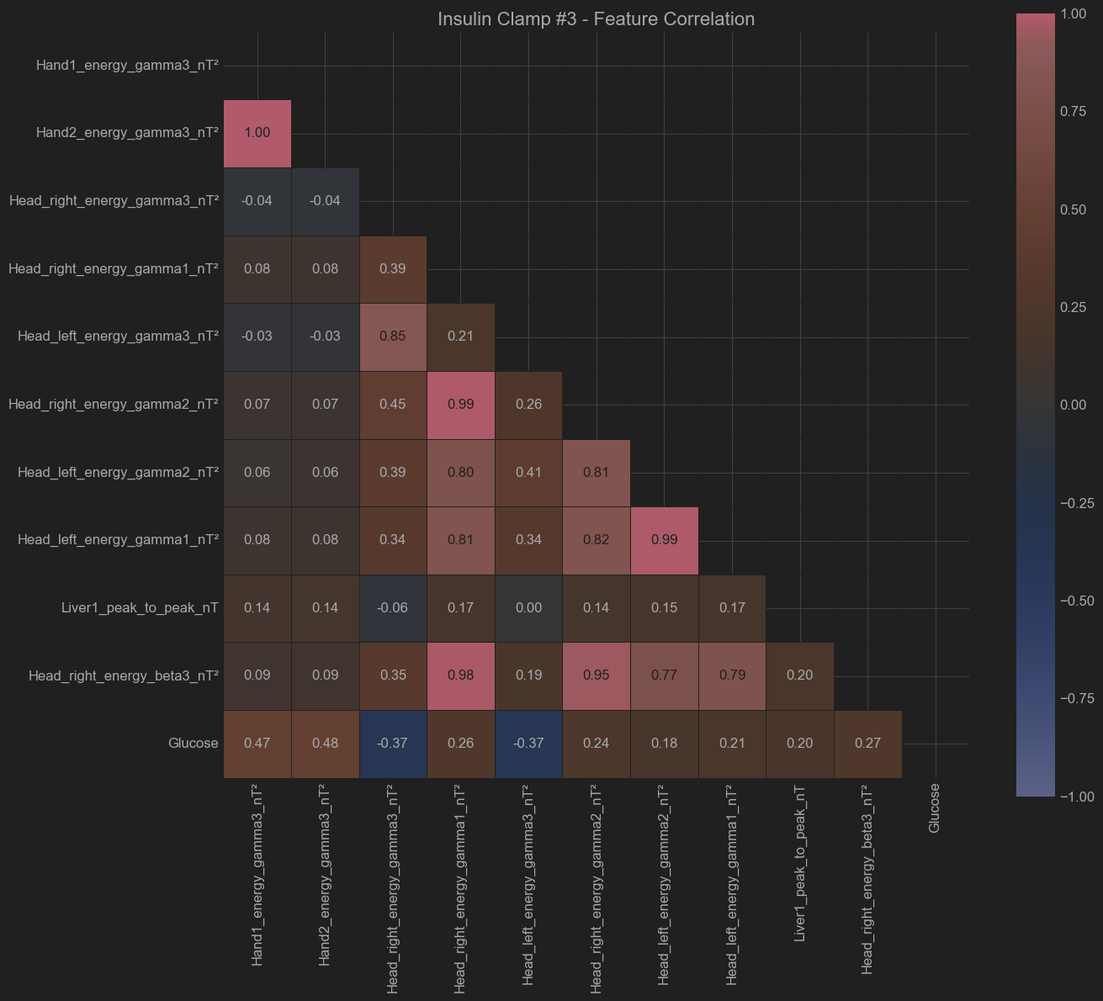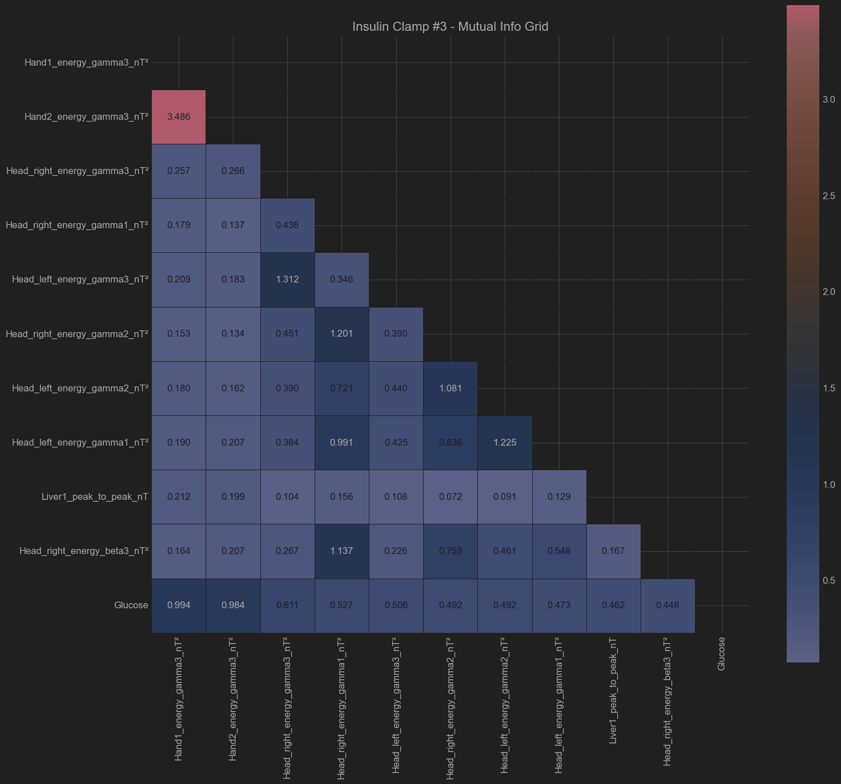

Patient - Insulin Clamp #4

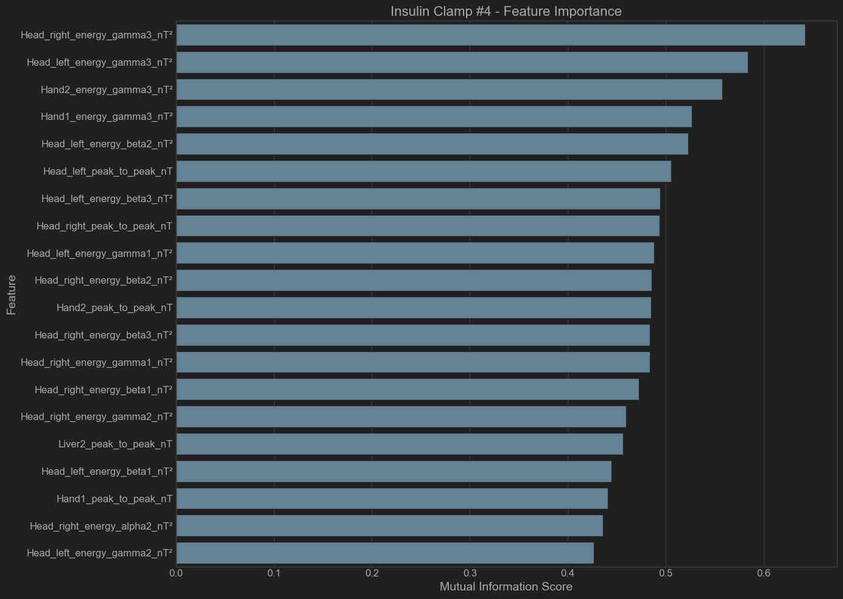

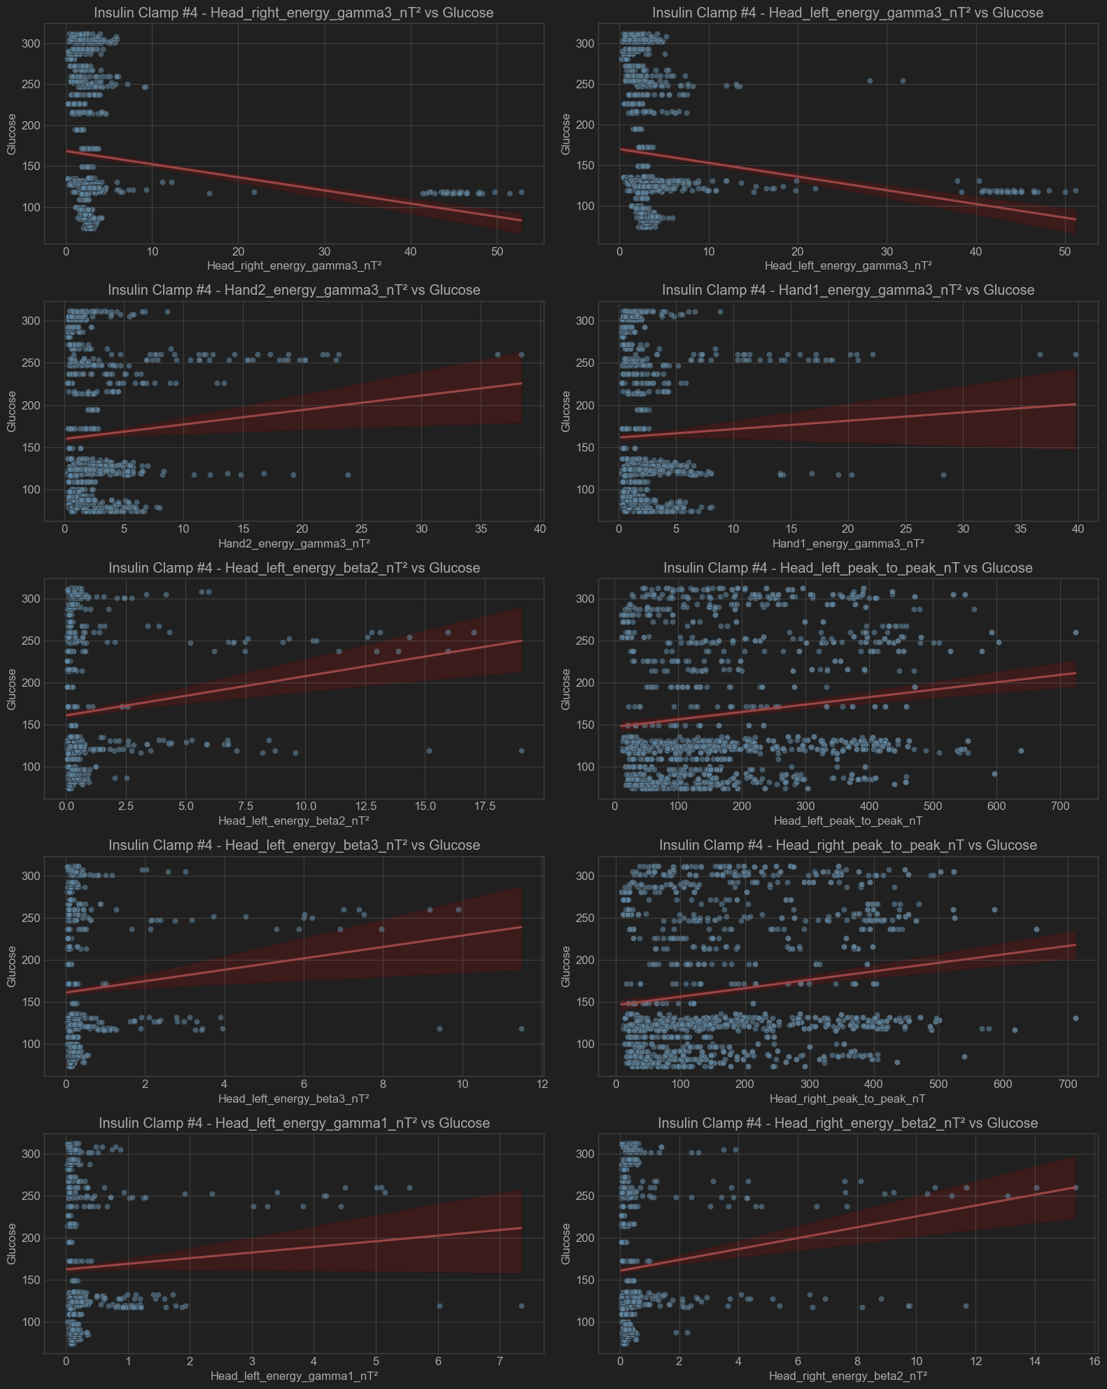

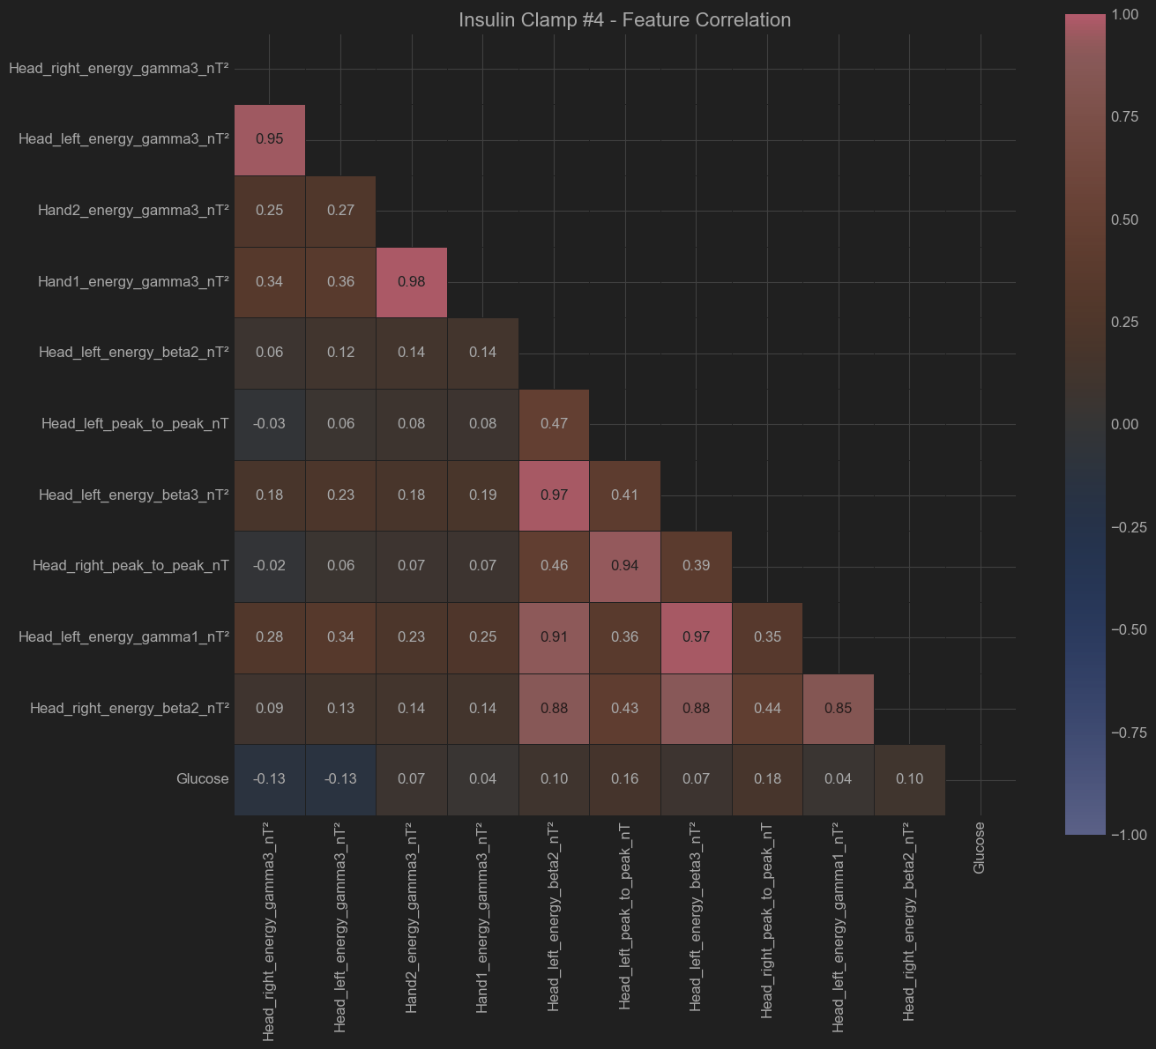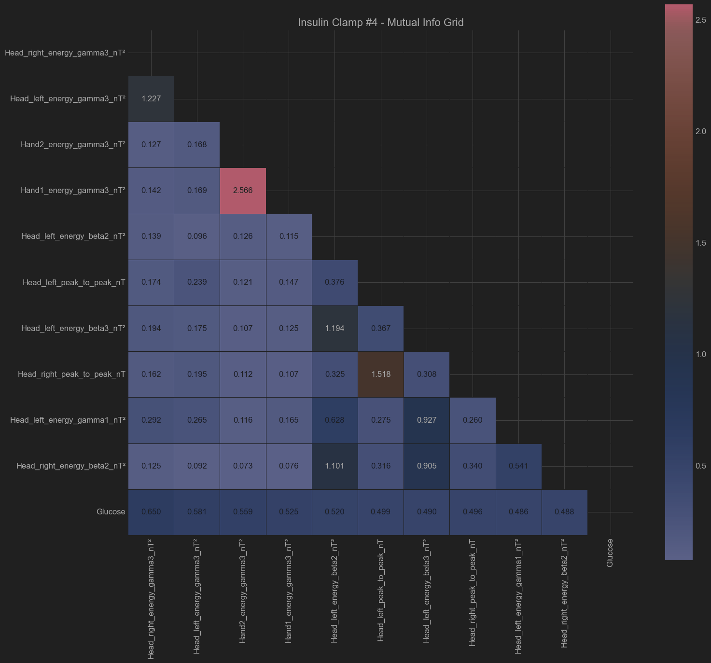

Patient - Insulin Clamp #5

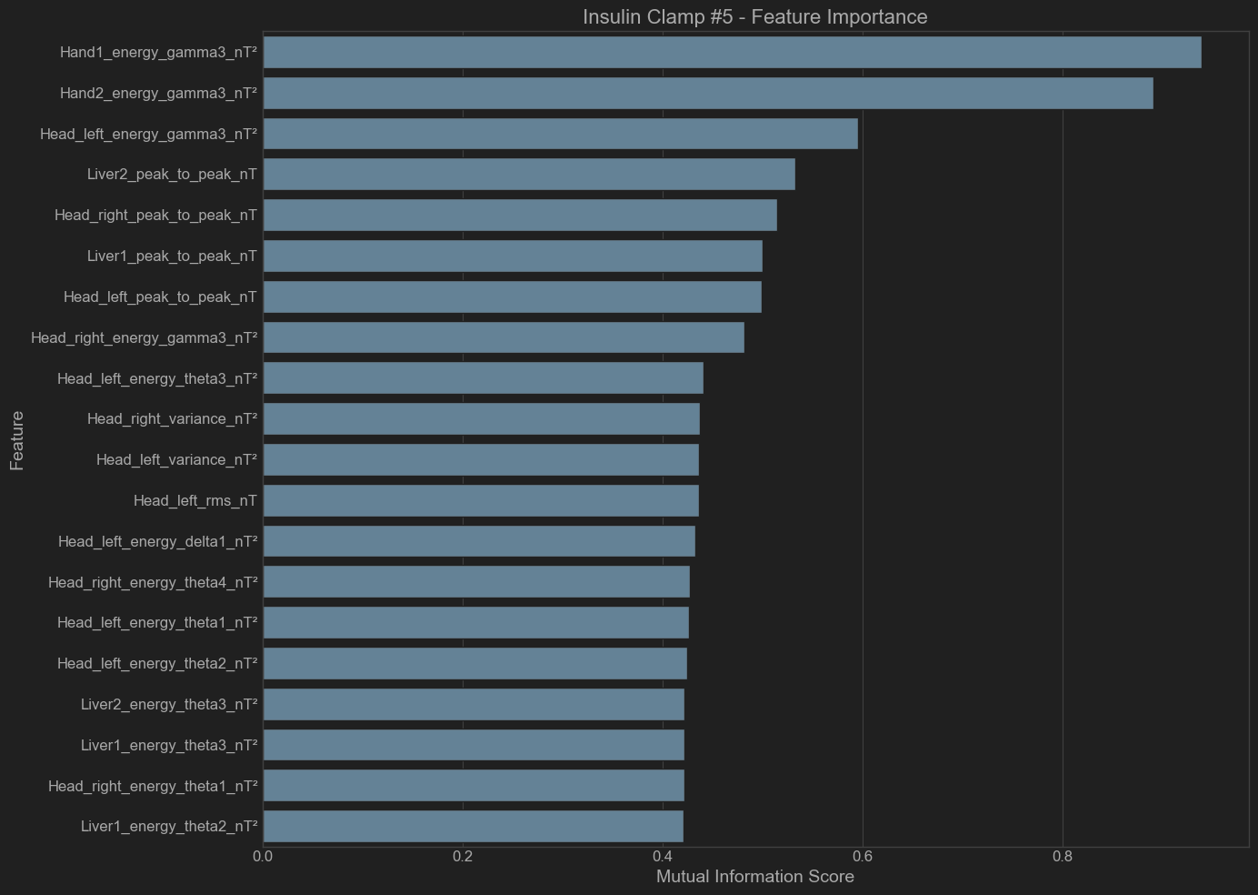

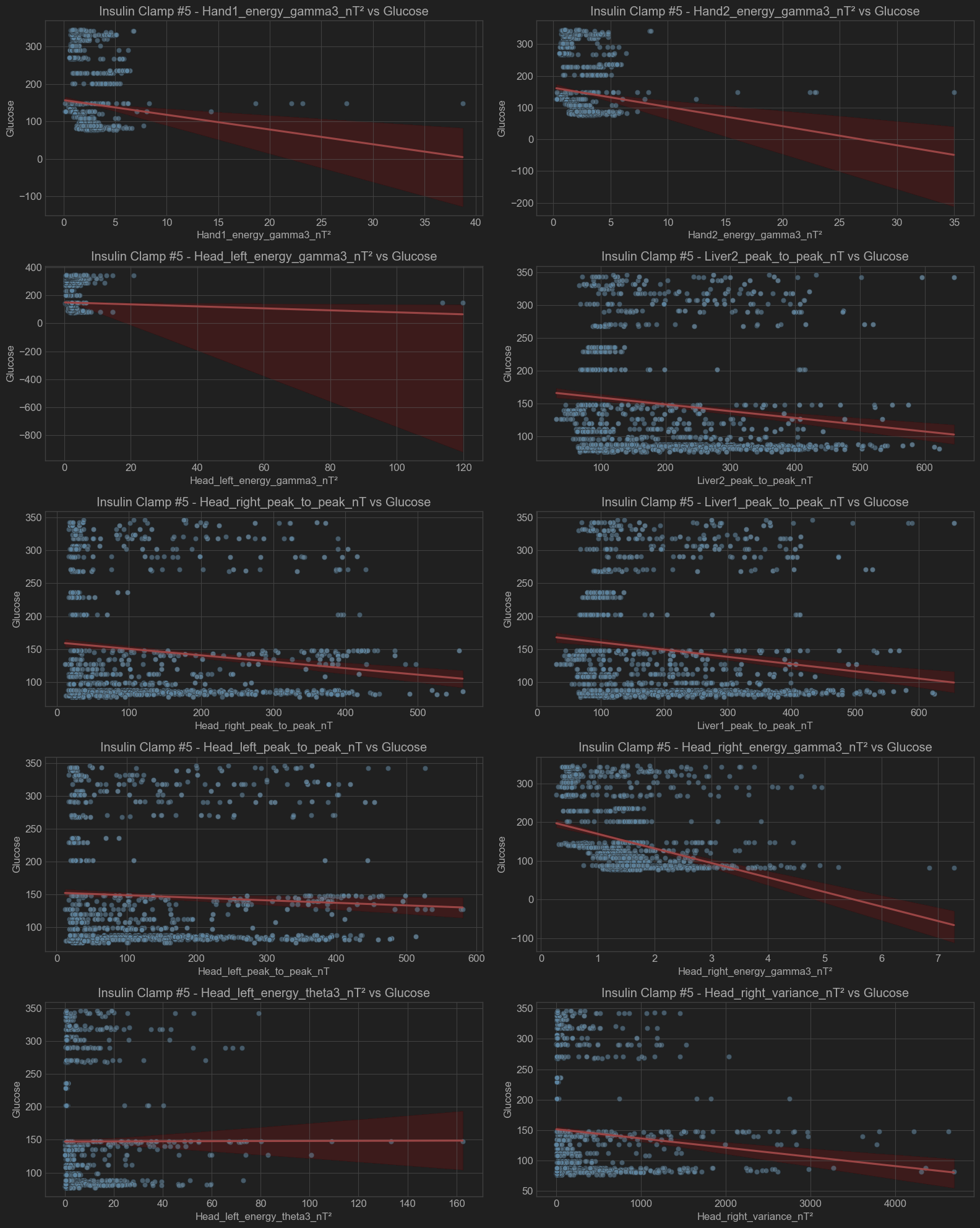

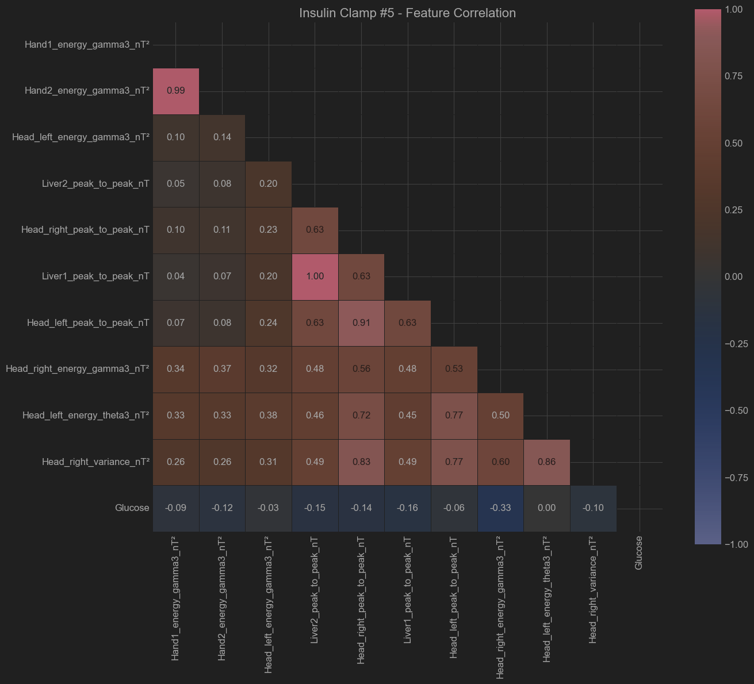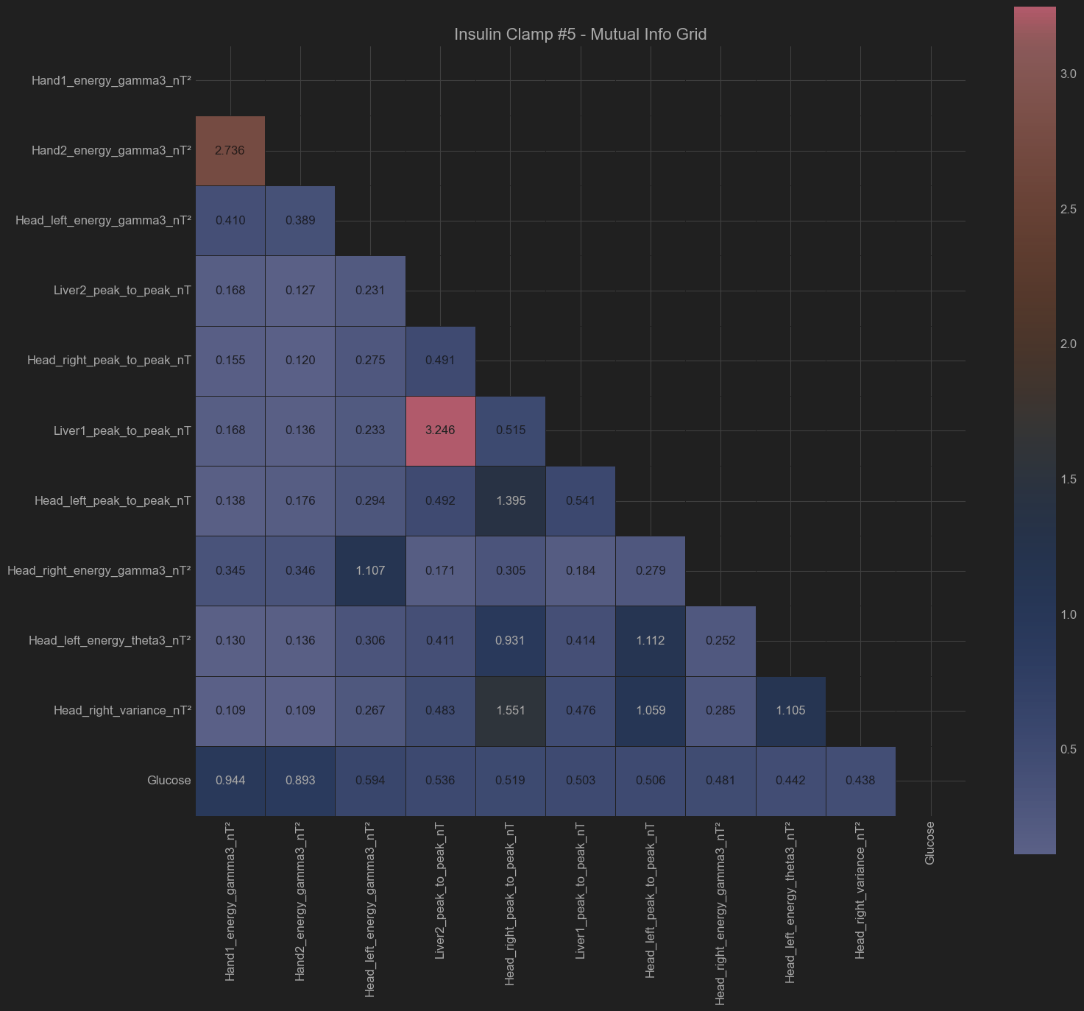

Patient - Insulin Clamp #6

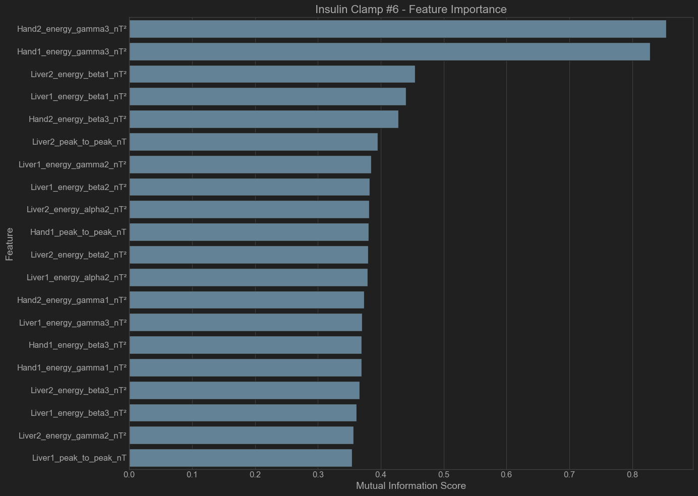

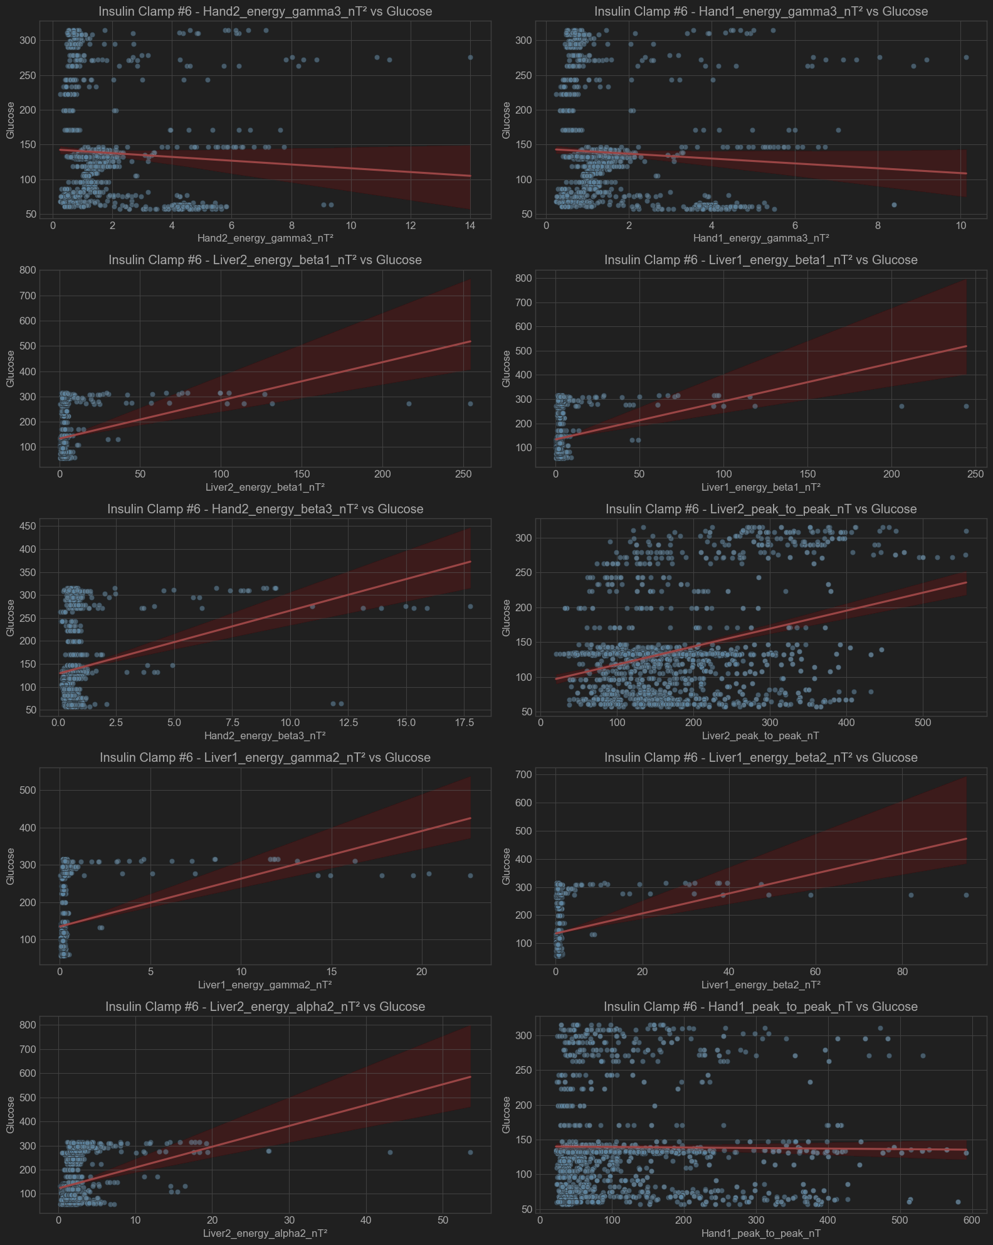

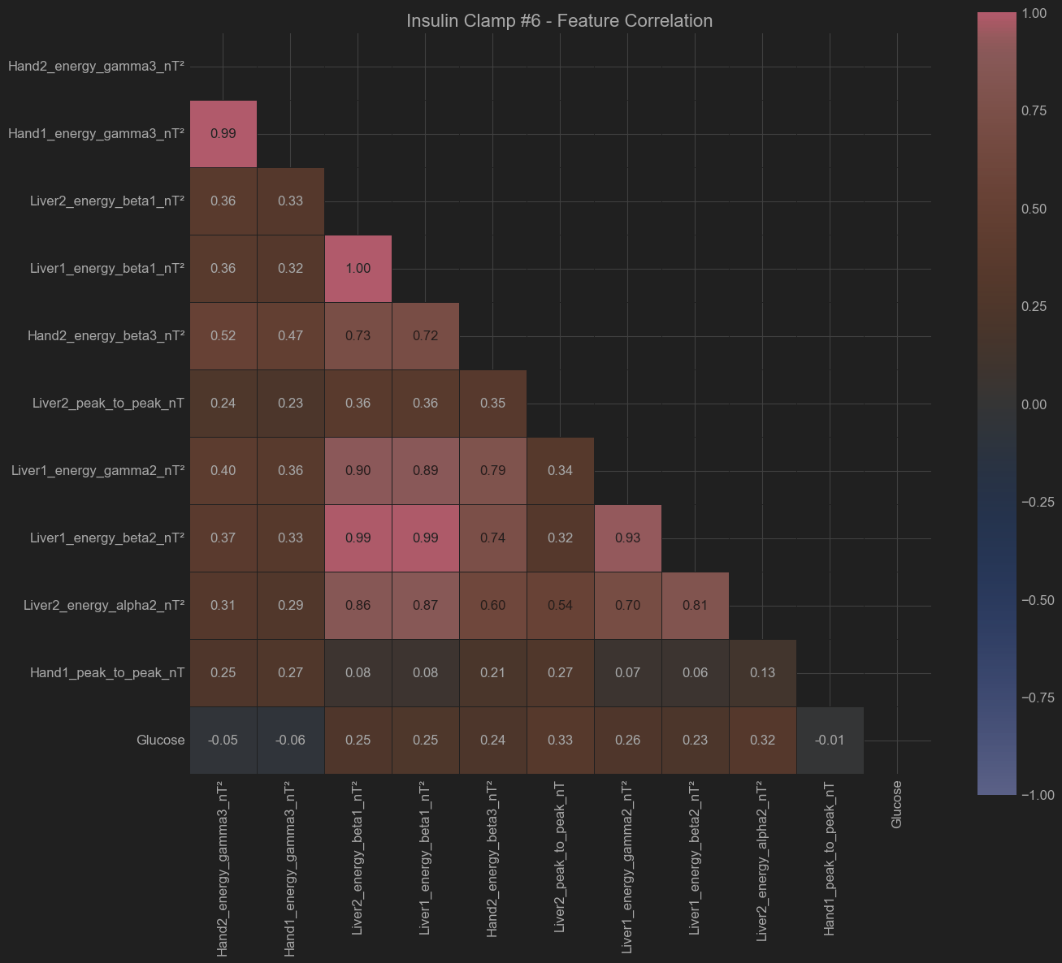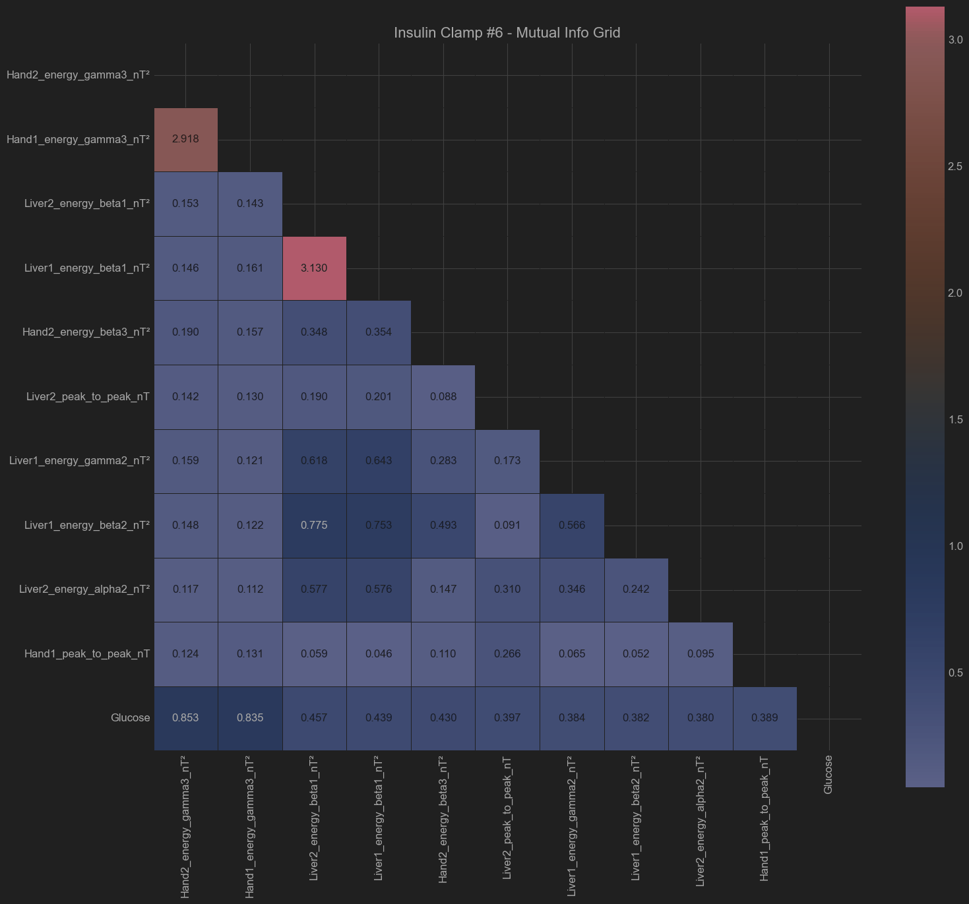

Patient - Insulin Clamp #7

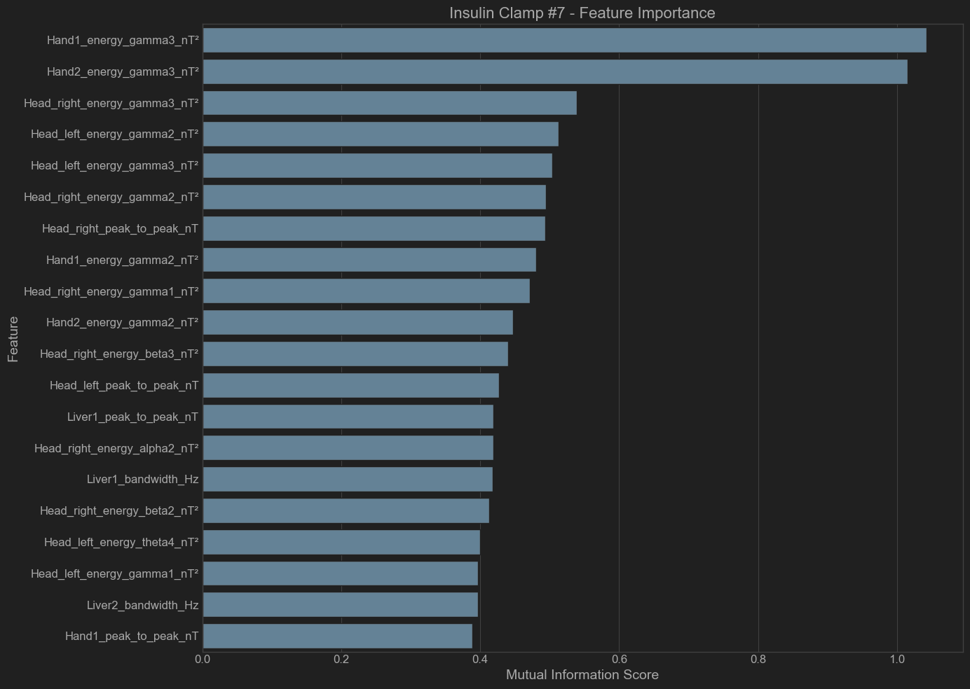

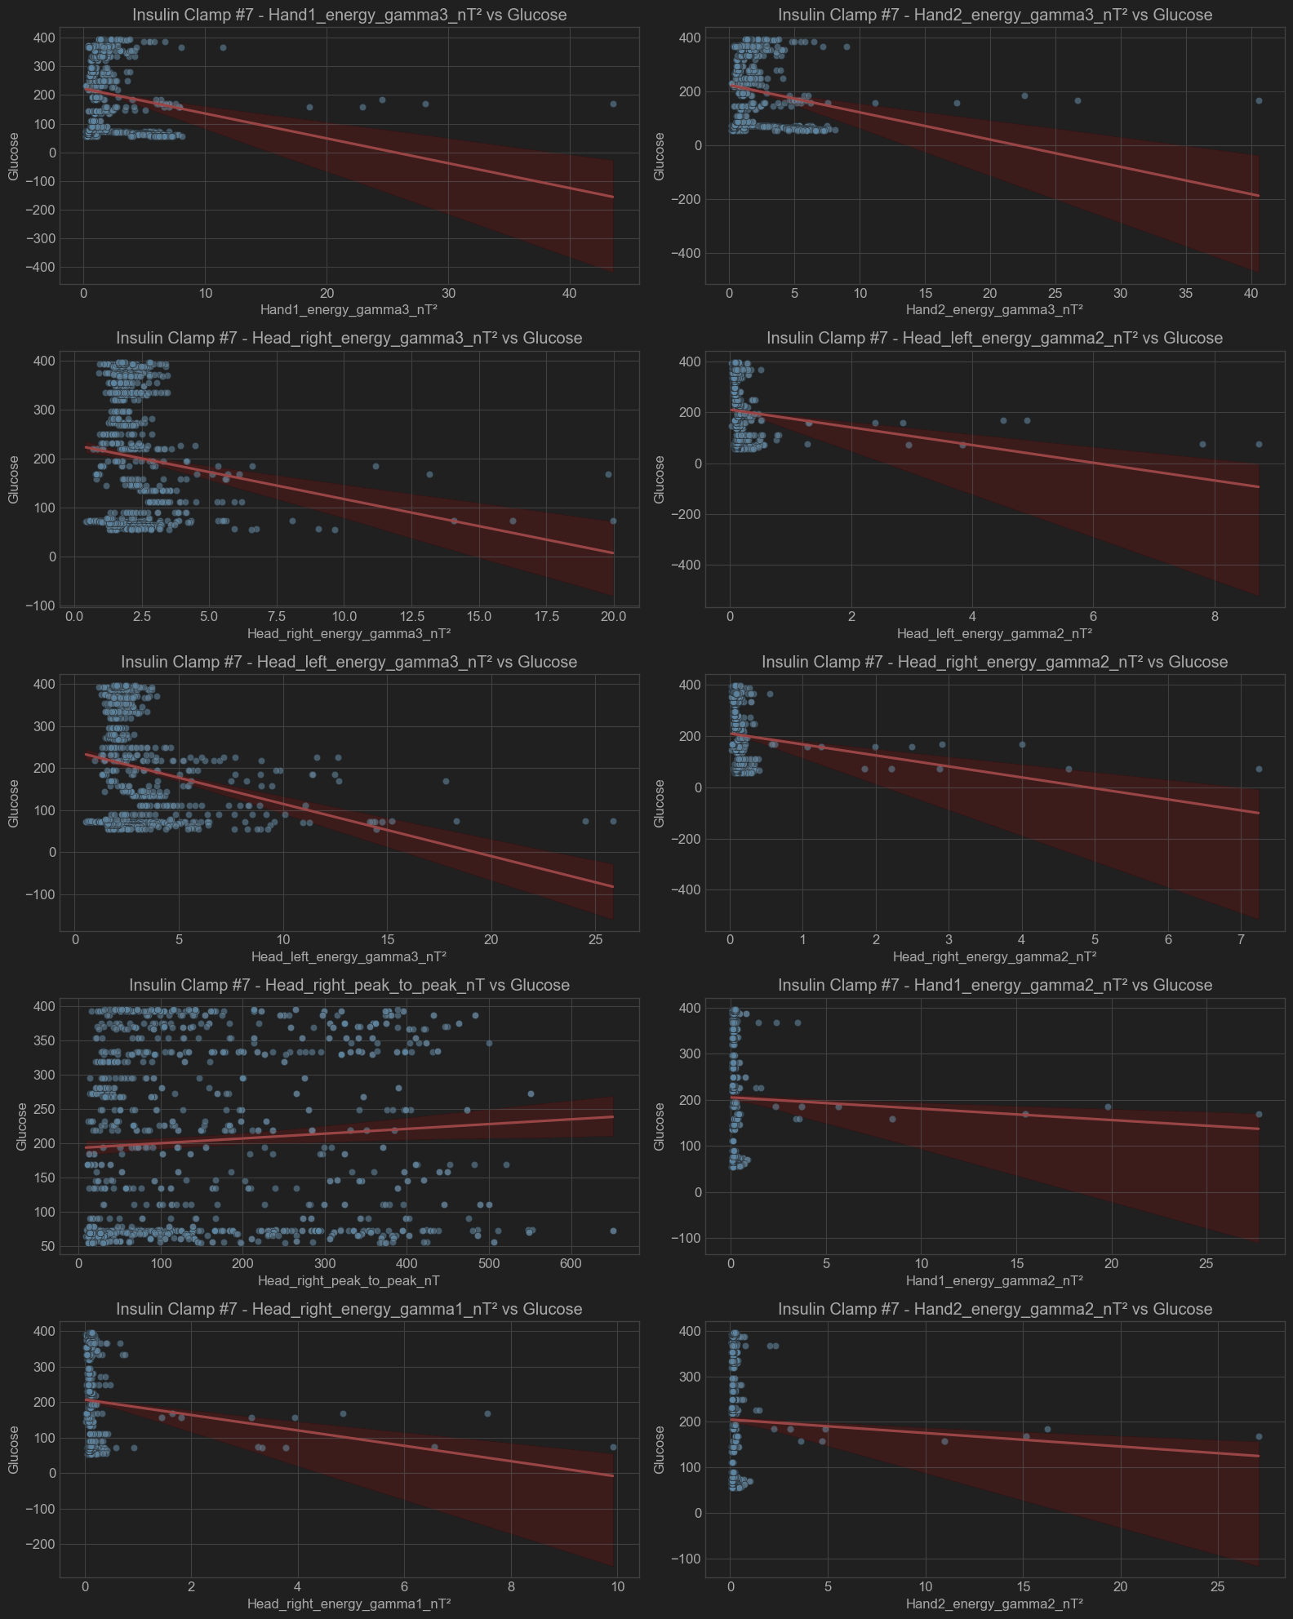

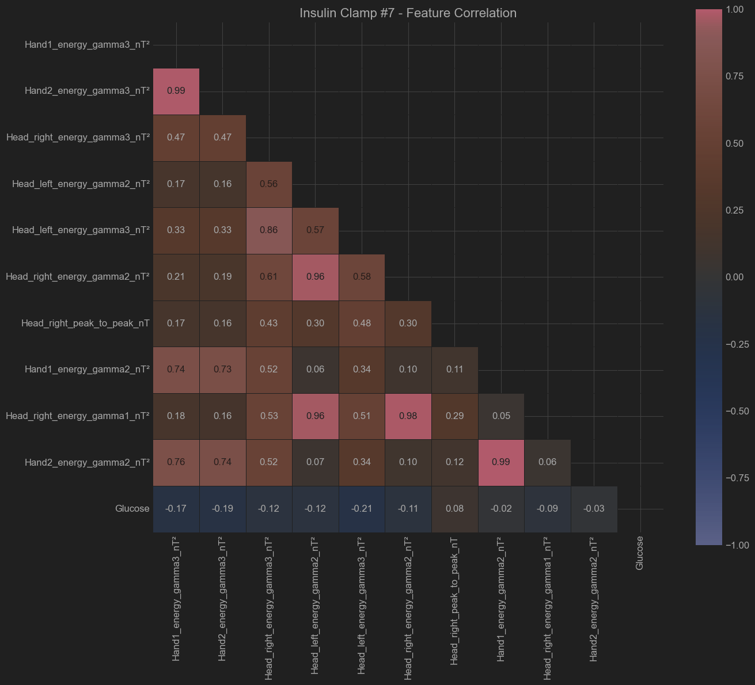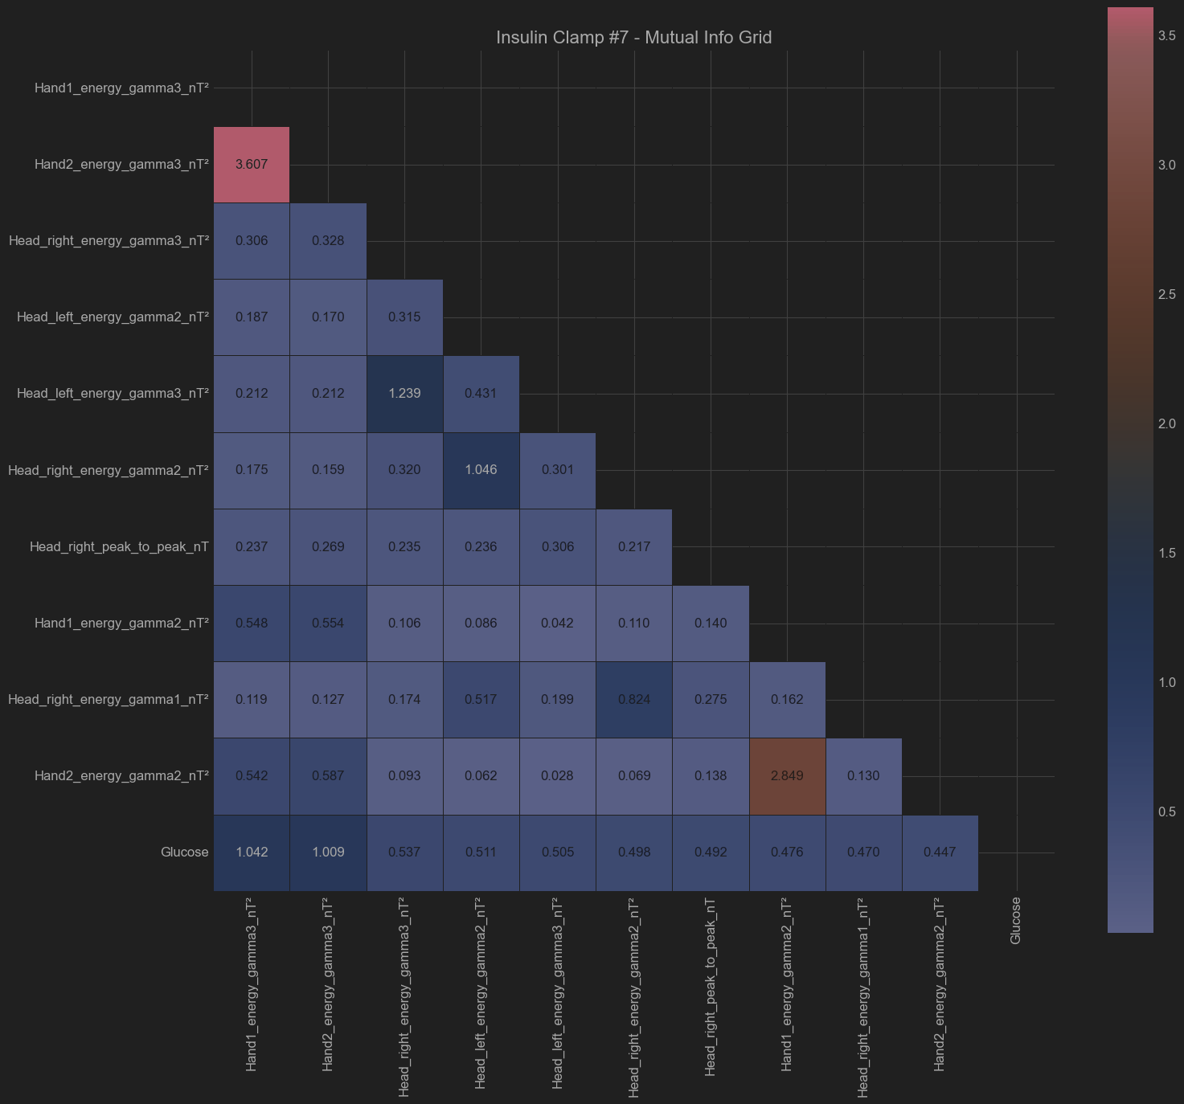

Patient - Insulin Clamp #8

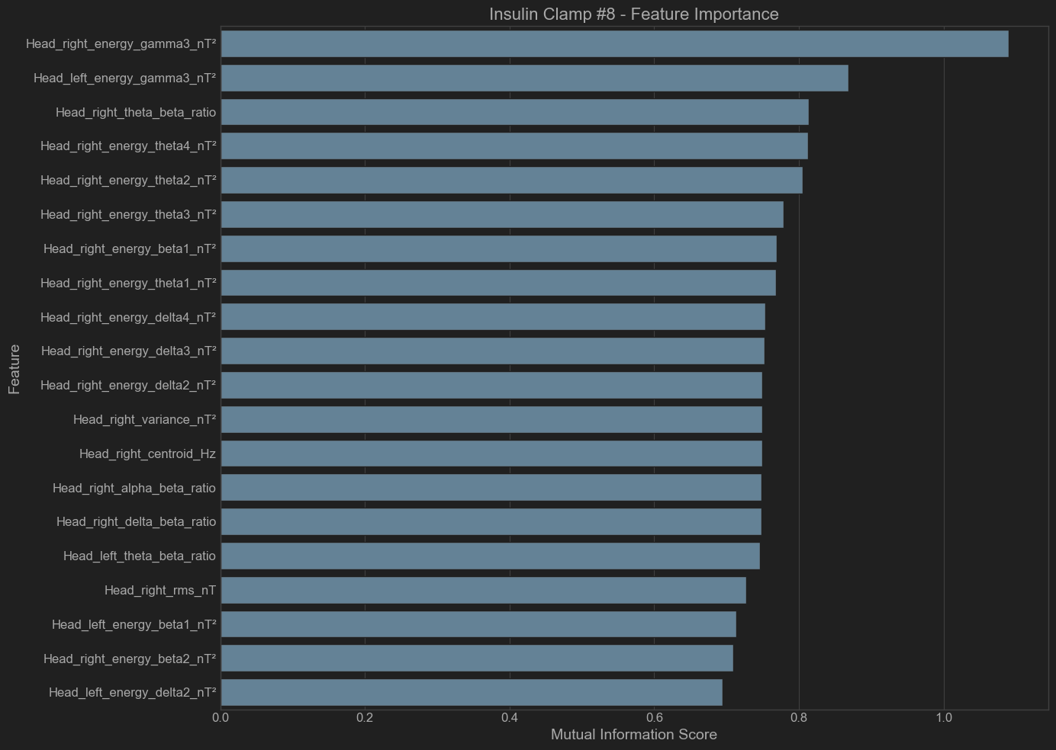

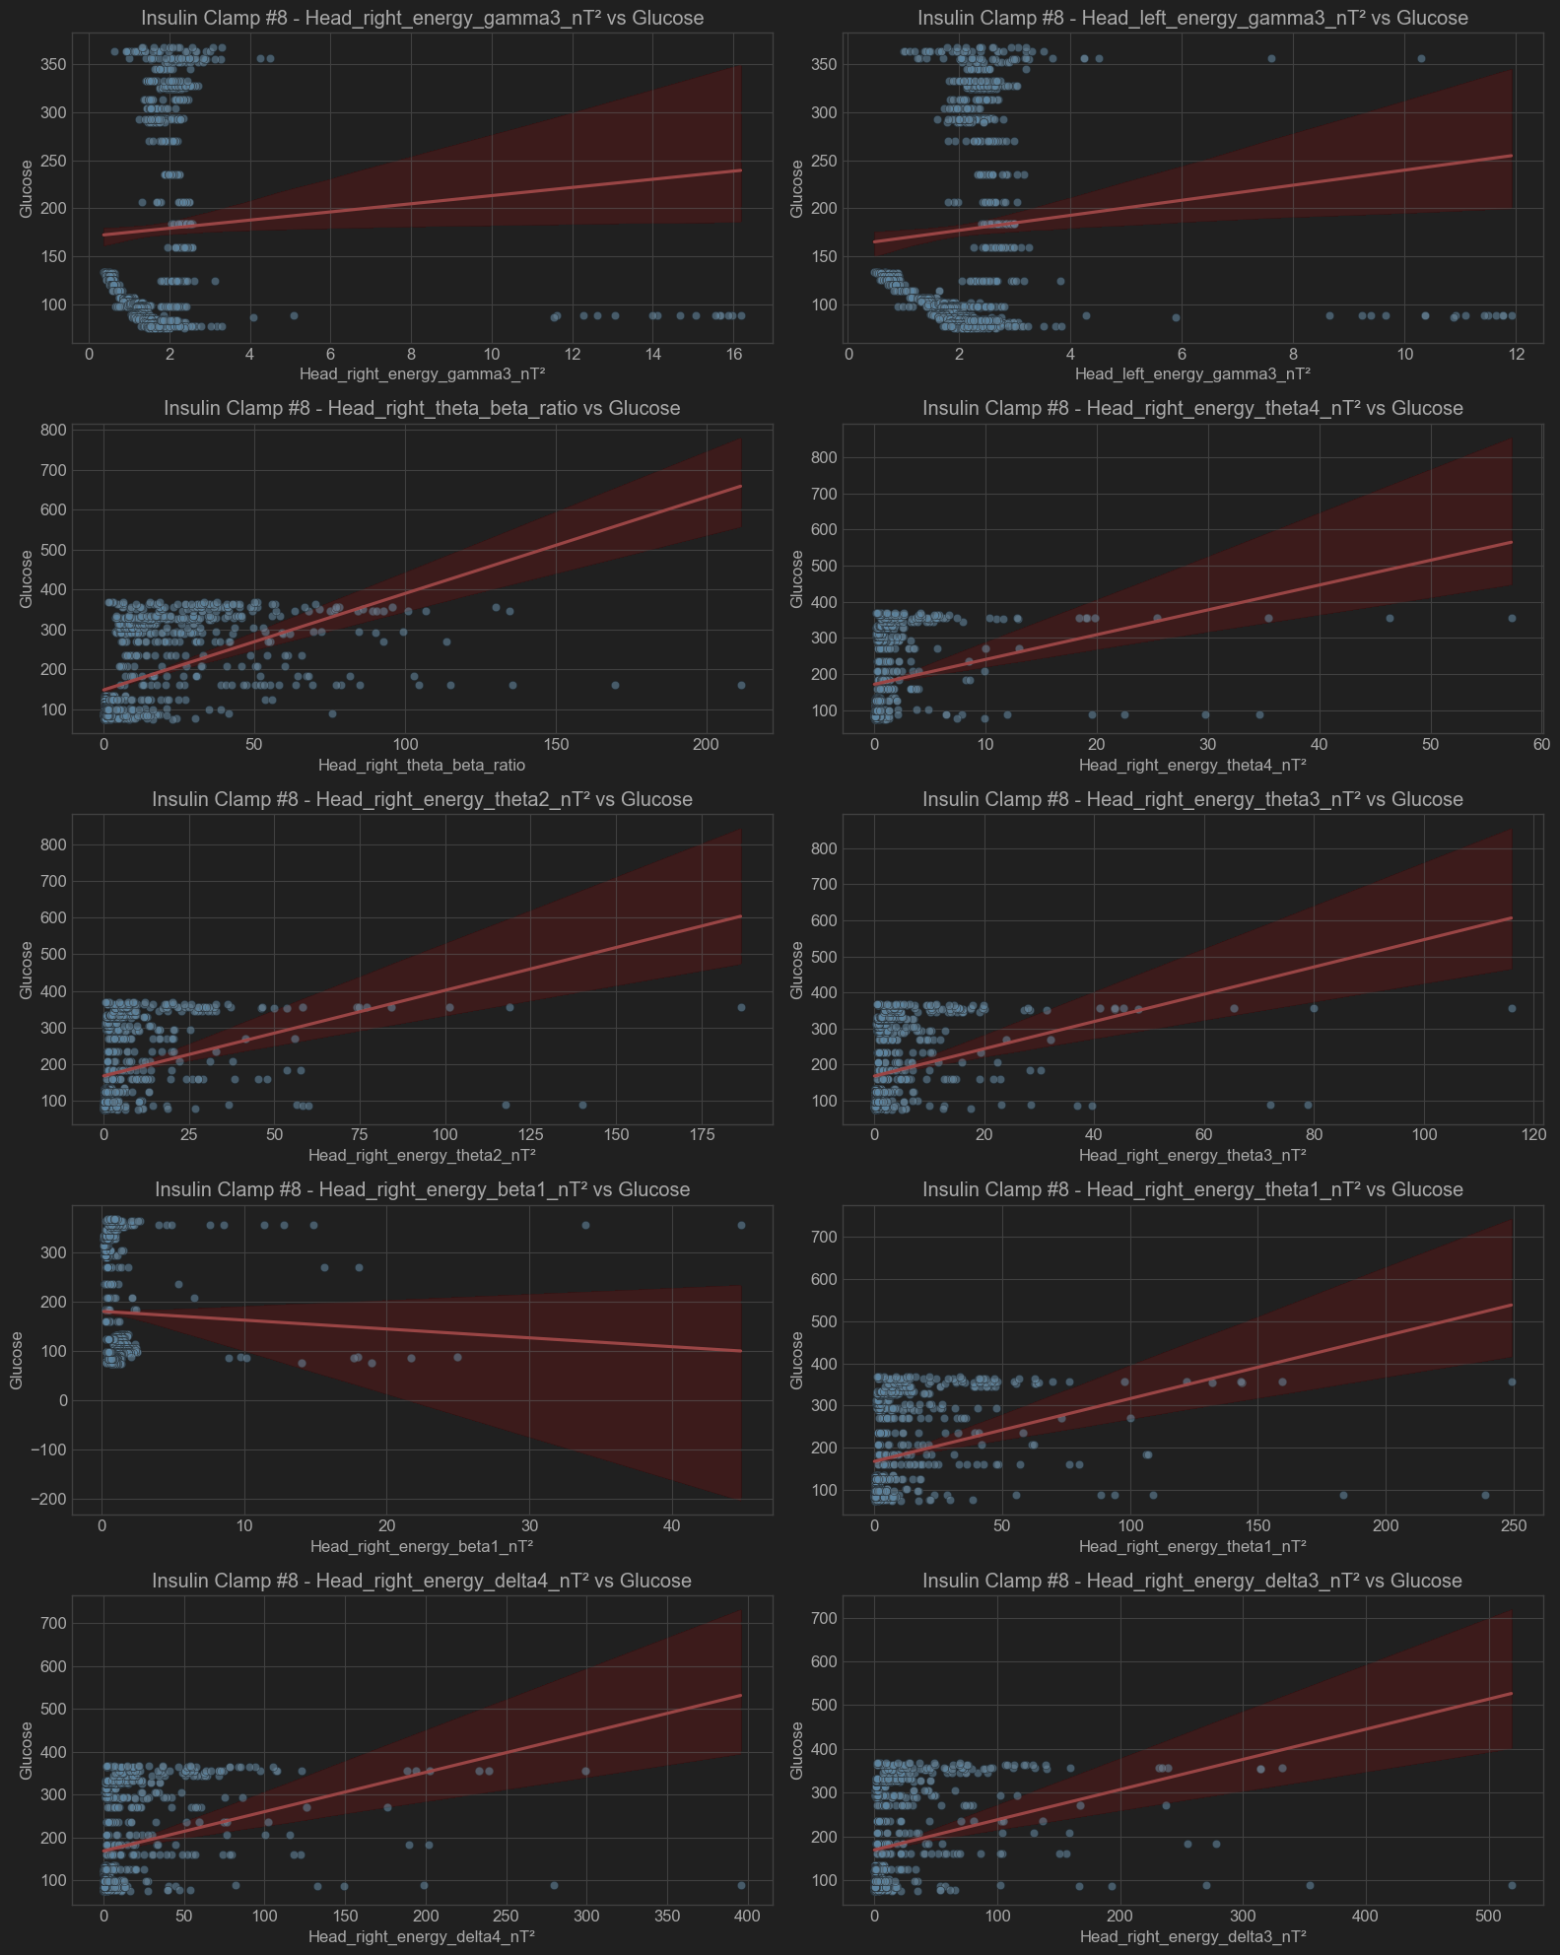

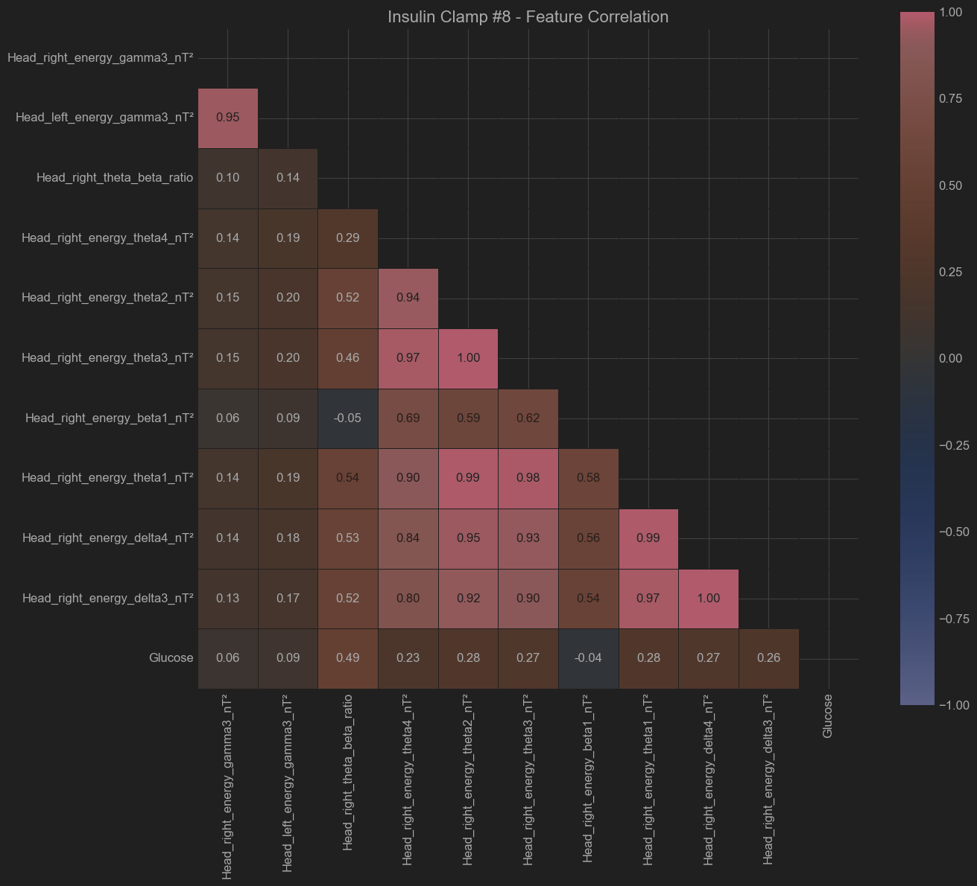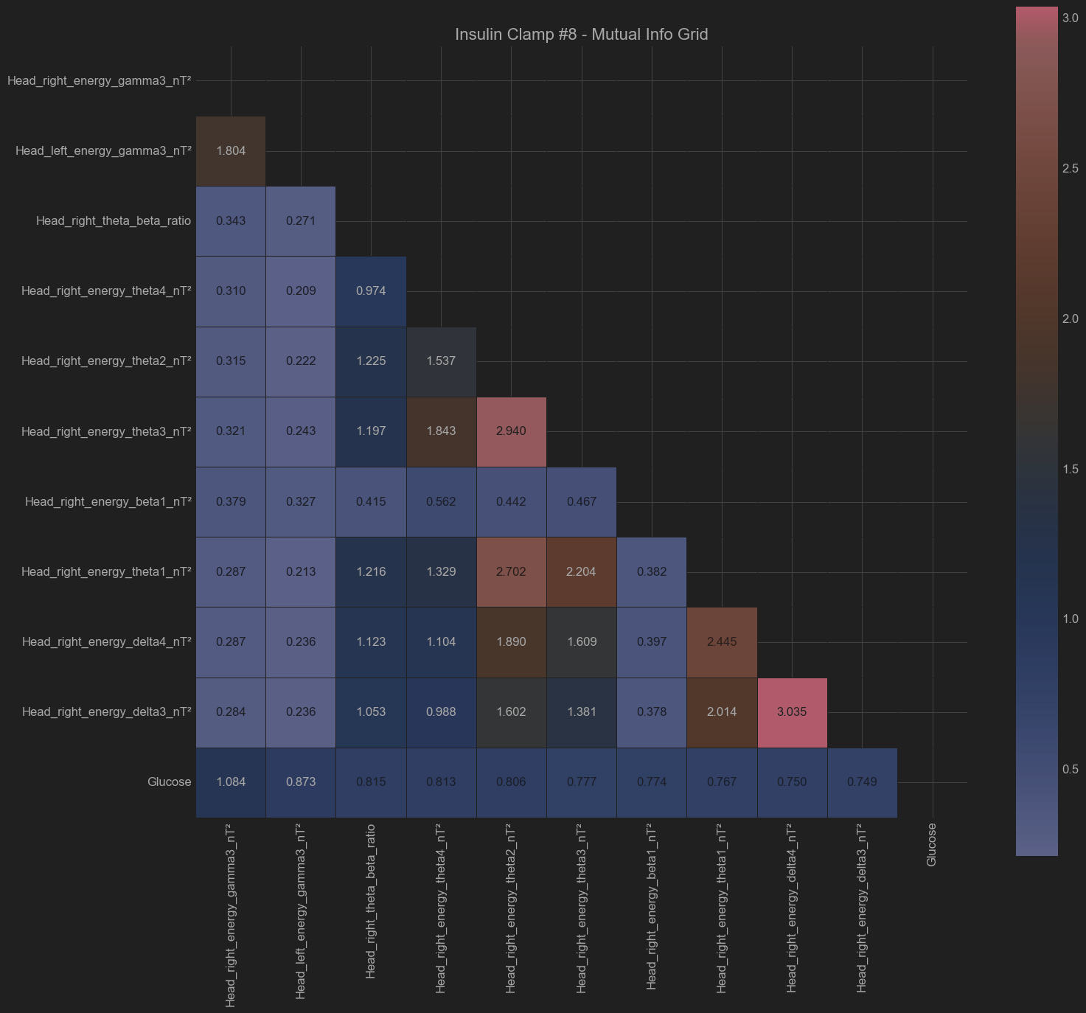

**Chart Explanations  
  
Feature Importance Bar Chart:**

* This chart displays the top features ranked by mutual information with glucose levels.
* Features with higher mutual information scores have stronger statistical relationships with glucose levels

**Feature vs Glucose Scatter Plots**

* Less informative, due to visible non-linearity of the features, but show some potential clustering
* These scatter plots intended to show the relationship between each top feature and glucose levels, with regression lines.

**Feature Correlation Matrix**

* This heatmap displays correlation coefficients between top features and glucose.  
   - Red indicates positive correlations  
   - Blue indicates negative correlations  
   - Color intensity shows correlation strength

**Mutual Information Matrix**

* This heatmap shows pairwise relationships between top features )including glucose(  
   - MI scores quantify the strength of non-linear relationships

**Summary for direct feature correlations**

* The direct correlations of the selected features to glucose levels are relatively weak
* Several features are mutually correlated with each other (expected)
* The frequency band analysis is particularly interesting - features from the Gama (30-50 Hz), Delta (0.1-4 Hz) and Theta (4-8 Hz) bands consistently appear as important. According to the metadata, these might represent:
  + Gamma (30-50 Hz): Ultra-fast synchronized metabolic network activity.
  + Delta band (0.1-4 Hz): Very slow metabolic oscillations related to baseline cellular processes
  + Theta band (4-8 Hz): Slow rhythmic activity potentially related to mitochondrial membrane potential fluctuations

*With a descent amount of caution, this might align with metabolic theory suggesting that slower oscillatory components may reflect fundamental energy production processes affected by glucose availability. Faster oscillatory components may also be related to membrane activity of the mitochondria energy complexes.*

**Lagged Correlation-Causality Analysis**

**Overview of Analysis:**

We have evaluated the correlation and potential “causality” between physiological “Events” (insulin injections and sugar drink "Ensure" administration) and sensor-derived features across multiple patients.

Data from Head, Hand, and Liver sensor channels were analyzed to determine feature relevance, optimal analysis windows for physiological response detection, and inter-patient variability.

**Methods:**

The analysis employed the following methods:

1. **Correlation Analysis:**
   * Calculated Pearson correlation coefficients between sensor-derived features and physiological events across multiple lag intervals.
2. **Optimal Window Selection:**
   * Evaluated the correlation strength across various temporal windows (10, 15, 30, and 45 minutes post-event) to identify the optimal timeframe for capturing physiological responses.

**Key Results** (Individual charts can be seen inside the Collab Notebook)

**Common High-Correlative Features (Across Patients):**

The following features demonstrated consistently strong correlations:

* **Hand2_stft_spectral_rolloff_Hz**: Avg correlation = 0.9341
* **Hand1_stft_spectral_centroid_Hz**: Avg correlation = 0.7145
* **Hand1_energy_delta2_nT²**: Avg correlation = 0.6075
* **Liver1_energy_alpha2_nT²**: Avg correlation = 0.5191
* **Liver1_energy_alpha1_nT²**: Avg correlation = 0.5054
* **Liver2_centroid_Hz**: Avg correlation = 0.4447
* **Liver1_centroid_Hz**: Avg correlation = 0.4406

**Comparison Between Sensor Types:**

* **Liver Sensors:**
  + Highest overall correlation (avg = 0.4558).
  + Average lag: 20.59 minutes, indicating potentially delayed metabolic responses.
* **Hand Sensors:**
  + High correlation (avg = 0.6265).
  + Average lag: 33.92 minutes, indicating significant but delayed metabolic-neurological mixed responses.
* **Head Sensors:**
  + Not among top correlated features in this analysis period.

**Optimal Analysis Windows:**

Correlation strength improved notably with increasing window size:

* **10 min window**: Avg correlation = 0.2197
* **15 min window**: Avg correlation = 0.2478
* **30 min window**: Avg correlation = 0.2648
* **45 min window**: Avg correlation = 0.3612 (Strongest avg correlations identified so far)

The 45-minute analysis window provided the strongest correlation, optimal for detecting robust physiological responses. Assuming the limiting window was 45min, we may expect even larger long-term correlations. However, the correlation of individual features can be optimal at different horizon scales. (See the file report for lagged correlation summary)

**Individual Patient Variability:**

Notable patient-specific differences observed:

* **Insulin Clamp #1**: Theta-band head features dominant.
* **Insulin Clamp #2**: Systemic synchronization (Max Pearson correlation) highly correlated.
* **Insulin Clamp #3**: Gamma-band hand features strongly correlated.
* **Insulin Clamp #4**: Gamma-band head features significant.
* **Insulin Clamp #5**: Liver spectral features consistently strong.
* **Insulin Clamp #6**: Liver alpha-beta ratios notable.
* **Insulin Clamp #7**: Exceptionally high correlation for Hand spectral rolloff.
* **Insulin Clamp #8**: Gamma-band head and liver features prevalent.

Since the most significant features are highly diverse among the patients, these findings may emphasize the potential need for personalized physiological monitoring strategies. Or think of better feature extraction strategies.

Some typical representative charts and diagrams of lagged correlation (see detailed ones, sorted by patients, channels and lag windows in the notebook)

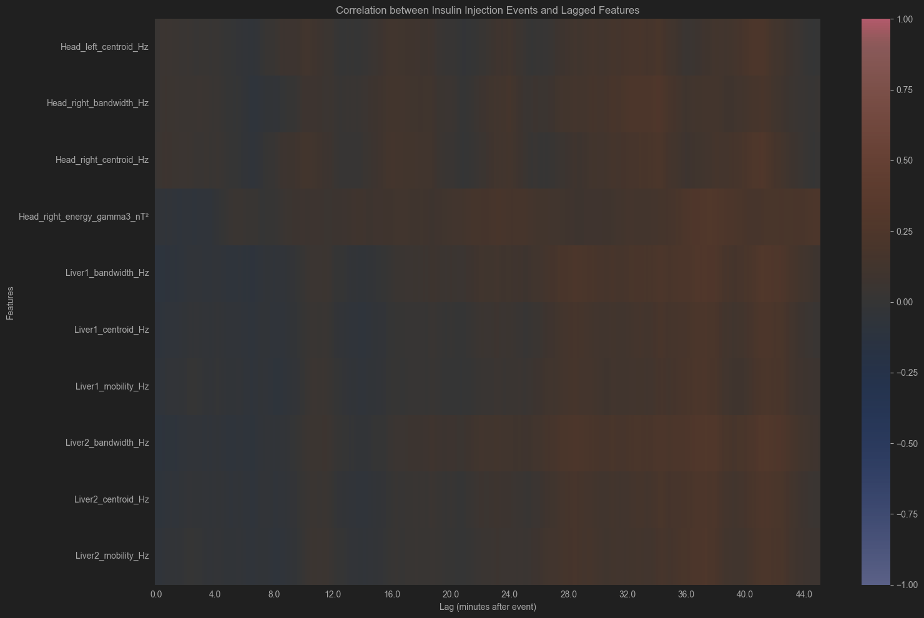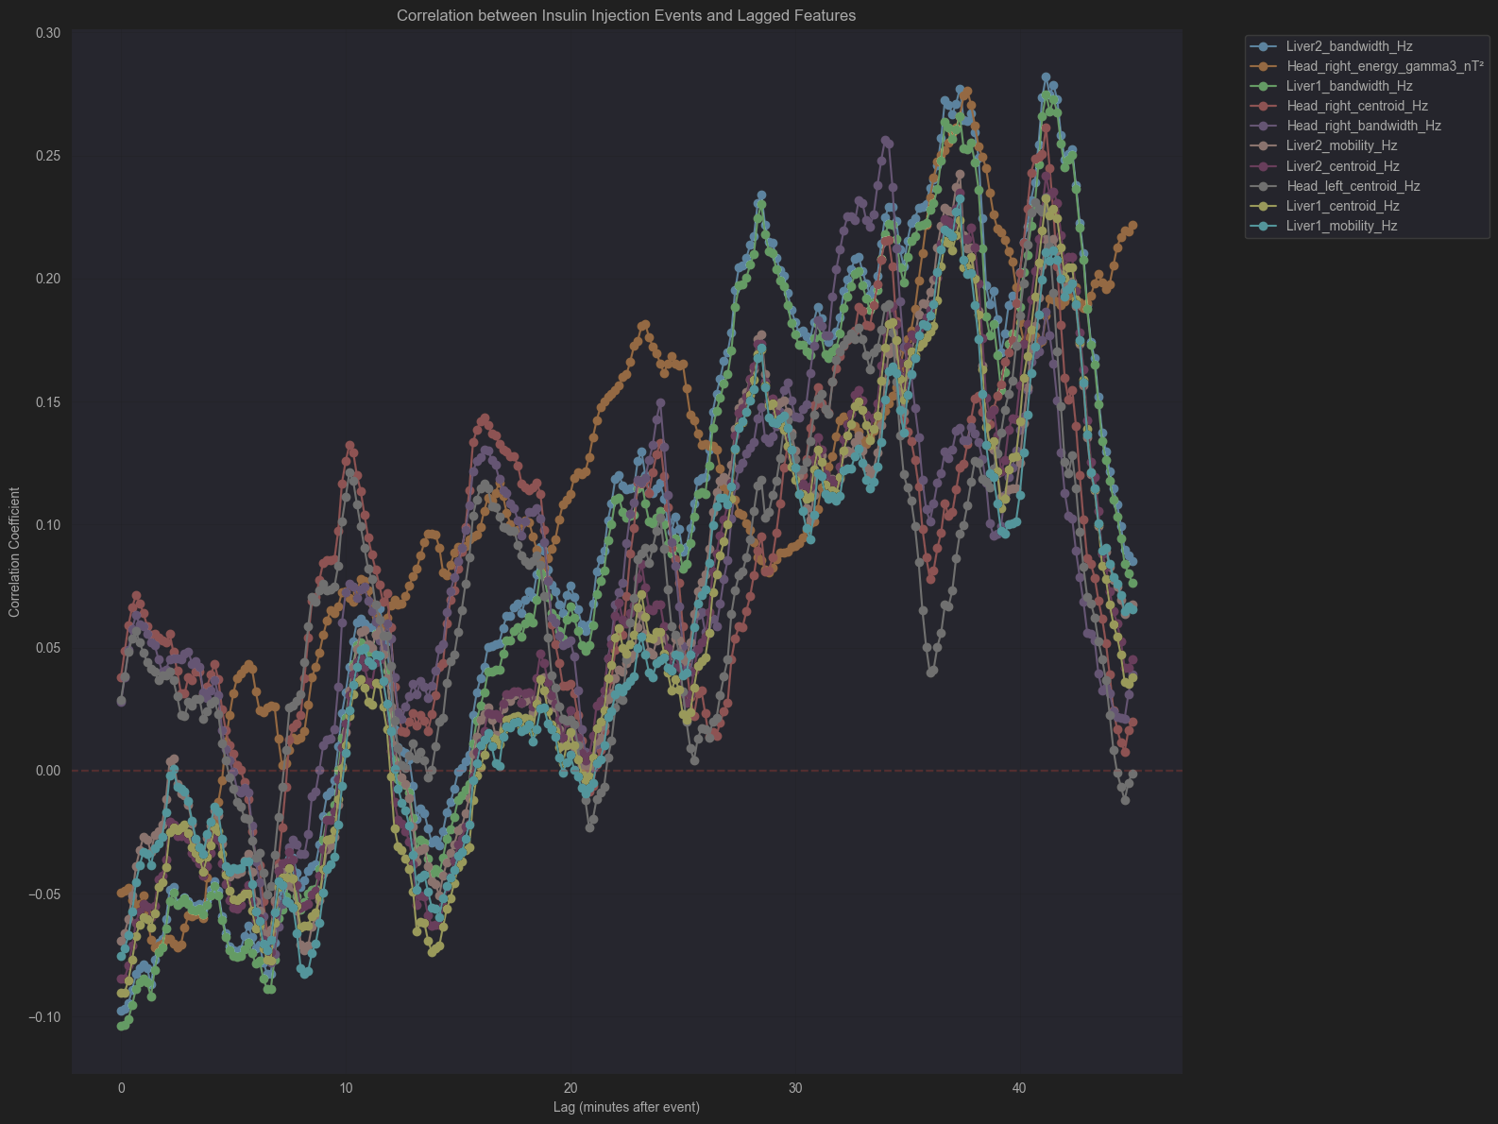

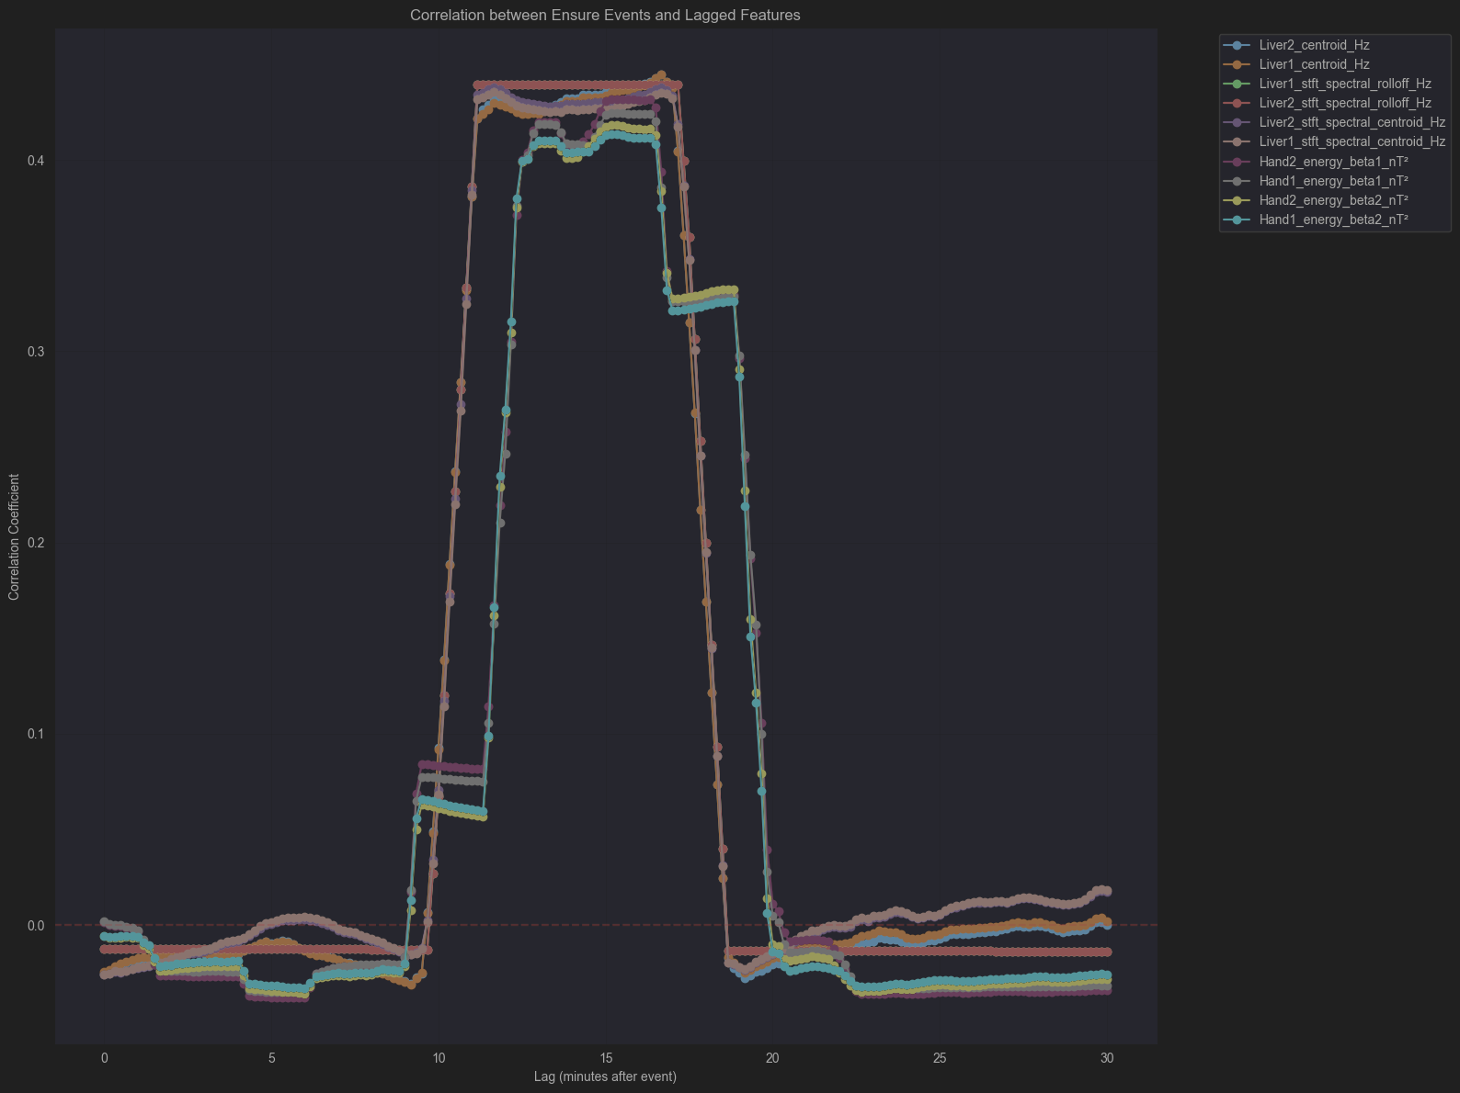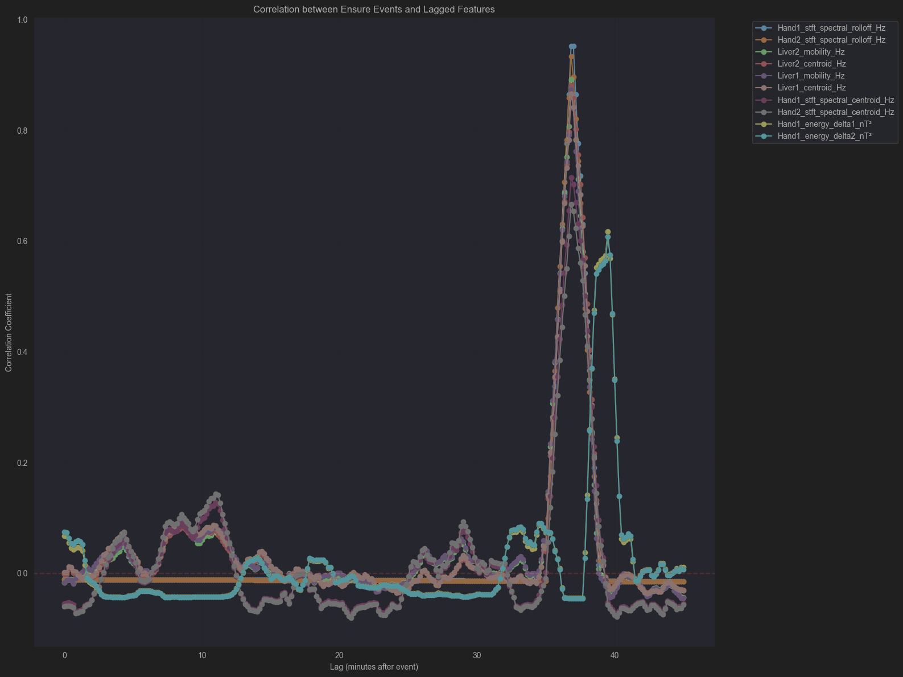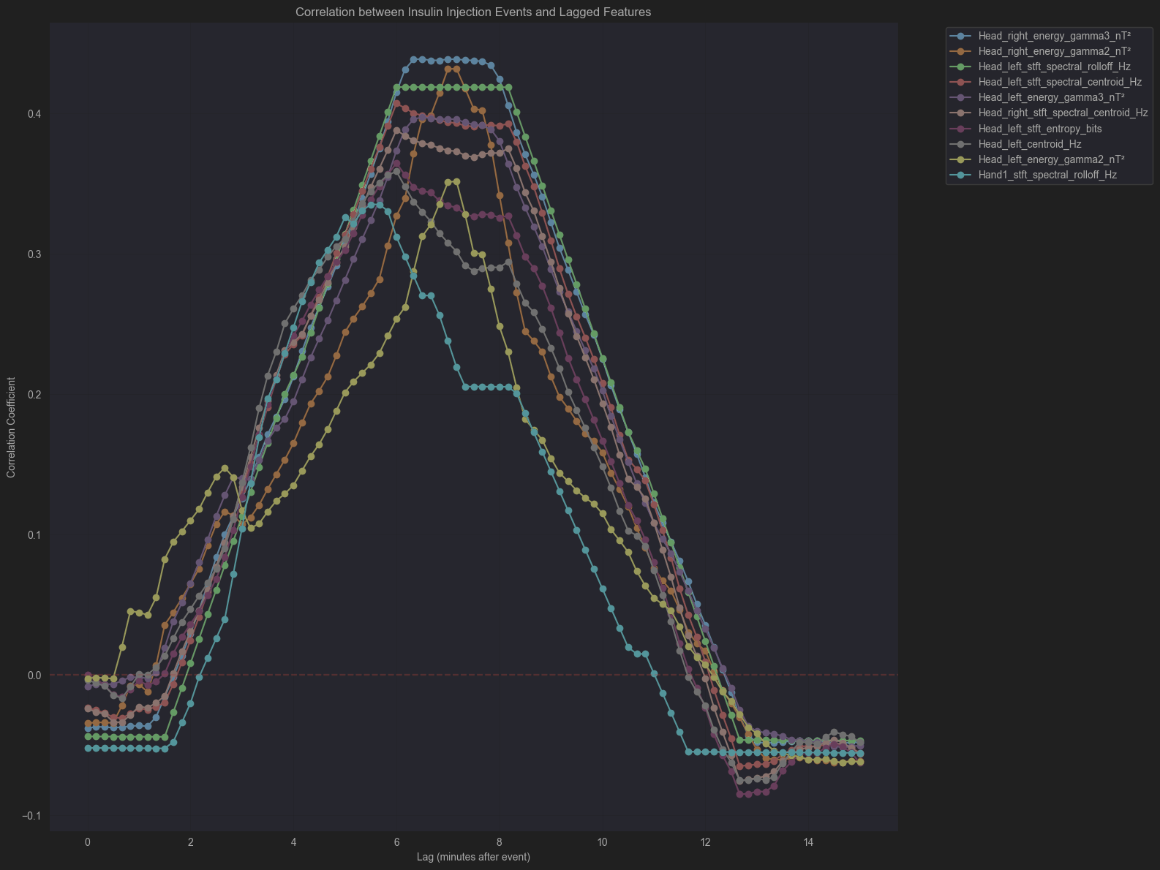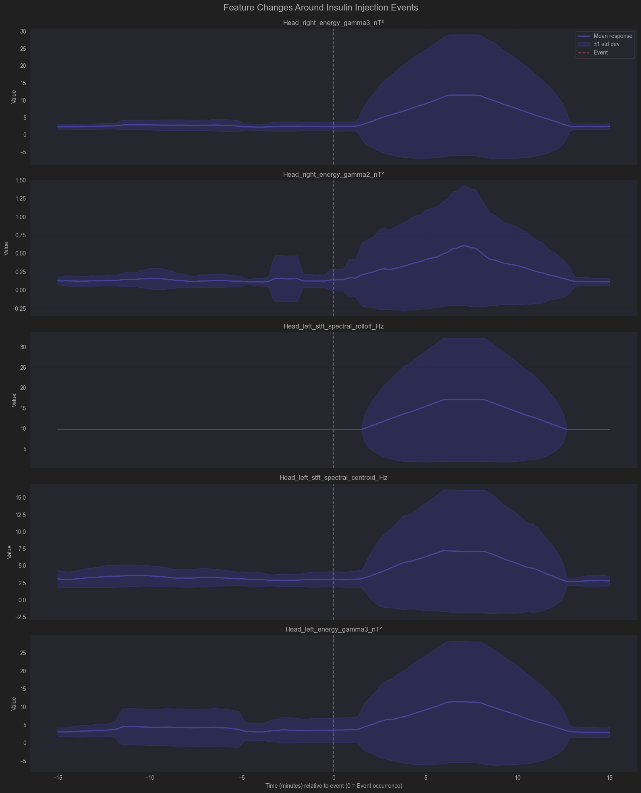

**Possible Physiological Interpretations:**

* **Liver spectral features** likely represent delayed metabolic adjustments related to insulin events, reflecting hepatic biochemical activities.
* **Gamma-band energies** (Hand and Head sensors) possibly signify rapid metabolic or neurological responses triggered by insulin, potentially indicative of cognitive or indirect neurological reactions.
* **Max Pearson correlation** captures systemic physiological synchronization, suggesting systemic integration but may not serve as a standalone predictive marker.

**Potential Next Steps:**

1. **Sensor Prioritization:**
   * **Liver sensors** for robust detection of delayed metabolic responses.
   * **Hand sensors** for capturing high-correlation mixed responses.
2. **Analysis Window:**
   * **45-minute post-event window** so far is the strongest horizon physiological correlation detection, however one may study a different lag correlations.
3. **Feature Prioritization:**
   * We might want to focus on liver spectral features (**alpha-band energies, spectral centroid and rolloff**) and **gamma-band energies** from hand sensors.
   * It is important to explore advanced features, such as **Wavelet** or **EMD decompositions**, for enhanced robustness, keeping computational demands in mind.
   * It may be wise to consider further analysis of **delta** and **theta bands** based on earlier direct correlation observations (non-lagged correlation analysis).
4. **Improved Signal Analysis:**
   * It may be important to filter out the sections of the signal with Sensor Overflow
   * One may combine paired signal channels with mutual correlation masking
   * Data from Normal Patients need to be extracted for Signal Baseline study